

**Department Of Computer Science & Engineering**

Graduation Project

Secure Infrastructure Network with SIEM

**By**

**Abubakr Gamal Abdulrazak Mohamed Mostafa nada**

**Amr Khaled salah Youssef Hamdy Ftouh**

|  |  |  |
| --- | --- | --- |
| **Supervisors** | **Head of the Department** | **Dean** |
| **Prof. / Ayman Elsayed** | **Prof. / Mohamed Berbar** | **Prof. / Ayman Elsayed** |

Table of Contents

Table of Contents 2

Abstract 8

Project Context 9

Chapter 1: Network Overview 10

1.1 Project Objectives 10

1.2 Site Architecture 10

1.3 Inter-Branch Connectivity 12

1.4 Redundancy and High Availability 12

1.5 Network Security Features 12

Chapter 2: Network Design 13

2.1 Physical Topology 13

2.2 Logical Topology 13

2.3 VLAN Design 14

2.4 IP Addressing Scheme 15

2.5 Layer 2 Security Features 15

Chapter 3: Device Configuration Samples 16

3.1 Cairo Branch – Distribution Switches 16

3.2 Access Layer 27

3.2.1 Cairo Branch – SWC-1 27

3.2.2 Cairo Branch – SWC-2 28

3.2.3 Cairo Branch – SWC-3 28

3.2.4 Cairo Branch – SWC-4 29

3.2 Access Layer 29

3.2.12.1 Hostname 35

3.2.12.2 VLAN and Port Differences 35

3.2.12.3 VLAN Interface 35

3.3 Core Layer 35

3.4 Edge Layer 39

3.5 Chapter Summary and Security Overview 40

Chapter 4: Network Services and Security Policies 41

– Cairo Branch 41

4.1 DHCP Snooping 41

4.2 Dynamic ARP Inspection (DAI) 42

4.3 Port Security 42

4.4 Spanning Tree Enhancements – BPDU Guard & PortFast 43

4.5 IP Helper Addresses 43

Summary of Security Features for Cairo Branch 44

4.2 Network Services and Security Policies – Alexandria Branch 44

4.2.1 DHCP Snooping 44

4.2.2 Dynamic ARP Inspection (DAI) 45

4.2.3 Port Security 45

4.2.4 Spanning Tree Enhancements – BPDU Guard & PortFast 46

4.2.5 IP Helper Addresses 46

4.2.6 Summary of Security Features for Alexandria Branch 47

4.3 Network Services and Security Policies – Data Center 47

4.3.1 DHCP Snooping 47

4.3.2 Dynamic ARP Inspection (DAI) 48

4.3.3 Port Security 48

4.3.4 Spanning Tree Enhancements – BPDU Guard & PortFast 48

4.3.5 IP Helper Addresses 49

4.3.6 Summary of Security Features for Data Center 49

Chapter 5: Administrator Windows Server 49

1-Introduction to Windows Server 50

Key Features: 50

Importance in Network Infrastructure: 50

2: Installing Windows Server 51

Installation Steps 51

1. Workgroup (Peer-to-Peer Network) 58

2. Domain (Server-Based Network) 58

3. Hybrid Network 58

4: Active Directory Domain Services (AD DS) 59

What is Active Directory? 59

Key Components of Active Directory 59

5: Installing and Configuring Active Directory Domain Services (AD DS) 60

Step 2: Add the Active Directory Domain Services Role 61

step 3: Promote Server to a Domain Controller 65

6: How to Join a Client Machine to the Domain 68

7.Creating the users and groups 71

1. User Account 72

2. Security Group 72

Organizational Unit (OU) 72

Steps to Create an Organizational Unit (OU) in Active Directory 72

Why Place Users Inside Specific OUs (e.g., HR, Sales)? 74

Steps to Create a User in Active Directory 75

purpose of Groups: 80

Default Local Groups Created After Joining a Domain 84

1. Administrators 84

2. Users 84

8. creating group policy 84

What is Group Policy (GPO)? 84

Main Goals of GPO: 85

Group Policy Objects Applied to HR OU 90

1 disable-USB 90

2.prevent CMD 90

3.prevent automatic update programs 91

4.Enforce Password Complexity and Expiration 91

5.Disable "Run" command 91

6 disable control panel 91

7.map network drive 91

1.Allow Remote Desktop Access 92

2.Disable Automatic Restart After Updates 93

3.Enable PowerShell Logging & Transcription 93

4.disable-USB 93

5.Enforce Screen Lock After Inactivity 93

6.map network drive 94

Group Policy Objects Applied to SALES OU 94

1. Disable "Run" Command 94

2.Disable Control Panel 95

3. disable-USB 95

4.Enforce Password Complexity and Expiration 95

5.prevent CMD 95

6.Disable Windows Store and Game Features 95

7.maped network drive 95

9. configure DHCP srever 96

Why Use DHCP? 96

How It Works (DHCP Lease Process): 96

What Can DHCP Configure? 96

Steps to configure DHCP 97

Step 1: Install the DHCP Server Role 97

Step 2: Authorize the DHCP Server 98

Step 3: Create a New Scope 98

Step 4: Test the Configuration 102

10. File server , shairing and disk qouta 105

File Sharing 105

Step 1: Install File Server Role (if not installed) 106

Step 2: Create a Shared Folder 106

Step 3: Set NTFS Permissions 108

Disk Quota 110

Configure Disk Quota 110

Additional Domain Controller (ADC) 113

Why Use an Additional Domain Controller? 113

How It Works 114

Step 1: Prepare the Second Server 114

Step 2: Join the Existing Domain 114

Step 3: Install Active Directory Domain Services (AD DS) 114

FortiGate Firewall Integration for Network Security: A Graduation Project Case Study 118

Abstract 118

6.1: Introduction to Network Security and Firewalls 118

1.1 Introduction to Network Security 118

1.2 Understanding Cyber Threats 119

1.3 The Role of Firewalls in Network Security 119

1.4 Types of Firewalls 119

1.5 Why FortiGate for This Project? 120

1.6 Document Structure 120

6.2: FortiGate Firewall Overview 121

2.1 Introduction to Fortinet and FortiGate 121

2.2 FortiGate Architecture and FortiOS 121

2.3 FortiGate Operating Modes 121

2.4 Initial Access and Management 122

6.3 Network Design and FortiGate Integration Planning 123

3.1 Current Network Topology Analysis 123

3.2 Strategic Placement of the FortiGate Firewall 123

3.3 IP Addressing Scheme for FortiGate Integration 124

3.4 Physical Cabling Plan 124

6.4: FortiGate Firewall Configuration (Practical Implementation) 125

4.1 Interface Configuration 125

4.2 Routing Configuration (Static Routing Focus) 131

4.3 Firewall Policy Configuration 134

4.4 Network Address Translation (NAT) Configuration 137

6.5: Testing, Verification, and Security Enhancements 138

5.1 Connectivity and Routing Verification 138

5.2 Firewall Policy Enforcement Testing 139

5.3 Basic Security Features Implementation 139

5.4 Challenges Encountered and Solutions 140

5.5 Logging and Monitoring 140

6.6: Conclusion and Future Work 141

6.1 Project Summary and Achievements 141

6.2 Lessons Learned 141

Definition and Purpose 143

SIM vs. SEM 143

Core SIEM Functions 143

Importance of SIEM in Modern Security 144

2. QRadar Overview 144

3. Data Collection in QRadar 146

Event Concepts 147

Event Properties and Metadata 148

Coalescing and Normalization 148

Practical Event Scenarios 148

Flow Fundamentals 148

Types of Flows 149

Flow Processing and Usage 149

Normalized Fields 149

Understanding Offenses 149

Offense Creation and Correlation 150

Threat Analysis and Forensics 150

Rule Building Blocks 150

Rule Types 150

Rule Actions and Responses 151

Datasets and Logic Flow 151

Asset Database and Grouping 151

Auto-Discovery and Enrichment 151

Asset Risk Evaluation 152

Report Configuration 152

Custom Reports 152

Data Sources and Outputs 152

Default vs. Custom Dashboards 153

KPI Monitoring 153

Creating and Sharing Dashboards 153

Threat Intelligence with X-Force 153

SaaS and Cloud Integration 154

App Marketplace 154

Incident Forensics and UBA 154

Types of Brute Force Attacks: 174

Why It's Done: 175

Types of Remote Scanning Attacks: 175

What is a DDoS Attack? 177

How DDoS Attacks Work: 177

Abstract  
 Secure Infrastructure Network with SIEM

This graduation project, titled **“Secure Infrastructure Network with SIEM”**, presents a comprehensive enterprise network design and implementation aligned with modern cybersecurity practices. The project simulates a multi-branch organization consisting of three key locations: Cairo, Alexandria, and a centralized Data Center, each structured according to Cisco’s three-tier hierarchical network model (Access, Distribution, Core).

The primary goal was to create a highly secure, redundant, and scalable infrastructure capable of supporting centralized threat detection and log management using IBM QRadar SIEM. The design ensures effective inter-branch connectivity, fault tolerance, and real-time visibility into network activities. The network segmentation was achieved through VLANs allocated to various departments (HR, IT, Sales, Customer Service), with IP subnets consistently assigned using a 192.168..0/24 scheme.

For high availability, multiple redundancy techniques were deployed: - **Hot Standby Router Protocol (HSRP)**: Provided virtual gateway redundancy - **EtherChannel (LACP/PAGP)**: Enabled link aggregation and load balancing - **Rapid-PVST+**: Ensured loop prevention with optimized convergence

To address security at Layer 2, the design integrated: - **DHCP Snooping** to block rogue DHCP responses - **Dynamic ARP Inspection (DAI)** to prevent ARP spoofing - **Port Security** with sticky MAC addressing and violation protection - **BPDU Guard** and **PortFast** to secure the Spanning Tree Protocol from rogue devices

The Data Center hosts critical services such as Active Directory, centralized DHCP, FTP, and QRadar SIEM. The SIEM component was configured to receive logs from domain controllers, firewalls, and routers to detect and correlate threats such as brute-force attacks, port scanning, and abnormal traffic patterns.

The routing backbone utilized OSPF (Area 0), supporting dynamic routing between branches. IP address planning used /30 subnets for point-to-point links and ensured clear address space for growth. Devices were emulated using PNETLab to simulate realistic enterprise environments and validate configurations.

The project team was divided into specialized roles: - **Network Design & Switching Configuration** - **Microsoft Server Administration (DHCP, AD, DNS, GPO)** - **FortiGate Firewall Deployment** - **IBM QRadar SIEM Integration**

Through this project, the team demonstrated practical understanding of enterprise networking, system configuration, firewall rule enforcement, and SIEM-based detection. The resulting infrastructure model serves as a scalable and secure reference architecture for real-world enterprise environments.

# Project Context

This graduation project, titled **“Secure Infrastructure Network with SIEM”**, presents the design and implementation of a secure, scalable, and enterprise-grade network architecture tailored to a simulated multi-branch corporate environment. Inspired by real-world network design standards, the project models three interconnected sites—**Cairo, Alexandria, and a centralized Data Center**—using Cisco’s three-tier hierarchical architecture: **Access**, **Distribution**, and **Core** layers.

The primary objective of the project is to build an infrastructure capable of supporting **centralized monitoring, threat detection, and incident response**, achieved through the deployment of **IBM QRadar SIEM**. The network incorporates advanced features such as **VLAN segmentation**, **HSRP for high availability**, **OSPF dynamic routing**, and **Layer 2 security enhancements** including **DHCP Snooping, Dynamic ARP Inspection (DAI), Port Security**, and **BPDU Guard**.

To ensure a practical and holistic implementation, the project was collaboratively executed by a team of four members, each specializing in a distinct domain:

* **Network Design & Switching Configuration**: Designed and implemented the multi-layer topology using VLANs, HSRP, STP, and dynamic routing.
* **Microsoft Server Configuration**: Deployed Active Directory, DHCP, DNS, and GPO services within the Data Center.
* **Firewall Implementation**: Configured and integrated FortiGate firewall to control inter-VLAN and branch traffic.
* **SIEM (QRadar) Setup**: Installed and integrated IBM QRadar for real-time log collection, threat correlation, and alert generation.
* **Network Testing & Validation**: Conducted failover simulations, security verifications, and performance testing using PNETLab.

This project not only demonstrates practical knowledge in enterprise network design and security but also highlights the integration of core IT infrastructure components into a unified monitoring and defense ecosystem.

## 

## Chapter 1: Network Overview

### 1.1 Project Objectives

The key objectives of the network design are:

* Connect three separate branches (Cairo, Alexandria, and the Data Center) through a scalable, redundant, and secure infrastructure.
* Provide layered segmentation using VLANs for improved traffic control, security, and SIEM visibility.
* Ensure high availability through redundancy mechanisms at both Layer 2 and Layer 3.
* Enable future expansion such as site-to-site VPNs and next-generation firewall integration.
* Apply standard enterprise protocols and security mechanisms to ensure resilience and alignment with best practices.

### 1.2 Site Architecture

Each branch in the network includes:

* 2 Distribution Layer Switches
* 4 Access Layer Switches
* 8 End Devices (PCs) *(optional depending on the branch design)*

The network follows a standard three-tier hierarchical model:

* **Access Layer**: Connects endpoints (e.g., PCs, phones) and enforces edge-level security.
* **Distribution Layer**: Aggregates traffic from access switches, routes between VLANs, and applies traffic filtering.
* **Core Layer**: Provides high-speed inter-branch connectivity and links to edge routers for external access.

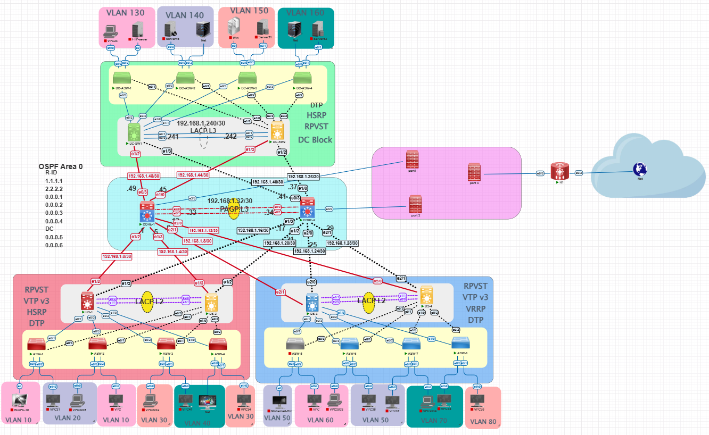**Figure 1.1**: Enterprise Network Topology Diagram.  
The diagram illustrates the hierarchical layout of the three branches, including Access, Distribution, and Core layers, along with inter-branch connectivity.

### 1.3 Inter-Branch Connectivity

Branches are interconnected via the public internet. A future enhancement includes deploying site-to-site VPN tunnels to secure inter-branch communication. VPN features were excluded from the current implementation due to hardware limitations in the virtual lab environment (e.g., CPU and RAM).

### 1.4 Redundancy and High Availability

The network includes the following redundancy mechanisms:

* **HSRP** on distribution switches to ensure default gateway redundancy.
* **EtherChannel** using **LACP** (or **PAGP** in some branches) for link aggregation between layers.
* **Rapid-PVST+** to prevent Layer 2 loops, with custom bridge priorities per VLAN to balance root bridge roles.

Redundant links and standby devices guarantee network continuity in the event of a failure. In the event that a primary device or link becomes unavailable, a backup or standby device automatically takes over its role to ensure uninterrupted network operations. This seamless transition allows for time to troubleshoot and repair the faulty component without impacting users.

Moreover, the presence of redundant devices not only provides fault tolerance but also contributes to better load distribution. By balancing network traffic across multiple active links and devices, the overall network performance and efficiency are improved, reducing bottlenecks and enhancing user experience.

### 1.5 Network Security Features

Security is integrated at both Layer 2 and Layer 3 using the following mechanisms:

* **Access Control Lists (ACLs)** applied on both routers and firewalls to control traffic flows and enforce security policies between VLANs and across sites.
* **Port Security** using sticky MAC addresses and maximum MAC bindings on access ports.
* **DHCP Snooping** to block rogue DHCP servers.
* **Dynamic ARP Inspection (DAI)** to validate ARP packets and prevent spoofing.
* **BPDU Guard** and **PortFast** to protect the Spanning Tree domain from rogue switches.

## Chapter 2: Network Design

### 2.1 Physical Topology

The network is built and tested using **PNETLab**, a virtual emulation platform. The layout reflects a typical enterprise structure:

* Each company floor is represented by an Access Switch.
* Distribution Switches aggregate the Access Layer.
* Core Switches interconnect all branches and link to Edge Routers.

**Device Interconnection Summary:**

* PCs connect to Access Switches via access ports.
* Access Switches connect to Distribution Switches using 802.1Q trunk ports.
* Distribution Switches connect to Core Switches using routed links.
* EtherChannel is implemented between each pair of Distribution or Core switches to provide link redundancy and increased bandwidth.
* Core Switches connect to Edge Routers via /30 IP point-to-point routed links.

### 2.2 Logical Topology

The design applies multiple Layer 2 and Layer 3 protocols:

**VLAN Trunking Protocol (VTP) v3**

* VTP Servers: Distribution Switch 1 at each site.
* VTP Clients: All Access Switches.
* Site-specific domain names and passwords.

**Trunking & DTP**

* Dot1q encapsulation on all inter-switch trunks.
* DTP mode set to trunk, auto, or off depending on the port role.

**Spanning Tree Protocol (STP)**

* Rapid-PVST+ used for fast convergence.
* Custom bridge priorities distribute root roles:
  + VLAN 10/20: Priority 24576 on SWCairo-D1
  + VLAN 30/40: Priority 24576 on SWCairo-D2

**EtherChannel**

* Port-Channel 12 (or equivalent) used.
* Uses LACP (mode active) or PAGP depending on the device.

**First-Hop Redundancy Protocol (HSRP)**

* Configured on VLAN interfaces.
* .254 used as the virtual gateway per VLAN.
* Example:
* standby 10 ip 192.168.10.254  
  standby 10 priority 102  
  standby 10 authentication md5 key-string Cairo

**OSPF Routing**

* All routers in Area 0.
* Network advertisement:
* router ospf 1  
  network 192.168.0.0 0.0.255.255 area 0

### 2.3 VLAN Design

The VLAN design segments the network based on department functions and server roles as follows:

|  |  |
| --- | --- |
| VLAN ID | Function |
| 10 | HR |
| 20 | IT |
| 30 | Sales |
| 40 | Customer Service |
| 130 | FTP Server |
| 140 | Active Directory Server |
| 150 | Additional Active Directory |
| 160 | SIEM Server |

* VLAN interfaces configured on Distribution Switches.
* DHCP requests forwarded to centralized DHCP server: 192.168.140.200
* Note: VLANs 130–160 are primarily hosted in the Data Center.
* VLAN interfaces configured on Distribution Switches.
* DHCP requests forwarded to centralized DHCP server: 192.168.140.200

### 2.4 IP Addressing Scheme

A consistent and scalable addressing scheme is used:

* Each VLAN is assigned a /24 subnet: 192.168.<VLAN_ID>.0/24
* Virtual Gateway: .254
* Distribution Switches:
  + Cairo: .151 and .152
  + Alexandria & Data Center: .251 and .252
* Each Distribution Switch contains a virtual interface (SVI) for each VLAN. These interfaces use the format:
  + Cairo: 192.168.<VLAN_ID>.151 and .152
  + Alexandria & Data Center: 192.168.<VLAN_ID>.251 and .252
* Routed links between layers use /30 subnets:
  + Examples: 192.168.1.2/30, 192.168.1.6/30, etc.

### 2.5 Layer 2 Security Features

Key security features applied at Layer 2:

**DHCP Snooping**

* Enabled globally and per VLAN (e.g., 10–40, 70–80)
* Trusted interfaces defined toward DHCP sources

**Dynamic ARP Inspection (DAI)**

* Enabled on same VLANs
* Verifies MAC-IP bindings
* Trusted interfaces configured for known devices

**Port Security**

* Enforced on access ports:
  + Max 2 MAC addresses
  + Sticky MAC
  + Violation action: shutdown or restrict

**BPDU Guard & PortFast**

* Enabled on all access-facing ports
* Prevents rogue switches from influencing STP

These measures collectively safeguard the network from Layer 2 attacks and unauthorized access.

## Chapter 3: Device Configuration Samples

This chapter documents real configuration examples from all network devices used in the project. Configurations are organized by network layer (Access, Distribution, Core, and Edge), with notes indicating differences between branches. Each section includes explanation of commands and configuration logic to help readers understand and replicate the setup.

### 3.1 Cairo Branch – Distribution Switches

3.1.1 SWCairo-D1 (Distribution Switch 1)

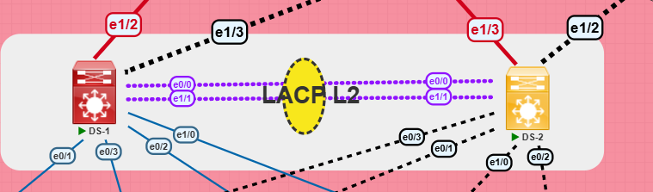

This switch acts as the primary HSRP router for VLANs 10 and 20 and root bridge for VLANs 10 and 20.

hostname SWCairo-D1

Defines the device hostname.

no ip domain-lookup  
enable secret cairo123  
banner motd #Unauthorized access is prohibited#

Basic security and management configuration: disables domain lookup, sets a secure enable password, and displays a login warning banner.

line console 0  
 password consolepass  
 login  
line vty 0 4  
 password sshpass  
 login  
 transport input ssh  
ip domain-name cairo.local  
crypto key generate rsa

Console and VTY line configuration for secure local and remote access. SSH setup with domain name and RSA keys. These commands ensure basic login protection, prevent DNS lookup delays on mistyped commands, and enforce secure remote access.

spanning-tree mode rapid-pvst  
spanning-tree extend system-id  
spanning-tree vlan 10,20 priority 24576  
spanning-tree vlan 30,40 priority 28672

Configures STP with rapid-PVST mode. Assigns bridge priorities to make this switch root for VLANs 10 and 20. Setting bridge priorities helps in deterministic STP root bridge election, ensuring traffic flows optimally.

vtp domain cairo  
vtp mode server  
vtp version 3  
vtp password cairo hidden

VTP configuration in server mode to propagate VLAN info securely across switches. VTP helps simplify VLAN management by automatically propagating VLAN changes across switches in the same domain.

interface range e0/0,e0/2  
 switchport mode access  
 switchport access vlan 10

Access ports configured for VLAN 10 with port-security and BPDU Guard to prevent attacks. These security features prevent common Layer 2 threats like rogue device access and BPDU spoofing.

interface range e0/1,e0/3  
 switchport trunk encapsulation dot1q  
 switchport mode trunk  
 spanning-tree portfast trunk

Trunk ports configured for uplinks with dot1q encapsulation. Portfast trunk is enabled for quicker convergence on trunk links.

interface Port-channel12  
 switchport trunk encapsulation dot1q  
 switchport mode trunk  
  
interface range g0/0,g0/1  
 channel-group 12 mode active

EtherChannel configuration for trunk redundancy between distribution switches. Combining physical links into a logical Port-channel enhances bandwidth and provides fault tolerance.

interface vlan10  
 ip address 192.168.10.151 255.255.255.0  
 standby 10 ip 192.168.10.254  
 standby 10 priority 102  
 standby 10 preempt  
 no shutdown  
  
interface vlan20  
 ip address 192.168.20.151 255.255.255.0  
 standby 20 ip 192.168.20.254  
 standby 20 priority 102  
 standby 20 preempt  
 no shutdown

SVIs for VLANs 10 and 20 with HSRP configuration (primary router). HSRP enables high availability for the gateway IPs. This switch takes over in case the secondary is unreachable.

router ospf 1  
 router-id 0.0.0.1  
 network 192.168.10.0 0.0.0.255 area 0  
 network 192.168.20.0 0.0.0.255 area 0

Enables OSPF routing for VLANs 10 and 20. OSPF provides dynamic routing capabilities within the internal network, allowing the distribution layer switches to share reachability info with the core layer.

#### 3.1.2 SWCairo-D2 (Distribution Switch 2)



This switch is configured similarly to SWCairo-D1 and serves as the secondary device in the distribution layer redundancy design. The two switches form a high-availability pair using HSRP, STP, and EtherChannel. SWCairo-D2 acts as:

* HSRP standby router for VLANs 10 and 20
* HSRP active router for VLANs 30 and 40
* Secondary root bridge for VLANs 10 and 20
* Primary root bridge for VLANs 30 and 40
* Passive peer in the EtherChannel trunk to SWCairo-D1
* VTP client

Only the configuration differences from SWCairo-D1 are shown below:

3.1.2.1 Hostname

hostname SWCairo-D2

3.1.2.2 Spanning Tree Priority (STP)

spanning-tree vlan 30,40 priority 24576

spanning-tree vlan 10,20 priority 28672

SWCairo-D2 is the root bridge for VLANs 30 and 40, and backup for VLANs 10 and 20.

3.1.2.3 VTP Configuration

vtp mode client

Configured as client to receive VLAN information from SWCairo-D1.

3.1.2.4 Access Port Assignment

interface range e0/0,e0/2

switchport mode access

switchport access vlan 20

Access ports use VLAN 20 instead of VLAN 10.

3.1.2.5 EtherChannel Configuration

interface range g0/0,g0/1

channel-group 12 mode passive

Passive mode used for channel formation (with SWCairo-D1 using active).

3.1.2.6 HSRP Gateway Configuration

interface vlan10

ip address 192.168.10.152 255.255.255.0

standby 10 priority 100

standby 10 ip 192.168.10.254

standby 10 preempt

!

interface vlan20

ip address 192.168.20.152 255.255.255.0

standby 20 priority 100

standby 20 ip 192.168.20.254

standby 20 preempt

The standby IP addresses (192.168.X.254) are shared with SWCairo-D1 to provide seamless gateway failover using HSRP.

3.1.2.7 OSPF Configuration

router ospf 1

router-id 0.0.0.2

network 192.168.10.0 0.0.0.255 area 0

network 192.168.20.0 0.0.0.255 area 0

Different router ID to maintain uniqueness within the OSPF domain.

#### 3.1.3 Alexandria Branch – SWAlex-D1

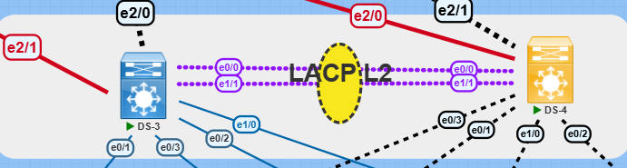

**Basic Initialization & Security:**

hostname SWAlex-D1  
no ip domain-lookup  
enable secret alex123  
banner motd #Unauthorized access is prohibited#  
line console 0  
 password consolepass  
 login  
line vty 0 4  
 password sshpass  
 login  
 transport input ssh  
ip domain-name alex.local  
crypto key generate rsa

**VTP Server Mode:**

vtp domain alex  
vtp version 3  
vtp mode server  
vtp password alex

**Spanning Tree Configuration:**

spanning-tree mode rapid-pvst  
spanning-tree extend system-id  
spanning-tree vlan 50,60 priority 24576  
spanning-tree vlan 70,80 priority 28672

**EtherChannel and Trunking:**

interface Port-channel15  
 switchport trunk encapsulation dot1q  
 switchport mode trunk  
  
interface Ethernet0/0  
 channel-group 15 mode active  
...  
interface Ethernet1/1  
 channel-group 15 mode active

**VLAN Interfaces with HSRP and DHCP Relay:**

interface Vlan50  
 ip address 192.168.50.251 255.255.255.0  
 standby 50 priority 102  
 standby 50 ip 192.168.50.254  
 standby 50 preempt  
 standby 50 authentication md5 key-string Alex  
 ip helper-address 192.168.140.200

**OSPF Routing:**

router ospf 1  
 router-id 0.0.0.3  
 network 192.168.0.0 0.0.255.255 area 0

#### 3.1.4 Alexandria Branch – SWAlex-D2



This switch mirrors the configuration of SWAlex-D1 and serves as the secondary device in Alexandria’s distribution layer. It operates in tandem with SWAlex-D1 to provide redundancy and load balancing via HSRP, STP, and EtherChannel. SWAlex-D2 functions as:

* HSRP standby router for VLANs 70 and 80
* Secondary root bridge for VLANs 70 and 80
* Passive peer in the EtherChannel trunk to SWAlex-D1
* VTP client

**Only the configuration differences from SWAlex-D1 are highlighted below:**

**3.1.3.1 Hostname**

hostname SWAlex-D2

**3.1.3.2 Spanning Tree Priority (STP)**

spanning-tree vlan 70,80 priority 28672

**SWAlex-D2 is configured as the secondary root bridge for VLANs 70 and 80.**

**3.1.3.3 VTP Configuration**

vtp mode client

**Operates in VTP client mode to synchronize VLAN information from SWAlex-D1.**

**3.1.3.4 Access Port Assignment**

interface range e0/0,e0/2

switchport mode access

switchport access vlan 80

**Access ports assigned to VLAN 80 (as opposed to VLAN 70 on SWAlex-D1).**

**3.1.3.5 EtherChannel Configuration**

interface range g0/0,g0/1

channel-group 15 mode passive

**Passive mode for EtherChannel; SWAlex-D1 uses active mode.**

**3.1.3.6 HSRP Gateway Configuration**

interface vlan70

ip address 192.168.70.252 255.255.255.0

standby 70 ip 192.168.70.254

standby 70 priority 100

standby 70 preempt

!

interface vlan80

ip address 192.168.80.252 255.255.255.0

standby 80 ip 192.168.80.254

standby 80 priority 100

standby 80 preempt

**Shared virtual gateway IPs are the same as SWAlex-D1, but SWAlex-D2 uses a lower priority.**

**3.1.3.7 OSPF Configuration**

router ospf 1

router-id 0.0.0.4

network 192.168.70.0 0.0.0.255 area 0

network 192.168.80.0 0.0.0.255 area 0

#### 3.1.5 Data Center – SWDC-D1

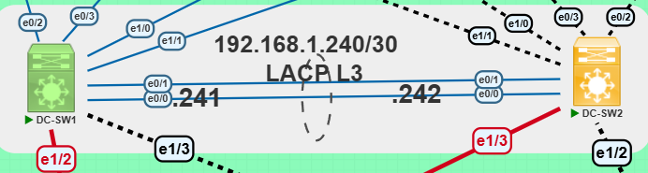

**Basic Initialization & Security:**

hostname SWDC-D1  
no ip domain-lookup  
enable secret datacenter123  
banner motd #Unauthorized access is prohibited#  
line console 0  
 password consolepass  
 login  
line vty 0 4  
 password sshpass  
 login  
 transport input ssh  
ip domain-name datacenter.local  
crypto key generate rsa

* Configures hostname and disables DNS lookup.
* Applies security policies with console and vty line passwords.
* Enables SSH access using generated RSA key.

**VTP Server Mode:**

vtp domain datacenter  
vtp version 3  
vtp mode server  
vtp password datacenter

* Acts as the VTP server for the data center domain.

**Spanning Tree Configuration:**

spanning-tree mode rapid-pvst  
spanning-tree extend system-id  
spanning-tree vlan 130,140 priority 24576  
spanning-tree vlan 150,160 priority 28672

* Rapid PVST+ enabled for fast convergence.
* VLANs 130/140 prioritized as root bridge.

**EtherChannel and Trunking:**

interface Port-channel20  
 switchport trunk encapsulation dot1q  
 switchport mode trunk  
  
interface Ethernet0/0  
 channel-group 20 mode active  
...  
interface Ethernet1/1  
 channel-group 20 mode active

* EtherChannel uses LACP in active mode.
* Provides trunk uplink to the core.

**VLAN Interfaces with HSRP and DHCP Relay:**

interface Vlan130  
 ip address 192.168.130.251 255.255.255.0  
 standby 130 priority 102  
 standby 130 ip 192.168.130.254  
 standby 130 preempt  
 standby 130 authentication md5 key-string DC  
 ip helper-address 192.168.140.200

* VLAN 130 assigned IP ending in .251.
* HSRP enabled with higher priority for active role.
* Forwards DHCP requests to centralized server.

**OSPF Routing:**

router ospf 1  
 router-id 0.0.0.5  
 network 192.168.0.0 0.0.255.255 area 0

* OSPF router ID set to 0.0.0.5.
* Participates in area 0.

#### 3.1.6 Data Center – SWDC-D2





This switch mirrors the configuration of SWDC-D1 and serves as the secondary distribution switch in the Data Center. It provides high availability via HSRP, load balancing through STP priority adjustment, and redundancy with EtherChannel trunking.

SWDC-D2 functions as:

* HSRP standby router for VLAN 130 and active for VLAN 160
* Secondary root bridge for VLANs 130 and 140
* Passive peer in the EtherChannel trunk to SWDC-D1
* VTP client

Only the configuration differences from SWDC-D1 are highlighted below:

**3.1.4.1 Hostname**

hostname SWDC-D2

**3.1.4.2 VTP Configuration**

**vtp mode client**

**Operates in VTP client mode to receive VLAN configuration from SWDC-D1.**

**3.1.4.3 Spanning Tree Priority (STP)**

spanning-tree vlan 150,160 priority 24576  
spanning-tree vlan 130,140 priority 28672

**Priorities are flipped compared to SWDC-D1 to ensure STP load balancing.**

**3.1.4.4 EtherChannel Configuration**

interface range Ethernet0/0, Ethernet1/1  
channel-group 20 mode passive

**EtherChannel is set to passive mode to form a bundle with SWDC-D1, which uses active mode.**

**3.1.4.5 HSRP and VLAN Interface Configuration**

interface Vlan130  
ip address 192.168.130.252 255.255.255.0  
standby 130 priority 100  
standby 130 ip 192.168.130.254  
standby 130 preempt  
standby 130 authentication md5 key-string DC  
ip helper-address 192.168.140.200  
!  
interface Vlan160  
ip address 192.168.160.252 255.255.255.0  
standby 160 priority 102  
standby 160 ip 192.168.160.254  
standby 160 preempt  
standby 160 authentication md5 key-string DC  
ip helper-address 192.168.140.200

**3.1.4.6 OSPF Routing**

router ospf 1  
router-id 0.0.0.6  
network 192.168.0.0 0.0.255.255 area 0  
Router ID is set to 0.0.0.6, and participates in OSPF area 0.

# 3.2 Access Layer

## 3.2.1 Cairo Branch – SWC-1

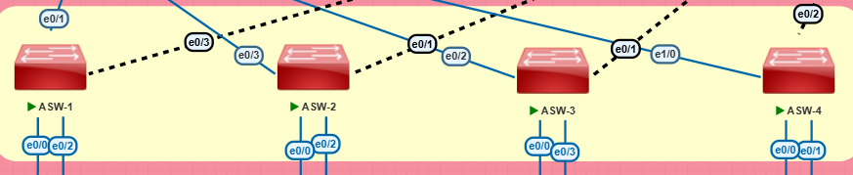

**Basic Configuration & VLANs:**

hostname SWC-1  
no ip domain-lookup  
enable secret cisco123  
banner motd #Unauthorized access is prohibited#  
line console 0  
 password consolepass  
 login  
line vty 0 4  
 password sshpass  
 login  
 transport input ssh  
ip domain-name cairo.local  
crypto key generate rsa  
spanning-tree mode pvst  
spanning-tree extend system-id  
vtp domain cairo  
vtp mode client  
vtp version 3  
vtp password cairo hidden

* Sets hostname and disables domain lookup.
* Secures device with enable secret, console, and SSH access.
* Enables SSH keys and domain name.
* Spanning Tree and VTP configured.

**Access and Trunk Ports:**

interface Ethernet0/0  
 switchport access vlan 10  
 switchport mode access  
 duplex auto  
  
iinterface Ethernet0/1  
 switchport trunk encapsulation dot1q  
 duplex auto  
  
interface Ethernet0/2  
 switchport access vlan 20  
 switchport mode access  
 duplex auto  
  
interface Ethernet0/3  
 switchport trunk encapsulation dot1q  
 switchport mode trunk  
 duplex auto

* Ethernet0/0 and 0/2 are access ports (VLANs 10 and 20).
* Ethernet0/1 and 0/3 are trunk links to distribution.

**VLAN Interfaces & DHCP Helper:**

interface Vlan10  
 ip helper-address 192.168.10.254  
 no shutdown  
  
interface Vlan20  
 ip helper-address 192.168.20.254  
 no shutdown

* Forwards DHCP requests to HSRP virtual IPs.

## 3.2.2 Cairo Branch – SWC-2

* **Hostname:**hostname SWC-2
* **Access VLANs swapped:**

Ethernet0/0 → VLAN 20

Ethernet0/2 → VLAN 10

## 3.2.3 Cairo Branch – SWC-3

**Hostname:** hostname SWC-3

**VLANs:**

Ethernet0/0 → VLAN 30

Ethernet0/3 → VLAN 40

**Trunk Links:**

* **Ethernet0/1 and Ethernet0/2 → Trunk ports**

**DHCP Helper:**

interface Vlan30  
ip helper-address 192.168.30.254  
interface Vlan40  
ip helper-address 192.168.40.254

## 3.2.4 Cairo Branch – SWC-4

**Hostname:** hostname SWC-4

**VLANs:**

Ethernet0/0 → VLAN 40

Ethernet0/1 → VLAN 30

**Trunk Links:**

Ethernet0/2

Ethernet1/0 → إضافة trunk redundancy

**DHCP Helper:**interface Vlan30  
ip helper-address 192.168.30.254  
interface Vlan40  
ip helper-address 192.168.40.254

# 3.2 Access Layer

#### 3.2.5 Alexandria Branch – SWC-5

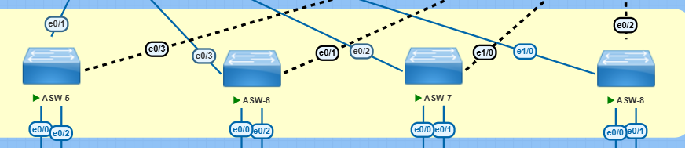

**Basic Configuration & VLANs:**

hostname SWC-5  
no ip domain-lookup  
enable secret cisco123  
banner motd *#Unauthorized access is prohibited#*  
line console 0  
 password consolepass  
 login  
line vty 0 4  
 password sshpass  
 login  
 transport input ssh  
ip domain-name alex.local  
crypto key generate rsa  
spanning-tree mode pvst  
spanning-tree extend system-id  
vtp domain alex  
vtp mode client  
vtp version 3  
vtp password alex hidden

* Device initialization, SSH access, domain identity and VTP setup.

**Access and Trunk Ports:**

interface Ethernet0/0  
 switchport access vlan 50  
 switchport mode access  
 duplex auto  
  
interface Ethernet0/1  
 switchport trunk encapsulation dot1q  
 duplex auto  
  
interface Ethernet0/2  
 switchport access vlan 60  
 switchport mode access  
 duplex auto  
  
interface Ethernet0/3  
 switchport trunk encapsulation dot1q  
 switchport mode trunk  
 duplex auto

* VLAN 50 and 60 for host access.
* Trunk ports to connect to distribution switches.

**VLAN Interfaces & DHCP Helper:**

interface Vlan50  
 ip helper-address 192.168.50.254  
 no shutdown  
  
interface Vlan60  
 ip helper-address 192.168.60.254  
 no shutdown

* Interfaces forward DHCP to virtual gateways (.254).

#### 3.2.6 Alexandria Branch – SWC-6

Follows SWC-5 with the following changes:

**3.2.6.1 Hostname**hostname SWC-6

**3.2.6.2 VLAN Assignments**

interface Ethernet0/0

switchport access vlan 70

switchport mode access

duplex auto

!

interface Ethernet0/1

switchport access vlan 80

switchport mode access

duplex auto

Assigned to VLANs 70 and 80 instead of 50 and 60.

**3.2.6.3 VLAN Interfaces**

interface Vlan70

ip helper-address 192.168.70.254

no shutdown

!

interface Vlan80

ip helper-address 192.168.80.254

no shutdown

#### 3.2.7 Alexandria Branch – SWC-7

Similar setup as SWC-6. Notable differences:  
**3.2.7.1 Hostname:**  
hostname SWC-7

**3.2.7.2 Port Assignments:**interface Ethernet0/3

switchport access vlan 80

switchport mode access

duplex auto

!

interface Ethernet0/1

switchport trunk encapsulation dot1q

duplex auto

!

interface Ethernet0/2

switchport trunk encapsulation dot1q

duplex auto

Port 0/3 used for VLAN 80. Includes two trunk links.

#### 3.2.8 Alexandria Branch – SWC-8

Final access switch in Alexandria.

**3.2.8.1 Hostname:**hostname SWC-8  
**3.2.8.2 Port Assignments:**

interface Ethernet0/0

switchport access vlan 80

switchport mode access

duplex auto

!

interface Ethernet0/1

switchport access vlan 70

switchport mode access

duplex auto

!

interface Ethernet0/2

switchport trunk encapsulation dot1q

switchport mode trunk

duplex auto

!

interface Ethernet1/0

switchport trunk encapsulation dot1q

switchport mode trunk

duplex auto

VLANs swapped from SWC-7. Adds trunk link on Ethernet1/0.

**3.2.8.3 VLAN Interfaces**

interface Vlan70

ip helper-address 192.168.70.254

no shutdown

!

interface Vlan80

ip helper-address 192.168.80.254

no shutdown

#### 3.2.9 Data Center – SWDC-1

**Basic Configuration & VLANs:**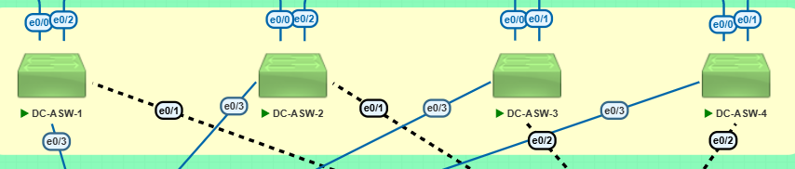

#### 3.2.10 Data Center – SWDC-2

hostname SWDC-1  
no ip domain-lookup  
enable secret cisco123  
banner motd *#Unauthorized access is prohibited#*  
line console 0  
 password consolepass  
 login  
line vty 0 4  
 password sshpass  
 login  
 transport input ssh  
ip domain-name datacenter.local  
crypto key generate rsa  
spanning-tree mode pvst  
spanning-tree extend system-id  
vtp domain Datacenter  
vtp mode client  
vtp version 3  
vtp password Datacenter hidden

* Initial device setup including hostname, secure access, SSH key generation, and VTP domain configuration.

**Access and Trunk Ports:**

interface Ethernet0/0  
 switchport access vlan 130  
 switchport mode access  
 duplex auto  
  
interface Ethernet0/1  
 switchport trunk encapsulation dot1q  
 switchport mode trunk  
 duplex auto  
  
interface Ethernet0/2  
 switchport access vlan 130  
 switchport mode access  
 duplex auto  
  
interface Ethernet0/3  
 switchport trunk encapsulation dot1q  
 switchport mode trunk  
 duplex auto

* Interfaces e0/0 and e0/2 serve as access ports for VLAN 130.
* Interfaces e0/1 and e0/3 are trunk links connecting to the distribution layer.

**VLAN Interfaces & DHCP Helper:**

interface Vlan1  
 no ip address  
 shutdown  
  
interface Vlan130  
 ip helper-address 192.168.130.254  
 no shutdown

* VLAN 130 is enabled for DHCP relay to forward requests to the central server.

#### 3.2.10 Data Center – SWDC-2

**3.2.10.1 Hostname**

hostname SWDC-2

**3.2.10.2 VLAN and Port Differences**

interface Ethernet0/0

switchport access vlan 140

switchport mode access

duplex auto

!

interface Ethernet0/2

switchport access vlan 140

switchport mode access

duplex auto

VLAN changed from 130 to 140.

**3.2.10.3 VLAN Interface**

interface Vlan140

ip helper-address 192.168.140.254

no shutdown

Supports DHCP relay for VLAN 140

#### 3.2.11 Data Center – SWDC-3

**3.2.11.1 Hostname**

hostname SWDC-3

**3.2.11.2 VLAN and Port Differences**

interface Ethernet0/0

switchport access vlan 150

switchport mode access

duplex auto

!

interface Ethernet0/2

switchport access vlan 150

switchport mode access

duplex auto

Assigned to VLAN 150.

**3.2.11.3 VLAN Interface**

interface Vlan150

ip helper-address 192.168.150.254

no shutdown

#### 3.2.12 Data Center – SWDC-4

### **3.2.12.1 Hostname**

hostname SWDC-4

### **3.2.12.2 VLAN and Port Differences**

interface Ethernet0/0

switchport access vlan 160

switchport mode access

duplex auto

!

interface Ethernet0/2

switchport access vlan 160

switchport mode access

duplex autoAccess VLAN changed to 160.

### **3.2.12.3 VLAN Interface**

interface Vlan160

ip helper-address 192.168.160.254

no shutdown

Used for SIEM or server VLAN.

### 3.3 Core Layer

**Basic Configuration:**

hostname SWCore-1  
no ip domain-lookup  
enable secret cisco123  
banner motd *#Unauthorized access is prohibited#*  
line console 0  
 password consolepass  
 login  
line vty 0 4  
 password sshpass  
 login  
 transport input ssh  
ip domain-name core.local  
crypto key generate rsa  
spanning-tree mode rapid-pvst  
spanning-tree extend system-id

* Basic initialization with secured access and passwords for both console and VTY.
* SSH enabled along with a legal warning message.

**Port-Channel to SWCore-2:**

interface Port-channel11  
 no switchport  
 ip address 192.168.1.33 255.255.255.252  
interface Ethernet0/0  
 no switchport  
 channel-group 11 mode desirable  
interface Ethernet0/1  
 no switchport  
 channel-group 11 mode desirable

* Uses L2 EtherChannel with SWCore-2.
* The Port-Channel interface is configured as Layer 3 with an IP address.

**Point-to-Point Interfaces to Other Devices:**

interface Ethernet0/2  
 no switchport  
 ip address 192.168.1.250 255.255.255.252  
interface Ethernet0/3  
 no switchport  
 ip address 192.168.1.49 255.255.255.252  
interface Ethernet1/0  
 no switchport  
 ip address 192.168.1.45 255.255.255.252  
interface Ethernet1/2  
 no switchport  
 ip address 192.168.1.1 255.255.255.252  
interface Ethernet1/3  
 no switchport  
 ip address 192.168.1.5 255.255.255.252  
interface Ethernet2/0  
 no switchport  
 ip address 192.168.1.13 255.255.255.252  
interface Ethernet2/1  
 no switchport  
 ip address 192.168.1.9 255.255.255.252

* Interfaces connect to distribution switches or other branch routers.
* /30 subnets are used to optimize IP usage and reduce waste.

**Routing Configuration:**

interface Vlan1  
 no ip address  
 shutdown  
  
router ospf 1  
 router-id 1.1.1.1  
 network 192.168.0.0 0.0.255.255 area 0

* OSPF is configured using Area 0 throughout the network.
* Unique Router ID ensures proper OSPF neighbor relationships.

**Basic Configuration:**

hostname SWCore-2  
no ip domain-lookup  
enable secret cisco123  
banner motd *#Unauthorized access is prohibited#*  
line console 0  
 password consolepass  
 login  
line vty 0 4  
 password sshpass  
 login  
 transport input ssh  
ip domain-name core.local  
crypto key generate rsa  
spanning-tree mode rapid-pvst  
spanning-tree extend system-id

* Same basic initialization steps as SWCore-1.

**Port-Channel to SWCore-1:**

interface Port-channel11  
 no switchport  
 ip address 192.168.1.34 255.255.255.252  
interface Ethernet0/0  
 no switchport  
 channel-group 11 mode auto  
interface Ethernet0/1  
 no switchport  
 channel-group 11 mode auto

* Counterpart of the EtherChannel link with SWCore-1.
* L2 EtherChannel using auto mode.

**Point-to-Point Interfaces to Distribution Devices:**

interface Ethernet0/2  
 no switchport  
 ip address 192.168.1.254 255.255.255.252  
interface Ethernet0/3  
 no switchport  
 ip address 192.168.1.41 255.255.255.252  
interface Ethernet1/0  
 no switchport  
 ip address 192.168.1.37 255.255.255.252  
interface Ethernet1/2  
 no switchport  
 ip address 192.168.1.21 255.255.255.252  
interface Ethernet1/3  
 no switchport  
 ip address 192.168.1.17 255.255.255.252  
interface Ethernet2/0  
 no switchport  
 ip address 192.168.1.25 255.255.255.252  
interface Ethernet2/1  
 no switchport  
 ip address 192.168.1.29 255.255.255.252

* Interfaces connect to the remaining distribution devices in the network.
* Each interface connects to a unique device or branch, ensuring redundancy.

**Routing Configuration:**

interface Vlan1  
 no ip address  
 shutdown  
  
router ospf 1  
 router-id 2.2.2.2  
 network 192.168.0.0 0.0.255.255 area 0

* Distinct Router ID from SWCore-1.
* Same OSPF settings to enable dynamic route exchange.

### 3.4 Edge Layer

#### 3.4.1 Internet Edge Router – Router

**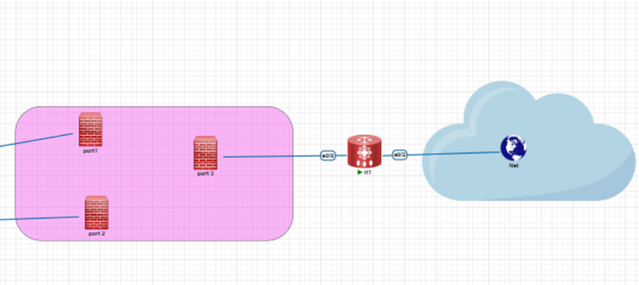  
Basic Configuration:**

hostname Router  
no ip domain-lookup  
enable secret cisco123  
banner motd *#Unauthorized access is prohibited#*  
line console 0  
 password consolepass  
 login  
line vty 0 4  
 password sshpass  
 login  
 transport input ssh  
ip domain-name edge.local  
crypto key generate rsa

* Device initialization with hostname and domain for SSH.
* Console and VTY password protection for secure management.
* SSH enabled for secure remote access.

**Interface Configuration:**

interface Ethernet0/0  
 ip address 192.168.1.253 255.255.255.252  
 ip nat inside  
 duplex full  
 no shutdown  
  
interface Ethernet0/1  
 ip address 192.168.1.249 255.255.255.252  
 ip nat outside  
 duplex full  
 no shutdown  
  
interface Ethernet0/2  
 ip address dhcp  
 ip nat outside  
 duplex full  
 no shutdown

* Interfaces E0/0 and E0/1 used for internal routing between the core network and edge router.
* E0/2 receives public IP via DHCP for Internet access.
* NAT roles defined: Inside (private network), Outside (Internet).

**Routing Configuration (OSPF):**

router ospf 1  
 router-id 3.3.3.3  
 network 192.168.0.0 0.0.63.255 area 0  
 network 192.168.128.0 0.0.31.255 area 0  
 network 192.168.160.0 0.0.0.255 area 0  
 default-information originate

* OSPF area 0 with summarized internal subnets.
* Default route is advertised to inform internal routers of Internet path.

**NAT Configuration:**

access-list 1 permit 192.168.0.0 0.0.63.255  
access-list 1 permit 192.168.128.0 0.0.31.255  
access-list 1 permit 192.168.160.0 0.0.0.255  
ip nat inside source list 1 interface Ethernet0/2 overload

* Access-list defines internal subnets allowed to access the Internet.
* NAT overload enables PAT (Port Address Translation) on public IP.

### 

### 3.5 Chapter Summary and Security Overview

#### 3.5.1 Device Role Summary Table

|  |  |  |  |
| --- | --- | --- | --- |
| Device Name | Role | VLANs Served | Key IP Interfaces |
| SWAlex-D1 | Access Layer | VLAN 10, 20 | E0/0, E0/2 |
| SWAlex-D2 | Access Layer | VLAN 10, 20 | E0/0, E0/2 |
| SWDC-1 | Access Layer | VLAN 130 | E0/0, E0/2 |
| SWDC-2 | Access Layer | VLAN 130 | E0/0, E0/2 |
| SWC-1 | Distribution | VLAN 10, 20 | VLAN10, VLAN20, E0/1 |
| SWC-2 | Distribution | VLAN 10, 20 | VLAN10, VLAN20, E0/1 |
| SWC-3 | Distribution | VLAN 30, 40 | VLAN30, VLAN40, E0/1 |
| SWC-4 | Distribution | VLAN 30, 40 | VLAN30, VLAN40, E0/2 |
| SWCore-1 | Core Layer | N/A (L3 only) | Multiple routed ports |
| SWCore-2 | Core Layer | N/A (L3 only) | Multiple routed ports |
| Router | Edge Router | N/A (L3 only) | E0/0, E0/1, E0/2 |

#### 3.5.2 Layer 2 and Edge Security Measures

Throughout the Access and Distribution layers, the following Layer 2 security techniques were applied:

* Port-Security: Limits the number of MAC addresses and applies sticky learning.
* DHCP Snooping: Protects against rogue DHCP servers.
* Dynamic ARP Inspection (DAI): Prevents ARP spoofing attacks.
* IP Source Guard (IPSG): Blocks packets from unverified IP-MAC bindings.
* 802.1X: Provides authentication before allowing network access.
* Native VLAN Control & BPDU Guard: Prevents VLAN hopping and STP manipulation.

These configurations ensure only authenticated and legitimate devices can participate in the network and mitigate risks of spoofing and Layer 2-based attacks.

## Chapter 4: Network Services and Security Policies

## – Cairo Branch

This chapter documents all Layer 2 and Layer 3 network services and security mechanisms implemented across the Cairo branch infrastructure. Each service is described by function, configuration, and device-specific deployment.

### 4.1 DHCP Snooping

**Purpose:** Prevents rogue DHCP servers from distributing unauthorized IP addresses by filtering DHCP messages based on trusted/untrusted interfaces.

**Global Configuration (applied on SWCairo-D1 & SWCairo-D2):**

ip dhcp snooping  
ip dhcp snooping vlan 10,20,30,40

**Trusted Interfaces Configuration:**  
On interfaces facing the DHCP server or connected to other trusted distribution/core devices.

interface range e1/0,e0/2  
 ip dhcp snooping trust

**Device-Specific Notes:**

* SWCairo-D1: Trust configured on trunk uplink to core and DHCP server (e0/2, e1/0).
* SWCairo-D2: Same configuration applied on matching uplinks.
* Access ports (to end-user devices) are untrusted by default.

### 4.2 Dynamic ARP Inspection (DAI)

**Purpose:** Protects against ARP spoofing by verifying ARP packets using DHCP snooping binding tables.

**Global Configuration (on SWCairo-D1 & D2):**

ip arp inspection vlan 10,20,30,40  
ip arp inspection validate ip  
ip arp inspection validate src-mac  
ip arp inspection validate dst-mac

**Trusted Interfaces (uplinks only):**

interface range e1/0,e0/2  
 ip arp inspection trust

**Device-Specific Notes:**

* SWCairo-D1 & D2: Trusted interfaces configured toward DHCP server/core.
* Access interfaces are left untrusted to enforce validation.

### 4.3 Port Security

**Purpose:** Limits the number and type of MAC addresses on access ports to prevent unauthorized devices from connecting.

**Applied on Access Switches only (Cairo Access Layer):**

interface range e0/0,e0/1  
 switchport mode access  
 switchport port-security  
 switchport port-security maximum 2  
 switchport port-security mac-address sticky

**Explanation:**

* Maximum of 2 learned MAC addresses per port.
* Sticky MACs dynamically saved to running config.
* Default violation mode: shutdown.

**Device-Specific Notes:**

* SWCairo-Access1, SWCairo-Access2, etc.: All access ports have port-security.
* Not applied on trunk or uplink ports.

### 4.4 Spanning Tree Enhancements – BPDU Guard & PortFast

**Purpose:**

* PortFast allows faster convergence on access ports.
* BPDU Guard shuts down ports receiving unexpected BPDUs to prevent STP manipulation.

**Applied on Access Switches only:**

interface range e0/0,e0/1  
 spanning-tree portfast edge  
 spanning-tree bpduguard enable

**Device-Specific Notes:**

* SWCairo-Access1, SWCairo-Access2, etc.: Applied on ports facing end devices.
* Not configured on uplinks.

### 4.5 IP Helper Addresses

**Purpose:** Forwards broadcast DHCP client requests to centralized DHCP server at 192.168.140.200.

**SVI Configuration on SWCairo-D1 (example):**

interface Vlan10  
 ip helper-address 192.168.140.200

**Device-Specific Notes:**

* Configured on SVIs for VLANs 10, 20, 30, 40 on both SWCairo-D1 & SWCairo-D2.
* All VLANs use virtual gateway IP .254 via HSRP.

### Summary of Security Features for Cairo Branch

|  |  |  |  |  |  |
| --- | --- | --- | --- | --- | --- |
| Device Name | DHCP Snooping | DAI | Port Security | BPDU Guard | IP Helper Address |
| SWCairo-D1 | Yes | Yes | No | No | Yes |
| SWCairo-D2 | Yes | Yes | No | No | Yes |
| SWCairo-Access | Yes (Client) | Yes | Yes | Yes | No |
| SWCore-1 / SWCore-2 | Not Required | No | No | No | No |

All security configurations are consistently applied across Cairo branch devices, ensuring maximum Layer 2 security and DHCP service integrity.

## 4.2 Network Services and Security Policies – Alexandria Branch

This chapter documents all Layer 2 and Layer 3 network services and security mechanisms implemented across the Alexandria branch infrastructure. Each service is described by function, configuration, and device-specific deployment.

### 4.2.1 DHCP Snooping

**Purpose:** Prevents rogue DHCP servers from distributing unauthorized IP addresses by filtering DHCP messages based on trusted/untrusted interfaces.

**Global Configuration (applied on SWAlex-D1 & SWAlex-D2):**

ip dhcp snooping  
ip dhcp snooping vlan 70,80

**Trusted Interfaces Configuration:**  
On interfaces facing the DHCP server or connected to other trusted distribution/core devices.

interface range e1/0,e0/2  
 ip dhcp snooping trust

**Device-Specific Notes:**

* SWAlex-D1: Trust configured on trunk uplinks toward core and DHCP server.
* SWAlex-D2: Same configuration applied on corresponding uplinks.
* Access ports (to end-user devices) are untrusted by default.

### 4.2.2 Dynamic ARP Inspection (DAI)

**Purpose:** Protects against ARP spoofing by verifying ARP packets using DHCP snooping binding tables.

**Global Configuration (on SWAlex-D1 & D2):**

ip arp inspection vlan 70,80  
ip arp inspection validate ip  
ip arp inspection validate src-mac  
ip arp inspection validate dst-mac

**Trusted Interfaces (uplinks only):**

interface range e1/0,e0/2  
 ip arp inspection trust

**Device-Specific Notes:**

* SWAlex-D1 & D2: Trusted interfaces configured toward DHCP server/core.
* Access interfaces are left untrusted to enforce validation.

### 4.2.3 Port Security

**Purpose:** Limits the number and type of MAC addresses on access ports to prevent unauthorized devices from connecting.

**Applied on Access Switches only (Alexandria Access Layer):**

interface range e0/0,e0/1  
 switchport mode access  
 switchport port-security  
 switchport port-security maximum 2  
 switchport port-security mac-address sticky

**Explanation:**

* Maximum of 2 learned MAC addresses per port.
* Sticky MACs dynamically saved to running config.
* Default violation mode: shutdown.

**Device-Specific Notes:**

* SWAlex-Access1, SWAlex-Access2, etc.: All access ports have port-security.
* Not applied on trunk or uplink ports.

### 4.2.4 Spanning Tree Enhancements – BPDU Guard & PortFast

**Purpose:**

* PortFast allows faster convergence on access ports.
* BPDU Guard shuts down ports receiving unexpected BPDUs to prevent STP manipulation.

**Applied on Access Switches only:**

interface range e0/0,e0/1  
 spanning-tree portfast edge  
 spanning-tree bpduguard enable

**Device-Specific Notes:**

* SWAlex-Access1, SWAlex-Access2, etc.: Applied on ports facing end devices.
* Not configured on uplinks.

### 4.2.5 IP Helper Addresses

**Purpose:** Forwards broadcast DHCP client requests to centralized DHCP server at 192.168.140.200.

**SVI Configuration on SWAlex-D1 (example):**

interface Vlan70  
 ip helper-address 192.168.140.200

**Device-Specific Notes:**

* Configured on SVIs for VLANs 70 and 80 on both SWAlex-D1 & SWAlex-D2.
* All VLANs use virtual gateway IP .254 via HSRP.

### 4.2.6 Summary of Security Features for Alexandria Branch

|  |  |  |  |  |  |
| --- | --- | --- | --- | --- | --- |
| Device Name | DHCP Snooping | DAI | Port Security | BPDU Guard | IP Helper Address |
| SWAlex-D1 | Yes | Yes | No | No | Yes |
| SWAlex-D2 | Yes | Yes | No | No | Yes |
| SWAlex-Access | Yes (Client) | Yes | Yes | Yes | No |
| SWCore-1/2 | Not Required | No | No | No | No |

All security configurations are consistently applied across Alexandria branch devices, ensuring maximum Layer 2 security and DHCP service integrity.

## 4.3 Network Services and Security Policies – Data Center

This section describes all Layer 2 and Layer 3 network services and security mechanisms implemented in the Data Center switching infrastructure. The configurations are tailored to support centralized resources with high availability and protection against common Layer 2 threats.

### 4.3.1 DHCP Snooping

**Purpose:** Prevents rogue DHCP servers from allocating unauthorized IP addresses by filtering DHCP messages on untrusted ports.

**Global Configuration (applied on SWDC-1 & SWDC-2):**

ip dhcp snooping  
ip dhcp snooping vlan 130

**Trusted Interfaces Configuration:**

interface range e0/1,e0/3  
 ip dhcp snooping trust

**Device-Specific Notes:**

* SWDC-1 & SWDC-2: Trusted applied on trunk links connecting to DHCP server and core network.
* Untrusted interfaces face end systems or access links.

### 4.3.2 Dynamic ARP Inspection (DAI)

**Purpose:** Prevents ARP spoofing by validating ARP packets against DHCP snooping database entries.

**Global Configuration:**

ip arp inspection vlan 130  
ip arp inspection validate ip  
ip arp inspection validate src-mac  
ip arp inspection validate dst-mac

**Trusted Interfaces:**

interface range e0/1,e0/3  
 ip arp inspection trust

**Device-Specific Notes:**

* SWDC-1 & SWDC-2: Trust set only on uplink interfaces.
* All access-facing ports remain untrusted for ARP inspection enforcement.

### 4.3.3 Port Security

**Purpose:** Limits MAC address access on access ports to prevent unauthorized device connections.

**Applied on Access Interfaces (e.g., SWDC access ports):**

interface range e0/0,e0/2  
 switchport mode access  
 switchport port-security  
 switchport port-security maximum 2  
 switchport port-security mac-address sticky

**Device-Specific Notes:**

* Only enabled on SWDC switches’ access-facing ports.
* Trunk ports and uplinks are excluded.

### 4.3.4 Spanning Tree Enhancements – BPDU Guard & PortFast

**Purpose:**

* PortFast reduces STP convergence time on access ports.
* BPDU Guard disables ports receiving unexpected BPDUs, protecting against rogue switches.

**Configuration:**

interface range e0/0,e0/2  
 spanning-tree portfast edge  
 spanning-tree bpduguard enable

**Device-Specific Notes:**

* Only enabled on SWDC access ports.
* Not enabled on uplinks.

### 4.3.5 IP Helper Addresses

**Purpose:** Forwards DHCP broadcasts to centralized DHCP server at 192.168.140.200.

**Configuration on VLAN Interface:**

interface Vlan130  
 ip helper-address 192.168.140.200

**Device-Specific Notes:**

* Configured on SWDC-1 & SWDC-2.
* VLAN 130 is the primary user VLAN in the Data Center.

### 

### 4.3.6 Summary of Security Features for Data Center

|  |  |  |  |  |  |
| --- | --- | --- | --- | --- | --- |
| Device Name | DHCP Snooping | DAI | Port Security | BPDU Guard | IP Helper Address |
| SWDC-1 | Yes | Yes | Yes | Yes | Yes |
| SWDC-2 | Yes | Yes | Yes | Yes | Yes |
| Access Devices | Yes (Client) | Yes | Yes | Yes | No |
| SWCore-1/2 | Not Required | No | No | No | No |

These configurations collectively enhance security and reliability in the Data Center network, aligned with the enterprise-wide design for consistency.

## Chapter 5: Administrator Windows Server

### **1-Introduction to Windows Server**

**Windows Server** is a specialized operating system developed by **Microsoft** to support enterprise-level management of networks, services, and infrastructure. It is designed to operate as a backbone for server environments rather than personal computing, providing a robust platform for hosting web services, managing users and devices, and implementing centralized control across networks.

Unlike desktop versions of Windows such as Windows 10 or 11, Windows Server includes a range of features tailored for IT administrators, including domain management, group policies, virtualization, and secure access controls. Its architecture supports high availability, scalability, and remote access, making it a core component in modern business environments.

The Windows Server family has evolved over the years, beginning with Windows Server 2003 and advancing through major releases like Server 2008, 2012, 2016, and the more recent **Windows Server 2019** and **Windows Server 2022**.

### **Key Features:**

* **Active Directory Domain Services (AD DS):**  
   Enables centralized user and resource management within a domain environment.
* **DNS and DHCP Services:**  
   Provides automatic IP assignment and name resolution within the network.
* **Group Policy Management:**  
   Allows administrators to enforce rules and settings across multiple systems.
* **File and Storage Services:**  
   Facilitates the secure sharing and management of files and drives.
* **Remote Desktop Services (RDS):**  
   Grants remote access to servers and applications, improving flexibility and productivity.

### **Importance in Network Infrastructure:**

Windows Server plays a critical role in enterprise IT environments by ensuring centralized control, enhanced security, and efficient resource management. It supports a wide range of services essential for business operations, such as authentication, file sharing, and user access policies. By consolidating administrative tasks and offering scalable solutions, Windows Server contributes significantly to maintaining a secure and organized network infrastructure.

## **2: Installing Windows Server**

Installing Windows Server is a critical part of setting up a secure and manageable network infrastructure. A clean and proper installation ensures that the server environment is stable, scalable, and ready to support enterprise-level operations.

The following are the general steps used to install Windows Server (such as Windows Server 2019 or 2022), either on physical hardware or in a virtual machine.

## **Installation Steps**

1. **Boot from Installation Media**  
 Insert the installation DVD or mount the ISO file. Restart the system and boot from the installation source.

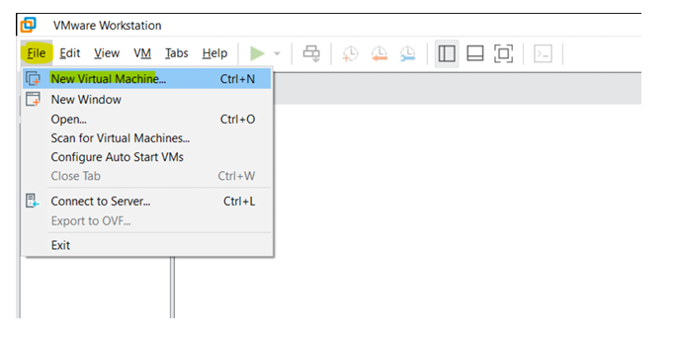

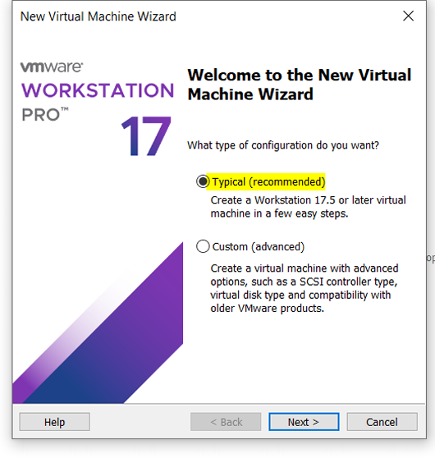

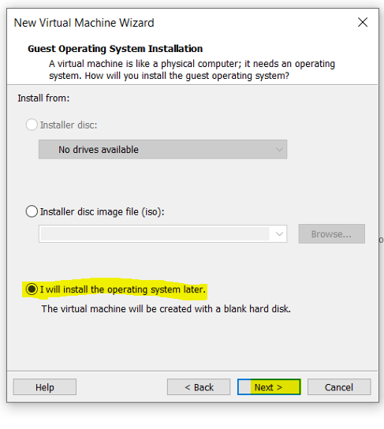

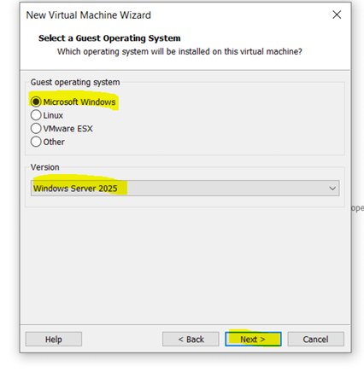

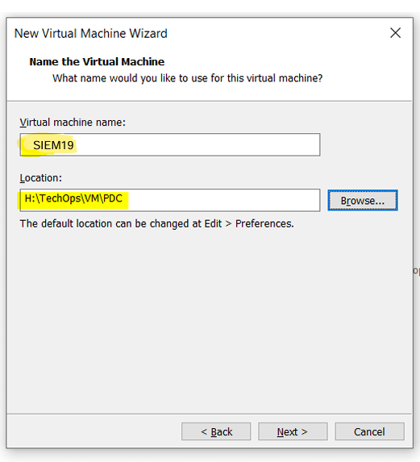

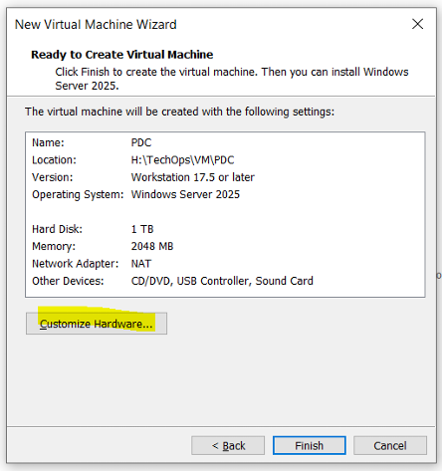

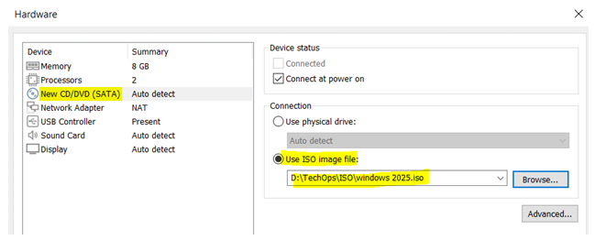

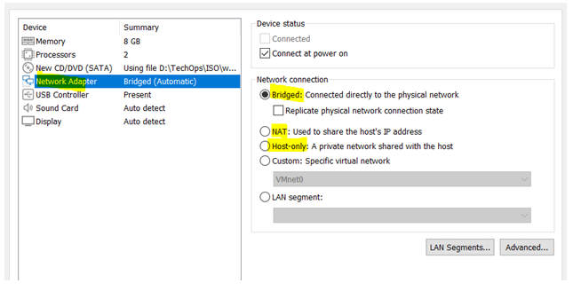

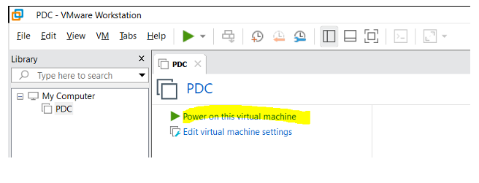

2. **Select Language and Preferences**  
 Choose the desired language, time and currency format, and keyboard layout. Click **Next** to proceed

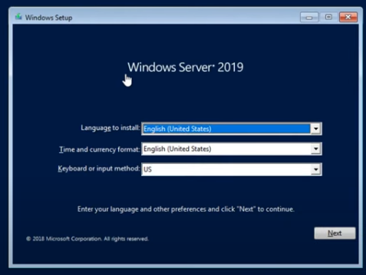

**3. Begin Installation**  
 Click on **Install now** to start the setup process.

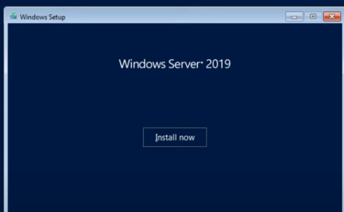

**4. Choose Edition**  
 Select the appropriate edition of Windows Server (e.g., Standard or Datacenter). For most users, the **Desktop Experience** version is recommended.

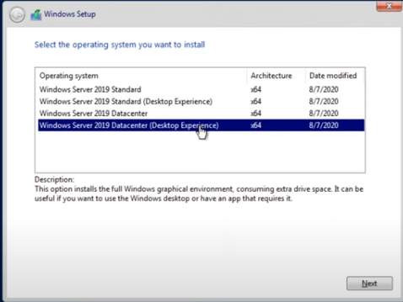

5. **Accept the License Agreement**  
 Read and accept the Microsoft Software License Terms, then click **Next**

**6. Select Installation Type**  
 Choose **Custom: Install Windows only (advanced)** for a fresh installation

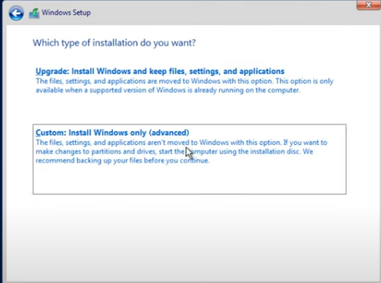

**7. Choose a Disk Partition**  
 Select the drive where the server will be installed. You may need to format the disk or create new partitions.

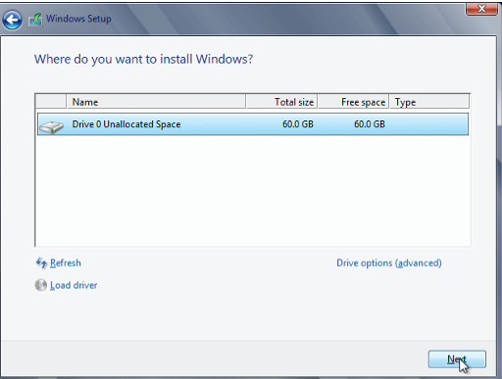

**8. Wait for Installation**  
 The system will copy files and install features. This may take several minutes and involve a few automatic restarts.

**9. Set Administrator Password**  
 After installation, you'll be prompted to set a strong password for the **Administrator** account.

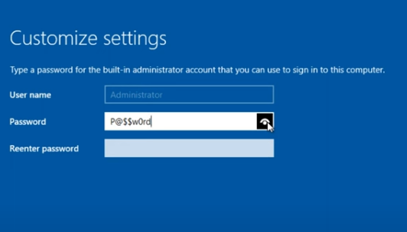

**3**. **Types of Network Management**

In any networked environment, managing resources, users, and devices can be done using different models or approaches. Understanding the differences between these types is essential for choosing the most efficient and secure structure for a specific organization or IT infrastructure.

### **1. Workgroup (Peer-to-Peer Network)**

In a **Workgroup**, each computer is independent and manages its own resources and user accounts. This model is typically used in small networks (usually under 10 computers) where centralized control is not required.

**Characteristics:**

* No central server or domain controller.
* Each machine has its own user accounts and settings.
* Simple and low-cost setup.
* Suitable for home or small office environments.
* Limited scalability and security management.

### **2. Domain (Server-Based Network)**

A **Domain** is a centralized network model where user accounts, permissions, and policies are managed by a central server called a **Domain Controller**, which runs **Active Directory**.

**Characteristics:**

* Centralized management of users, groups, and devices.
* High security through Group Policy and authentication.
* Scalable for large organizations with hundreds or thousands of devices.
* Requires at least one server running Windows Server with AD DS.

### **3. Hybrid Network**

A **Hybrid Network** combines aspects of both workgroup and domain models. It may include some standalone systems while also having centralized management through a domain controller.

**Characteristics:**

* Used during migration or in environments with mixed operating systems.
* Offers flexibility, but requires careful management.
* Can integrate with cloud services like Azure Active Directory.

## **4: Active Directory Domain Services (AD DS)**

### **What is Active Directory?**

**Active Directory (AD)** is a directory service developed by Microsoft that allows administrators to manage permissions and access to network resources in a centralized and secure manner. It is the backbone of enterprise-level Windows Server networks and enables centralized control over users, computers, groups, and policies.

When Active Directory is installed on a Windows Server, it transforms the server into a **Domain Controller (DC)** — a central authority that authenticates users and enforces security policies across the network.

### **Key Components of Active Directory**

1. **Domain**
   1. A logical group of network objects (users, computers, devices) managed by the same security database.
   2. Example: **siem.com**
2. **Organizational Units (OUs)**
   1. Containers used to organize users, groups, and computers within a domain.
   2. Allow delegation of administrative control and Group Policy application.
3. **Users and Groups**
   1. **Users:** Represent individual people with login credentials.
   2. **Groups:** Collections of users (and sometimes computers) used for simplified permission management.
4. **Domain Controllers (DCs)**
   1. Servers that store a copy of the AD database and handle authentication and directory lookups.
5. **Forest**
   1. The top-level structure that contains one or more domains.
   2. All domains within a forest share a common schema and trust relationships.
6. **Tree**
   1. A collection of domains in a contiguous namespace under the same forest.
   2. Example: it.company.local, hr.company.local
7. **Global Catalog**
   1. A distributed data repository that contains a searchable, partial representation of every object in every domain.
8. **Schema**
   1. Defines the structure of objects (what attributes a "user" or "computer" should have) within Active Directory.

## **5: Installing and Configuring Active Directory Domain Services (AD DS)**

**Step 1: Assign a Static IP Address**

Before promoting the server to a Domain Controller, it’s best to assign a **static IP**:

1. Go to **Control Panel → Network and Sharing Center → Change adapter settings**

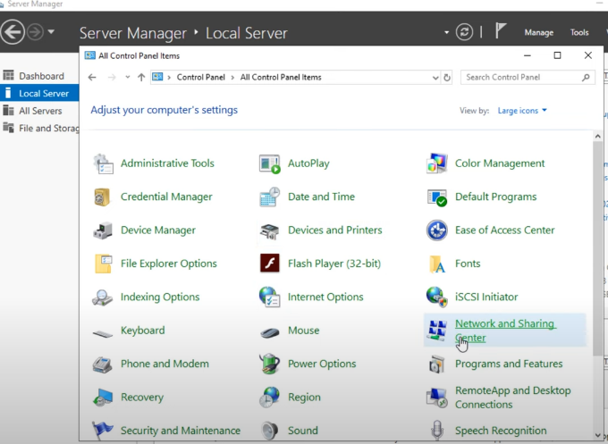

1. Right-click your network connection → **Properties**
2. Select **Internet Protocol Version 4 (TCP/IPv4)** → Click **Properties**

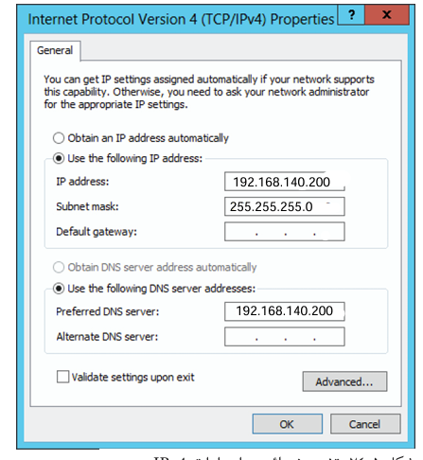

### **Step 2: Add the Active Directory Domain Services Role**

1. Open **Server Manager**
2. Click **Manage** → **Add Roles and Features**

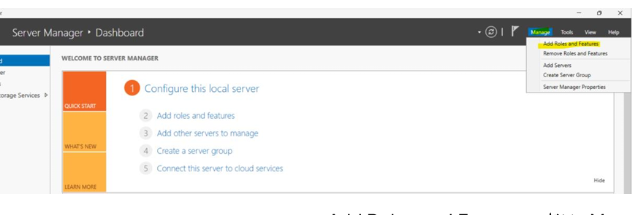

1. In the **Before You Begin** page → Click **Next**

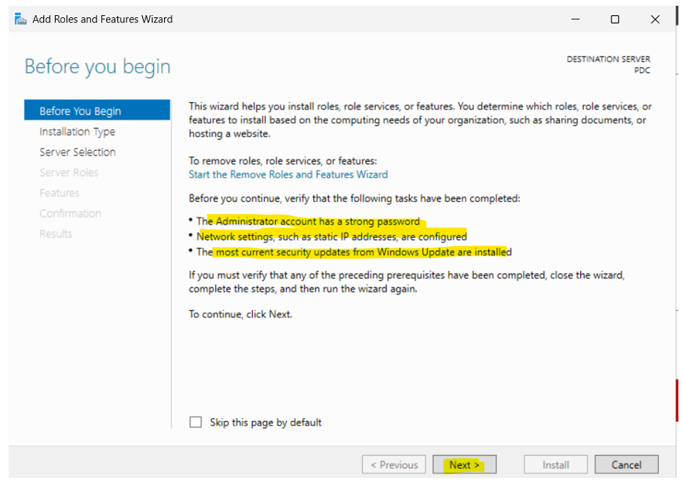

1. **Installation Type**: Choose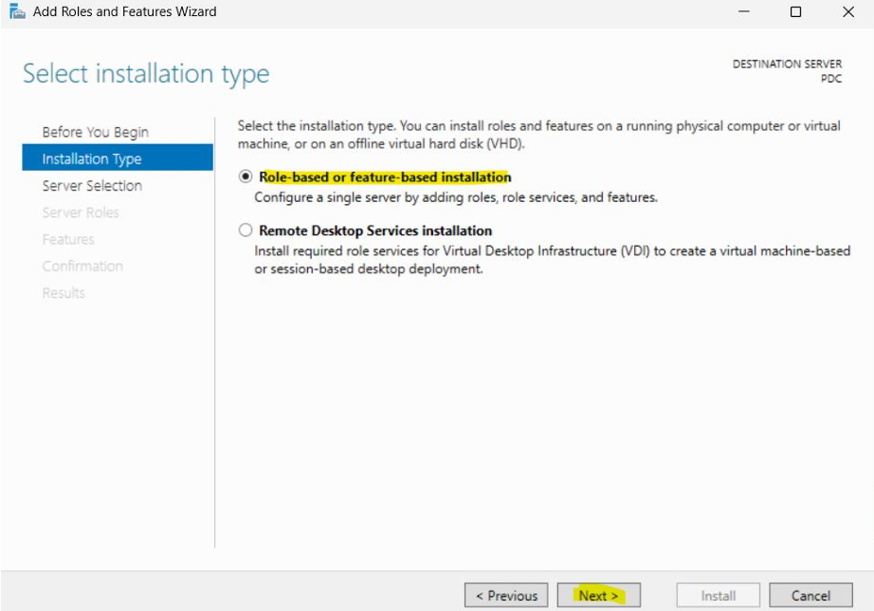
2. **Select Server**: Choose the local server → Click **Next**

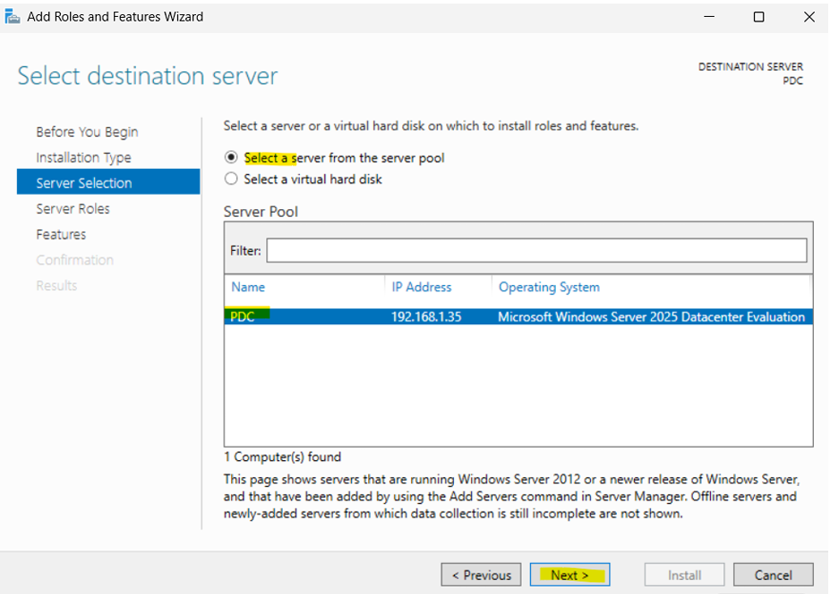

1. **Server Roles**:
   1. Check ✅ **Active Directory Domain Services**

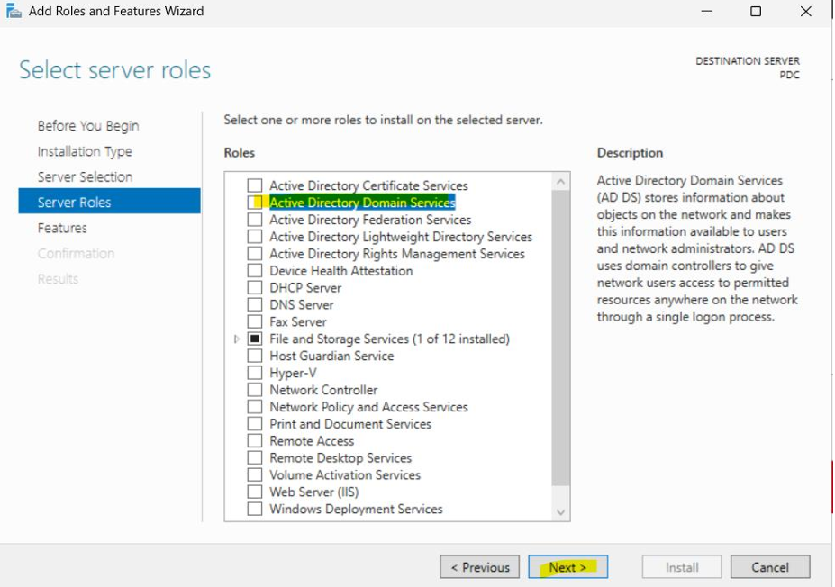

1. **Add Features**: Just click **Next**

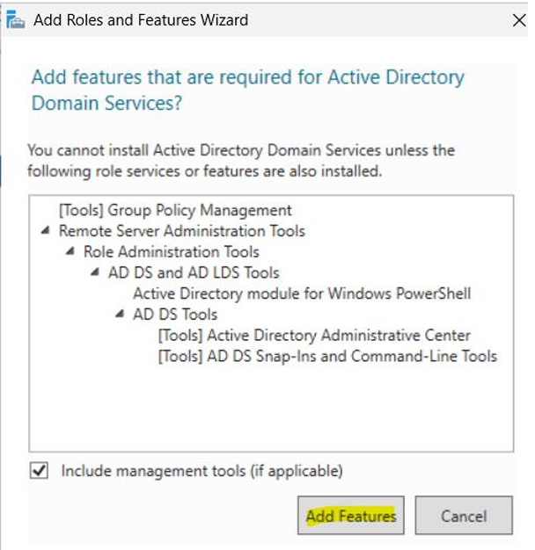

1. **AD DS Page**: Read overview → Click **Next**
2. **Confirmation**: Click **Install**

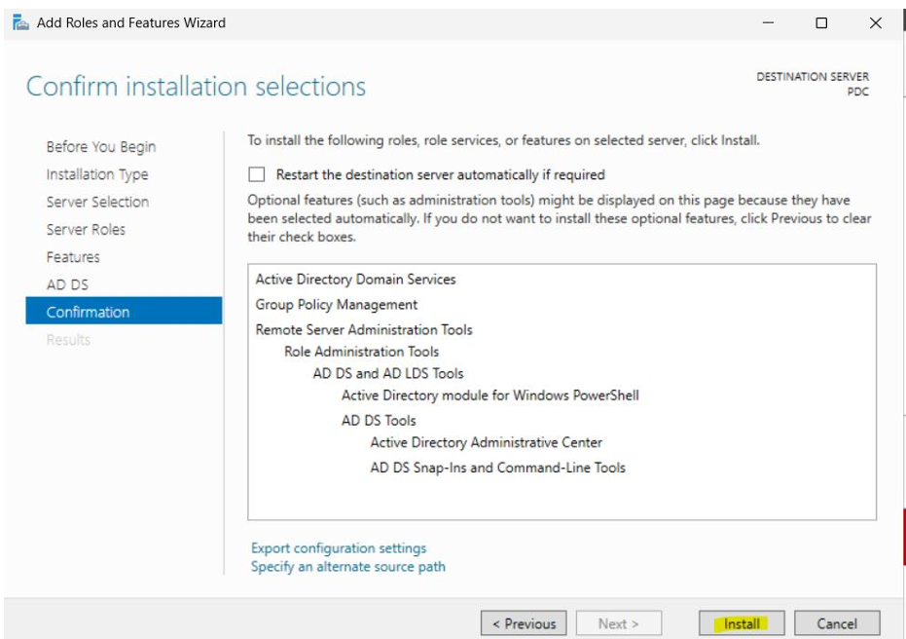

1. Wait for installation to finish, then click **Close**

### **step 3: Promote Server to a Domain Controller**

1. In **Server Manager**, a yellow flag will appear → Click it → Choose **Promote this server to a domain controller**

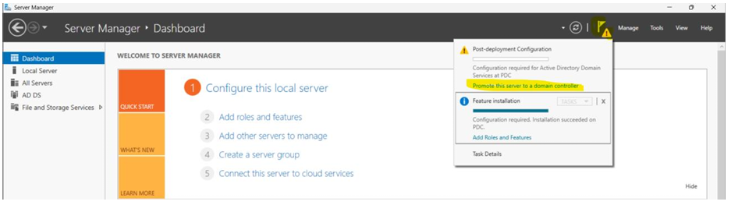

1. **Deployment Configuration**:
   1. Choose:  
       🔘 **Add a new forest**
   2. Enter **Root domain name**, **siem.com**
   3. Click **Next**

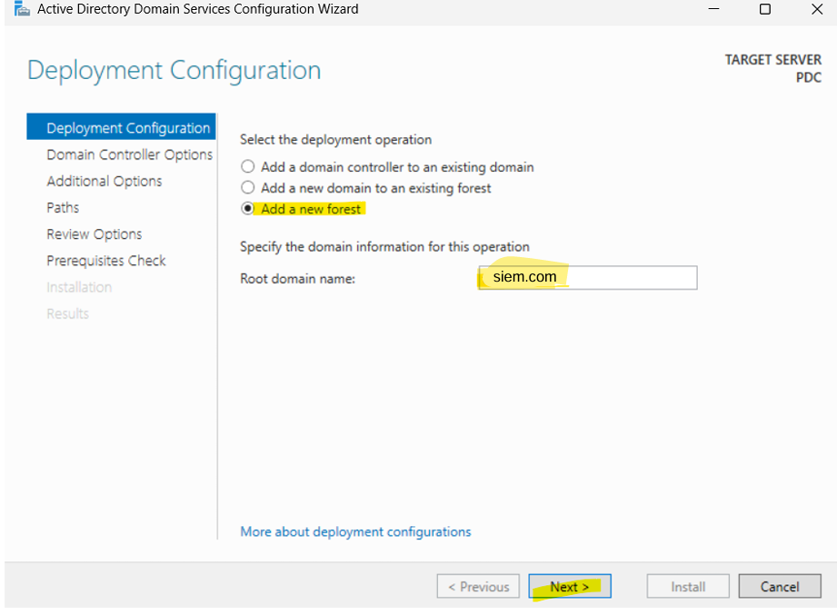

1. **Domain Controller Options**:
   1. Keep default options:
   2. Enter **Directory Services Restore Mode (DSRM)** password

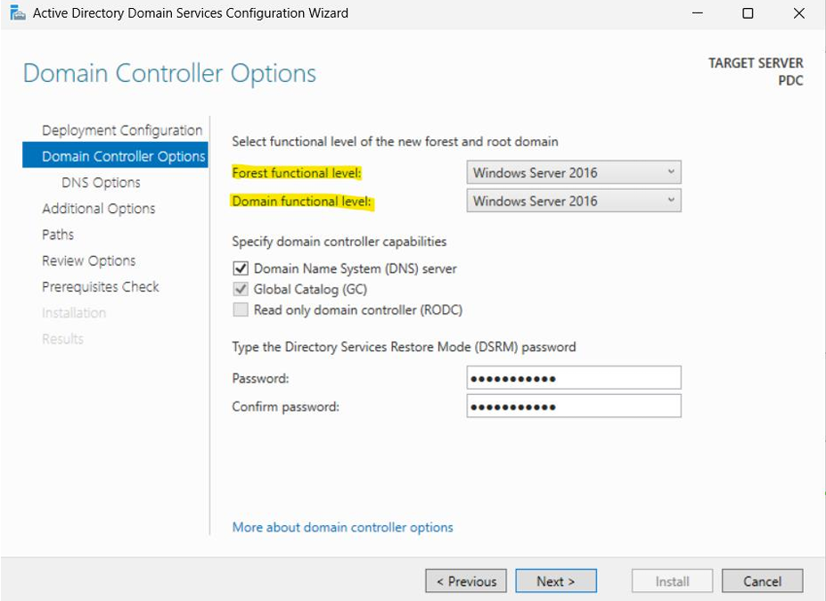

1. **DNS Options**:
   1. Ignore the warning if it appears (about delegation) → Click **Next**

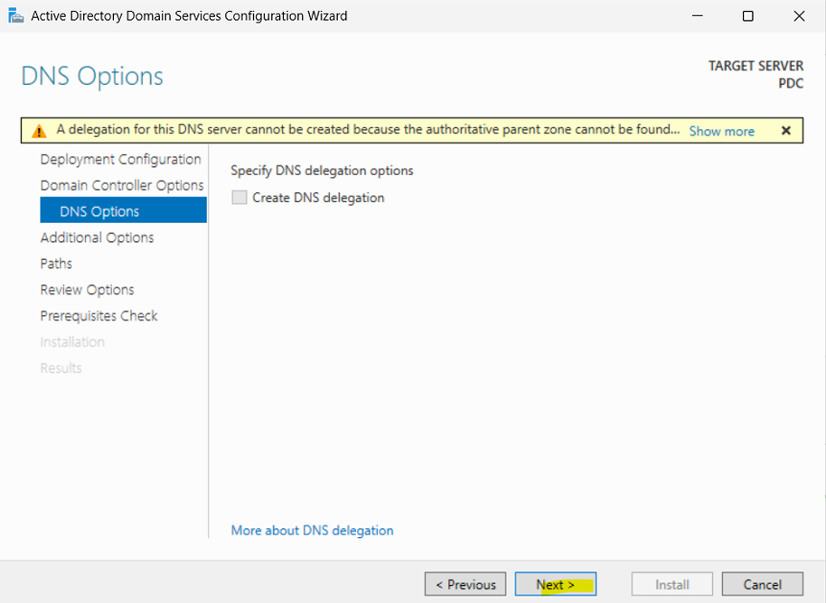

1. **Additional Options**:
   1. NetBIOS name auto-fills → e.g SIEM → Click **Next**

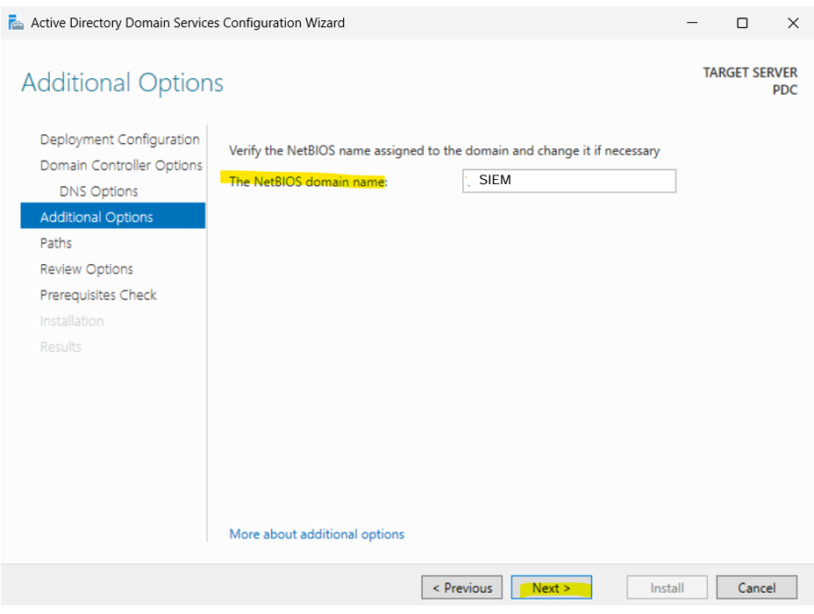

1. **Paths**: Keep defaults unless you have specific needs → Click **Next**

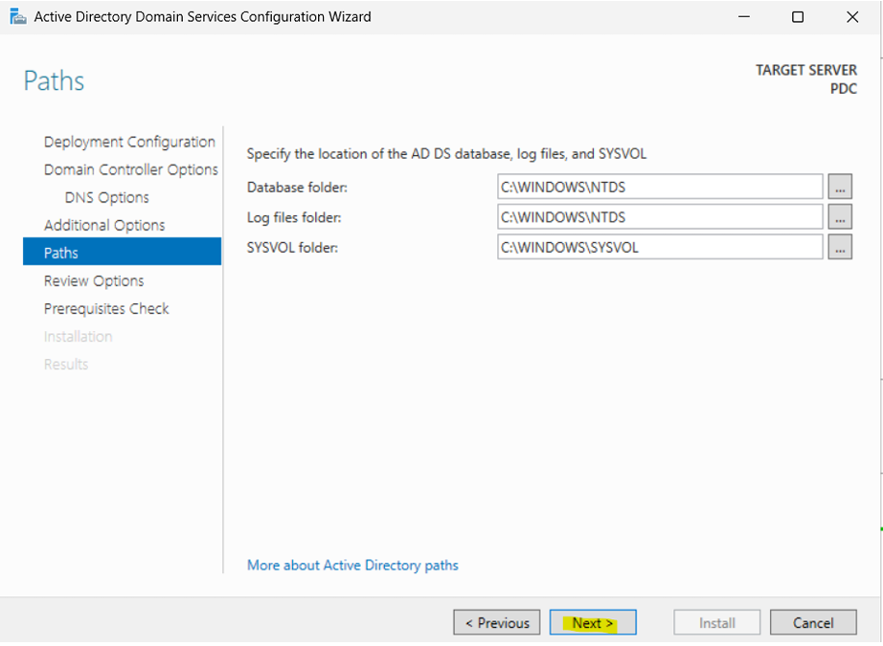

1. **Review Options**: Confirm settings → Click **Next**
2. **Prerequisites Check**:
   1. Let the system validate → Click **Install** when ready

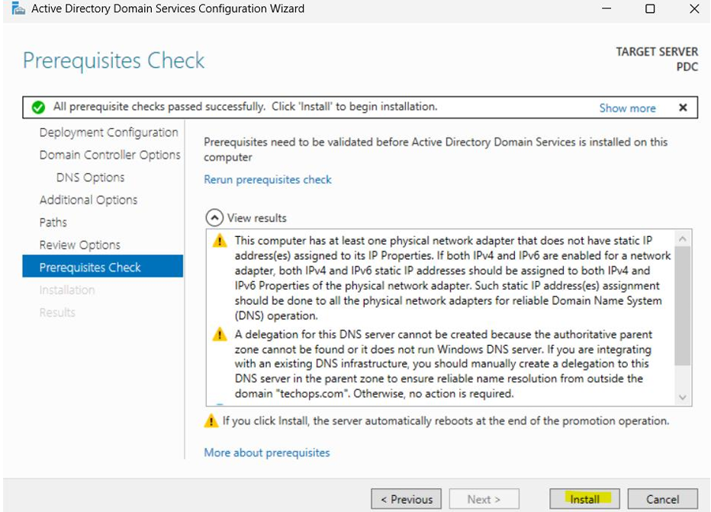

1. The server will **restart automatically** after promotion.

## **6: How to Join a Client Machine to the Domain**

After setting up your **Active Directory Domain Services (AD DS)** and promoting the server to a **Domain Controller**, the next step is to join client machines (like Windows 10/11 PCs) to your domain. This allows users to authenticate with domain credentials and apply centralized group policies.

**Step 1: Set the DNS to Point to the Domain Controller (192.168.140.200)**

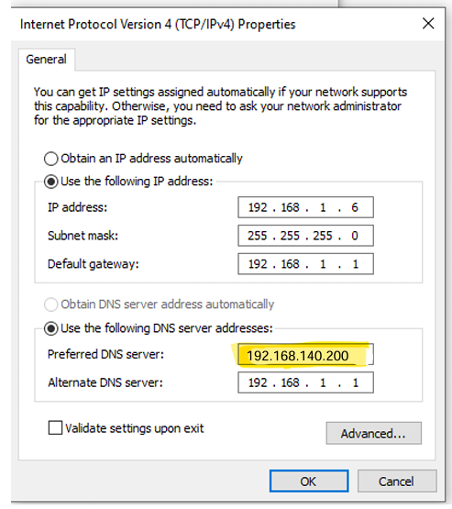

**Step 2: Join the Domain**

1.Right-click on **This PC** → **Properties**

2.Click **Rename this PC** (under computer name)

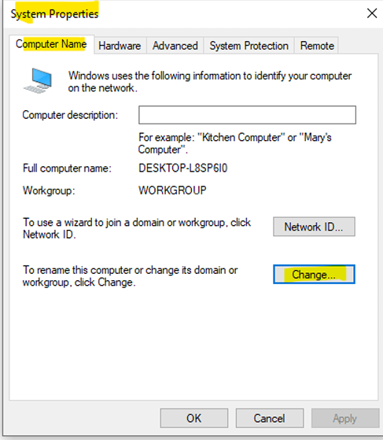

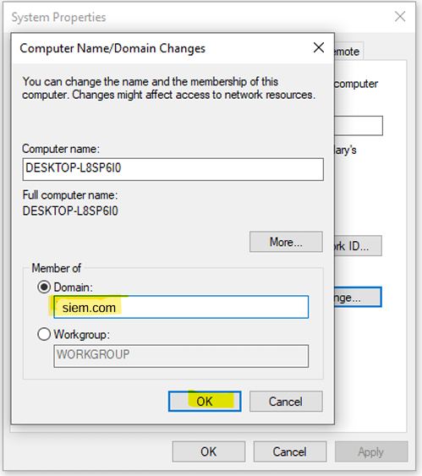

Enter Domain Credentials

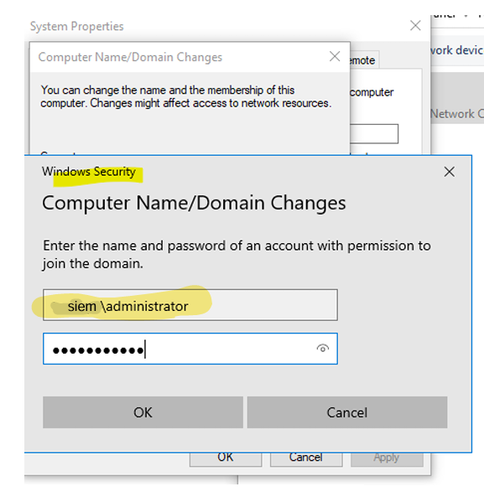

After successful login this pc (client) is now joining the domain

Them it will be restart

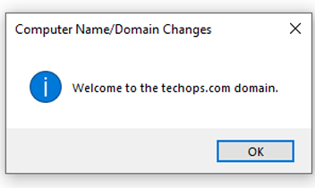

# **7.Creating the users and groups**

In a Windows Server environment with Active Directory Domain Services (AD DS), creating and managing **users** and **groups** allows you to control who can access what — whether it's files, systems, or network resources.

### **1. User Account**

* A user account is a **digital identity** assigned to a person or service in the domain.
* It allows login to the domain and access to network resources.
* Each user account has a **username** and **password**, and belongs to the domain.

### **2. Security Group**

* A **security group** is a collection of user accounts (or other groups) that share the same permissions.
* Instead of assigning permissions to each user individually, you assign them once to the group.

### **Organizational Unit (OU)**

is a logical container within **Active Directory Domain Services (AD DS)** that is used to organize and manage **users, groups, computers, and other OUs**.

It acts like a **folder** inside your domain structure, helping administrators apply **Group Policies**, delegate control, and keep objects organized.

* OUs are **not physical**, they are purely **logical structures** used for administration.
* They exist **within a domain** — each domain has its own independent OU structure.
* You can **nest OUs inside each other** (OU inside another OU

## **Steps to Create an Organizational Unit (OU) in Active Directory**

You must have **Domain Admin** or delegated rights to create an OU

* **Open** Server Manager  
   → Click on **Tools**  
   → Choose **Active Directory Users and Computers**
* 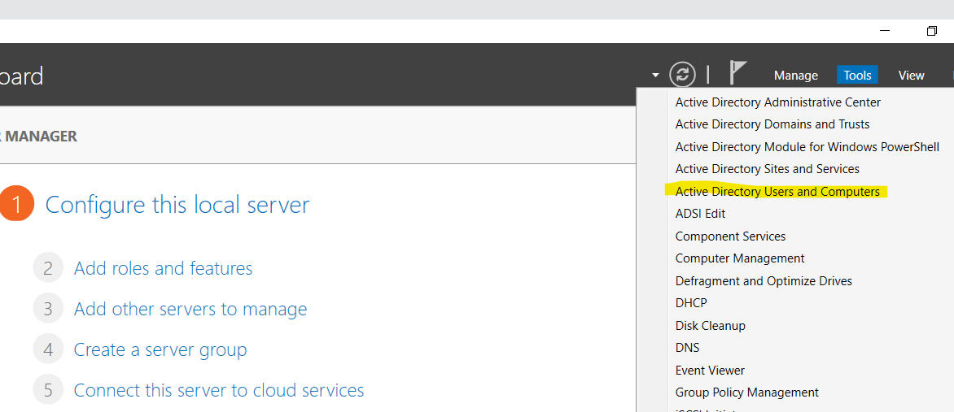
* **Right-click** on the domain name  
   → Select **New** → **Organizational Unit**

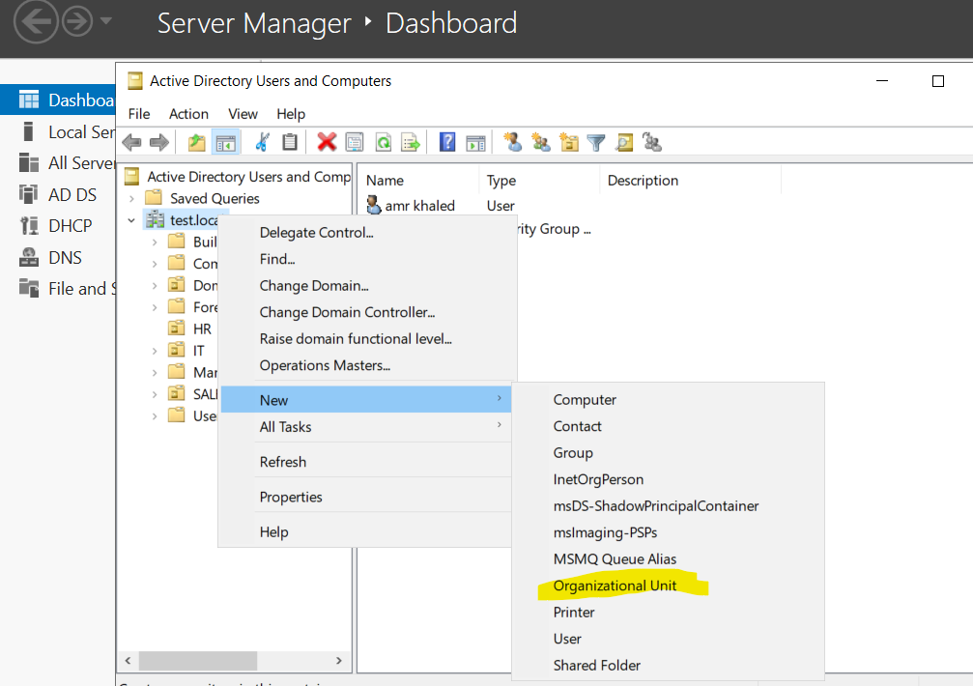

Enter the **name** of the OU

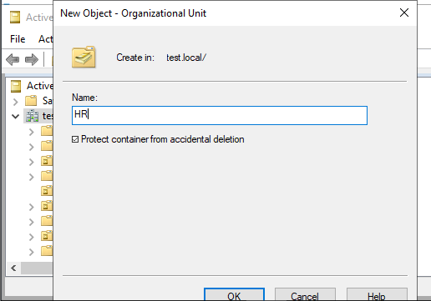

As part of the Active Directory structure setup, I created separate Organizational Units (OUs) to organize users and resources based on departments. This helps in applying group policies and delegating administrative control more efficiently.

**Created OUs:**

**Ou = HR ->** dedicated to HR department

**OU=IT** → Dedicated to IT department users and computers.

**OU=Sales** → Dedicated to Sales department staff and related resources.

These OUs were created under the domain siem.com using the **Active Directory Users and Computers**

'll create a user and assign it to a specific OU (e.g., IT or Sales), using the GUI method.

### Why Place Users Inside Specific OUs (e.g., HR, Sales)?

Placing users into **department-based Organizational Units (OUs)** — like HR, Sales, or IT — isn't just about organization. It has **real technical and administrative benefits**

1. Each OU can have **custom Group Policy Objects (GPOs)** linked to it.

This way, **you apply policies only to the users who need them** — not the whole domain

1. Improved Organization and Management

When users are placed into OUs based on departments or roles: Easier to **find users** quicly

1. If your company grows, your Active Directory structure can scale **logically** and cleanly

## **Steps to Create a User in Active Directory**

**Right-click** the HR OU  
 → Choose **New** → **User**

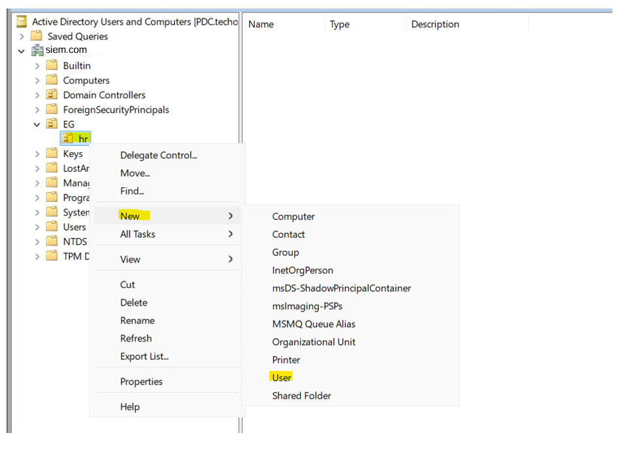

In the **New Object – User** window:

* First Name: mostafa
* Last Name: mahmoud
* Full Name: *(automatically filled)* or edit if needed
* User Logon Name: mostafa.mahmoud  
   → This becomes mostafa.mahmoud @siem.com

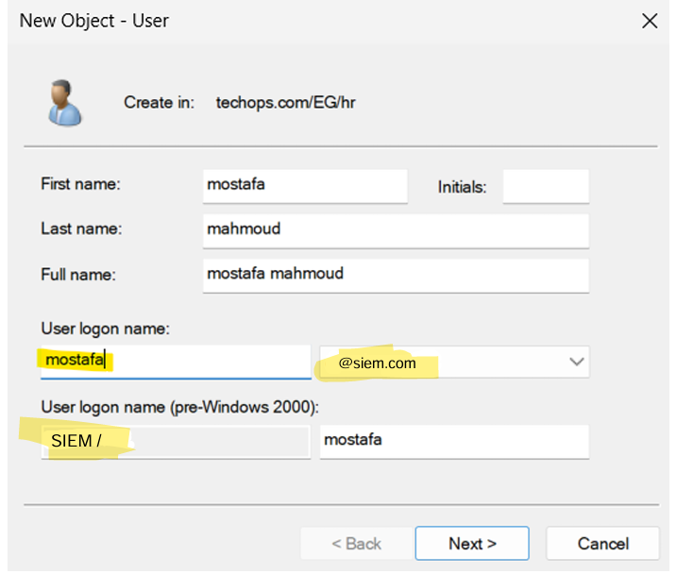

**Set a password** for the user (e.g., P@ssw0rd)  
 Choose from the following options:

* 🔲 *User must change password at next logon* (recommended for security)
* 🔲 *User cannot change password*
* ✔️*Password never expires*
* 🔲 *Account is disabled*

Click **Next** → Then **Finish**

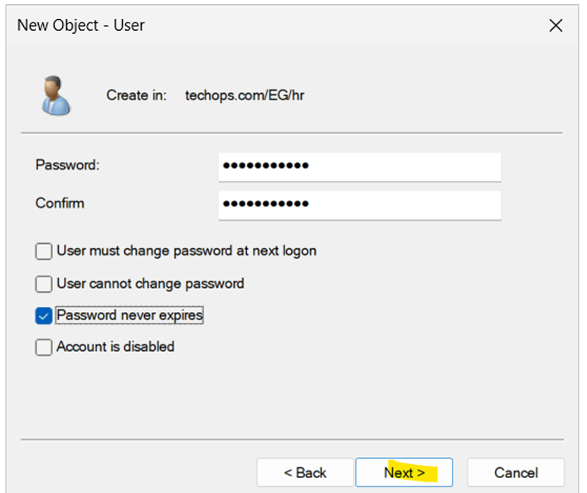

After creating a user we need to define the login hours and days to each user

This setting ensures that each user can only log in to the domain **during specific working hours**, like 9:00 AM to 5:00 PM, sunday to thursday

1. Navigate to the OU where your user is located  
    → e.g., OU=IT → right-click on the user
2. Select **Properties**
3. Go to the **Account** tab
4. Click on the **Logon Hours...** button

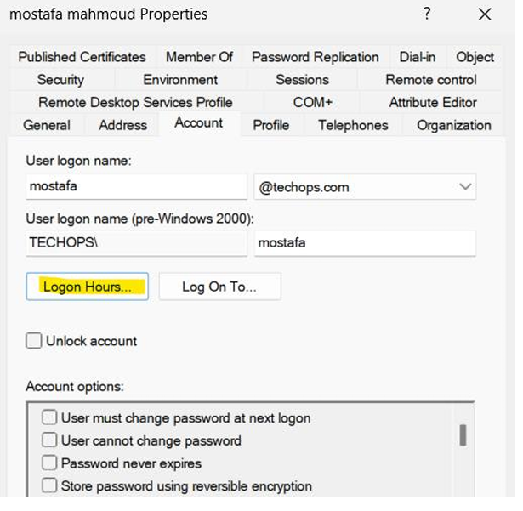

1. In the **Logon Hours** window:
   1. Select the **days** (e.g., Monday to Friday)
   2. Drag over the time **9:00 AM to 5:00 PM**
   3. Click **Logon Permitted**
   4. For all other hours, ensure they are marked as **Logon Denied**
2. Click **OK**, then **Apply**, then **OK** again

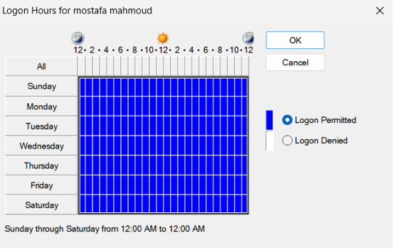

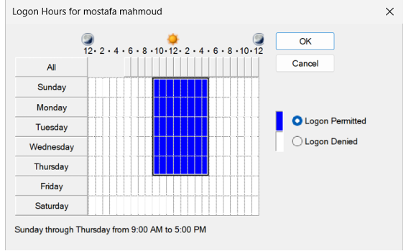

Also we can ensures the user can log in **only from a specific computer** (or computers) that are joined to the domain.

Becaus by default user can login into any device in the domain so we can restrict that

1.tab on log on to

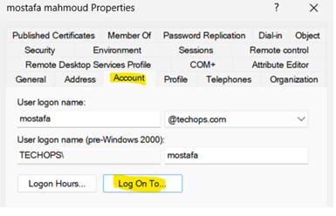

2.add name of computers

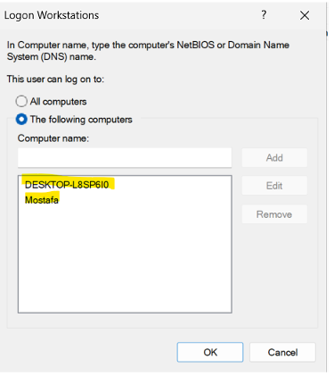

Also we can inlock login if the user write the password three times wrong from unlock account checkbox

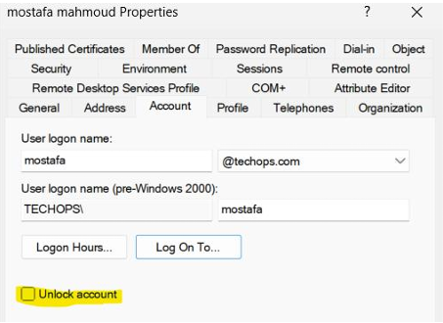

**Creating group in active directory**

1. **What is the group ?**

A **Group** in Active Directory is a collection of **user accounts**, **computer accounts**, or even **other groups**. Instead of assigning permissions or access individually to each user, you assign them to the group — and then give the group the required permissions.

This makes administration **faster**, **more secure**, and **scalable**, especially in large environments.

### **purpose of Groups:**

* **Centralized Access Management**:  
   Grant access to shared folders, printers, or applications by group, not by user.
* **Simplified Permissions**:  
   Instead of adding 50 users to a folder's security settings, you just add **one group**.
* **Better GPO Targeting**:  
   You can apply **Group Policy Objects (GPOs)** to groups for controlling system settings or software.
* **Delegation of Control**:  
   You can give limited admin rights to specific groups (like resetting passwords only for users in a certain group

**Steps to create a group**

1. Open **Active Directory Users and Computers**
2. In the **left pane**, navigate to the OU where you want to create the group  
    → For example: OU=IT
3. **Right-click** on the IT OU  
    → Select **New** → **Group**

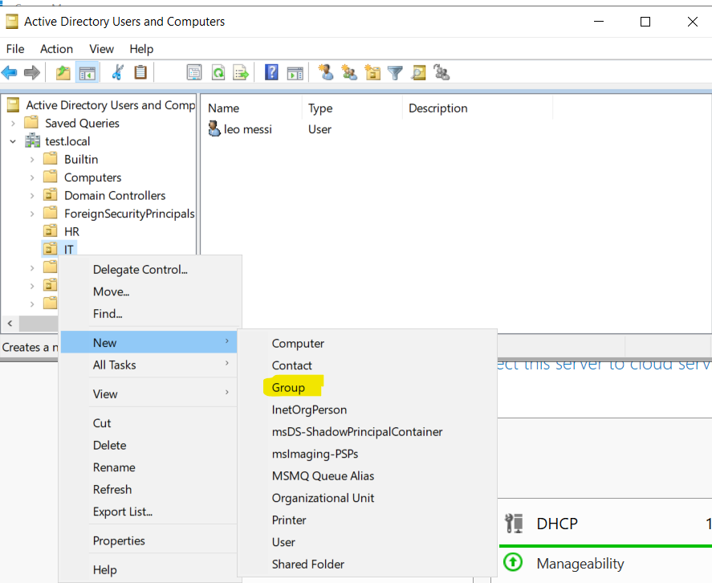

1. In the **New Object – Group** window:
   1. **Group Name**: IT_GROUP  
       (This will automatically fill the pre-Windows 2000 name as well)
   2. **Group Scope**:
      1. Global (recommended for department-level groups)
   3. **Group Type**:
      1. Security (used for assigning permissions and GPOs)

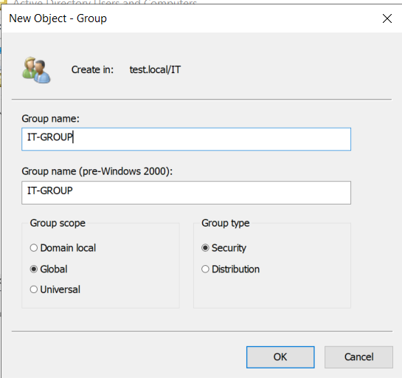

1. Click **OK** to create the group _>>>>>>> group created

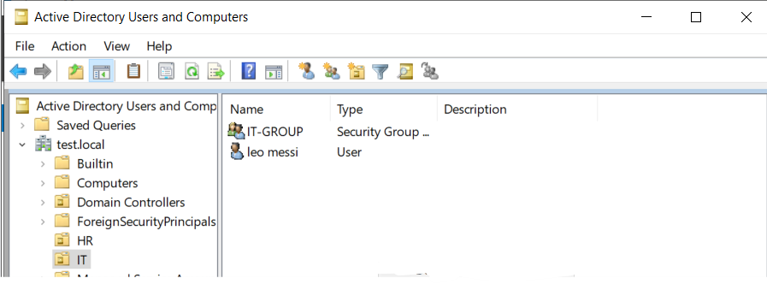

After creating a group ->>>> adding the users of OU to this groups to control them

1.r click on user and chose add to group

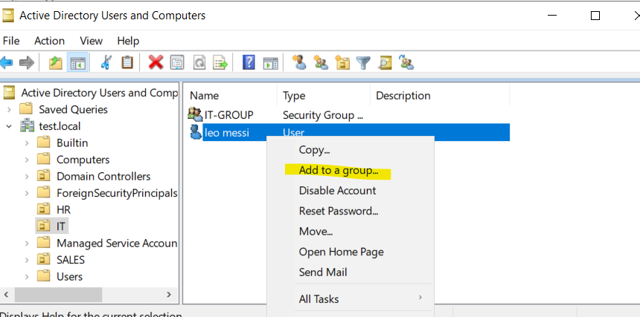2. Add group name and tab check name

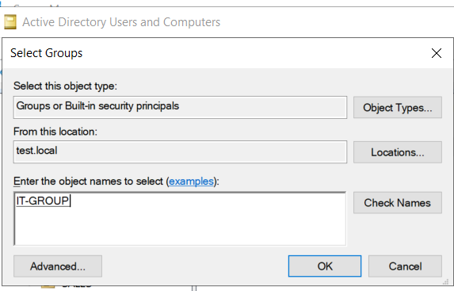

1. Click ok

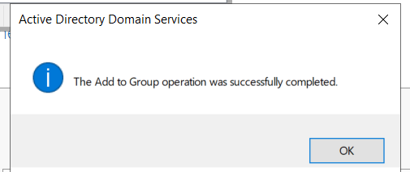

Within each Organizational Unit (OU) — **HR**, **IT**, and **Sales** — I created multiple user accounts representing the staff members in each department.

For better management and access control, I also created a corresponding **security group** inside each OU, named appropriately (e.g., HR_Group, IT_Group, Sales_Group).

All users belonging to a specific OU were added to their respective departmental group.

This approach simplifies the process of assigning permissions and applying group policies, as access can now be managed at the group level rather than individually. It also ensures a more organized, scalable, and secure Active Directory structure.

## Default Local Groups Created After Joining a Domain

### **1. Administrators**

* Members of this group have **full control** over the local computer.
* After joining the domain, the **Domain Admins** group is **automatically** added to this local group.
* This allows domain administrators to manage the machine remotely or locally with full privileges.

🔐 Example:  
 DOMAIN\Domain Admins → becomes a member of Local Administrators on the client PC.

### **2. Users**

* This group includes standard local users who have **limited access** to the system.
* Domain users who log in to the machine for the first time are automatically added as **temporary profiles** under this group, with restricted access.

# **8. creating group policy**

### What is Group Policy (GPO)?

**Group Policy** is a feature in Windows Server that allows administrators to **centrally manage and configure** operating systems, applications, and user settings across all computers in a domain.

Instead of going to each PC one by one, GPO lets you apply rules and settings **automatically** across many users or computers — saving time and improving consistency.

### **Main Goals of GPO:**

* **Enforce security policies**
* **Control user experience** (e.g., hide Control Panel, set desktop wallpaper)
* **Configure system settings** (like password length, lock screen timeout)
* **Install software automatically**
* **Block USB ports or restrict app usage**

**It Linked To:**

* Entire **domain**
* Specific **Organizational Unit (OU)**
* A particular **site**

**GPO Applies To:**

* **Users**
* **Computers**

**Steps to create a GPO in a certine OU**

1. **Open Group Policy Management Console (GPMC):**
   1. Go to Start → Server Manager
   2. Click Tools → **Group Policy Management**

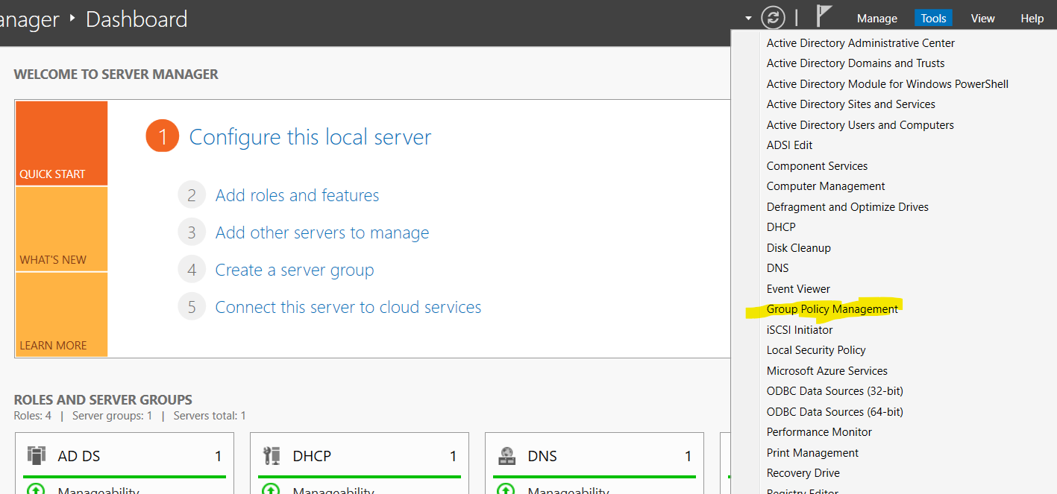

1. **Navigate to the Desired OU:**
   1. In the left pane, expand your domain → expand Organizational Units
   2. Select the OU where you want to apply the policy (e.g., HR)
2. **Create a New GPO:**
   1. Right-click the Sales OU → choose **"Create a GPO in this domain, and Link it here..."**

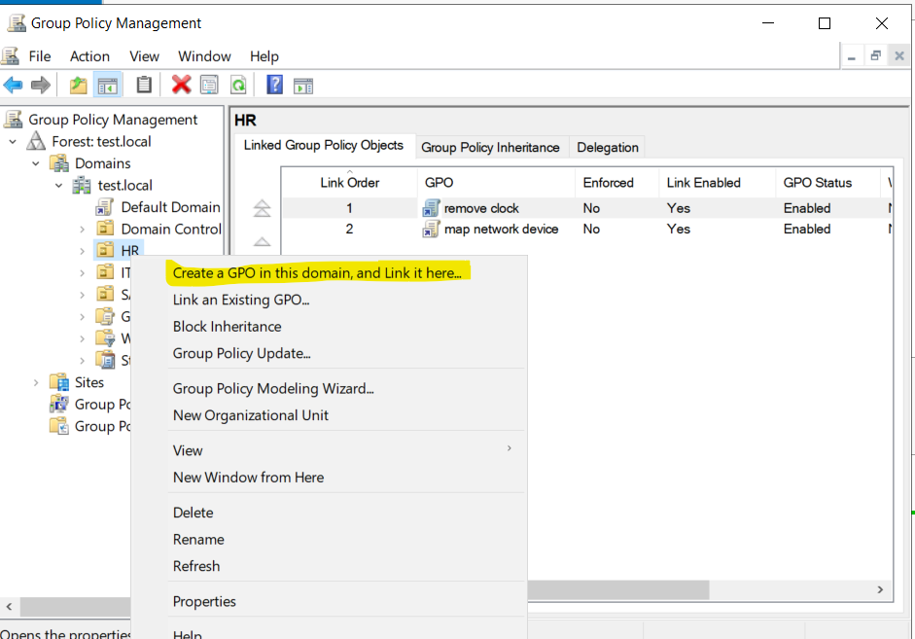

1. **Name the GPO:**
   1. Example: Disable_ControlPanel_HR
   2. Click **OK**

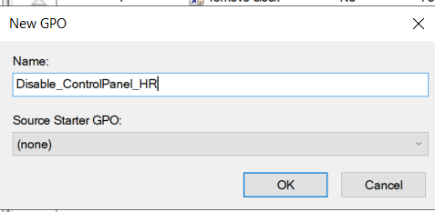

1. ⚙️ **Edit the GPO:**
   1. Right-click on the new GPO → select **Edit**

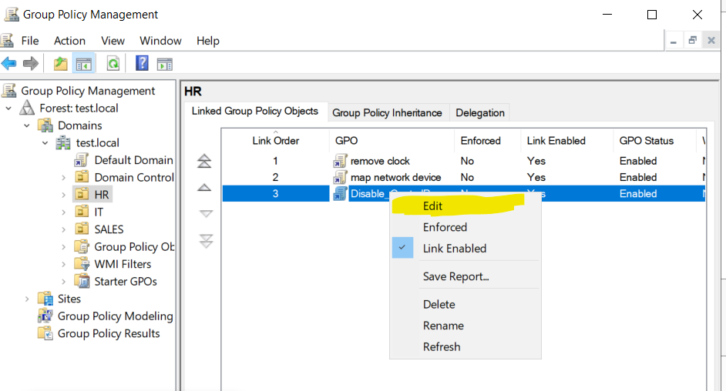

1. **Configure a Policy Setting:**
   1. Navigate to:  
       User Configuration → Administrative Templates → Control Panel
   2. Double-click **"Prohibit access to Control Panel and PC settings"**

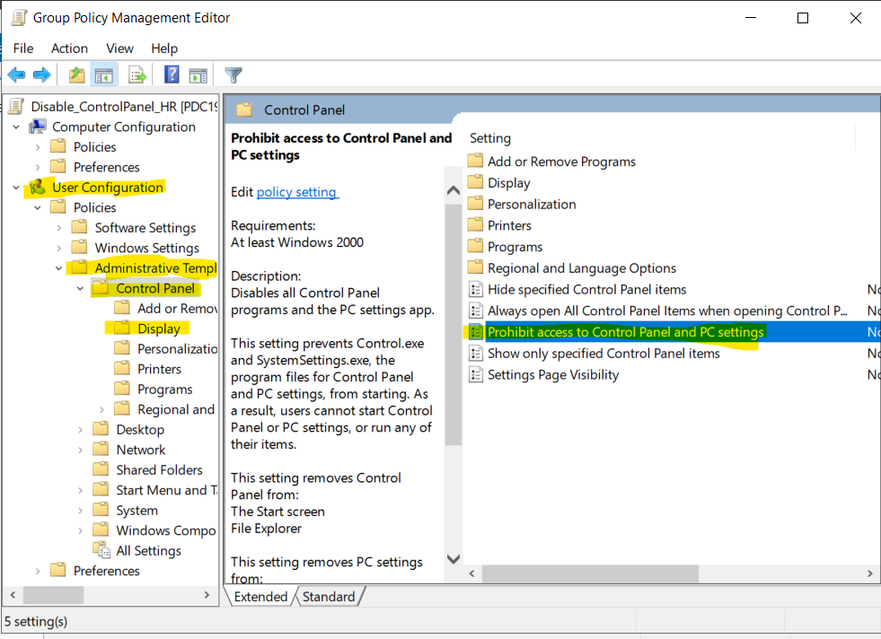

* 1. Set it to **Enabled** → then click **OK**

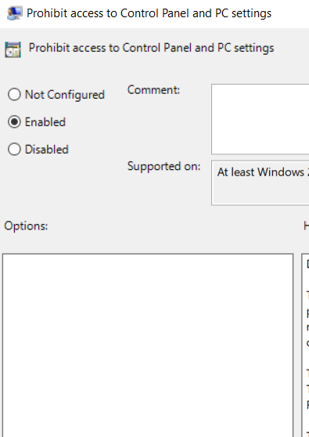

1. 🔄 **Force Policy Update (Optional):**
   1. On the client machine, run gpupdate /force in Command Prompt  
       *(Or wait ~90 minutes for it to apply automatically)*

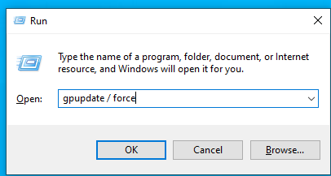

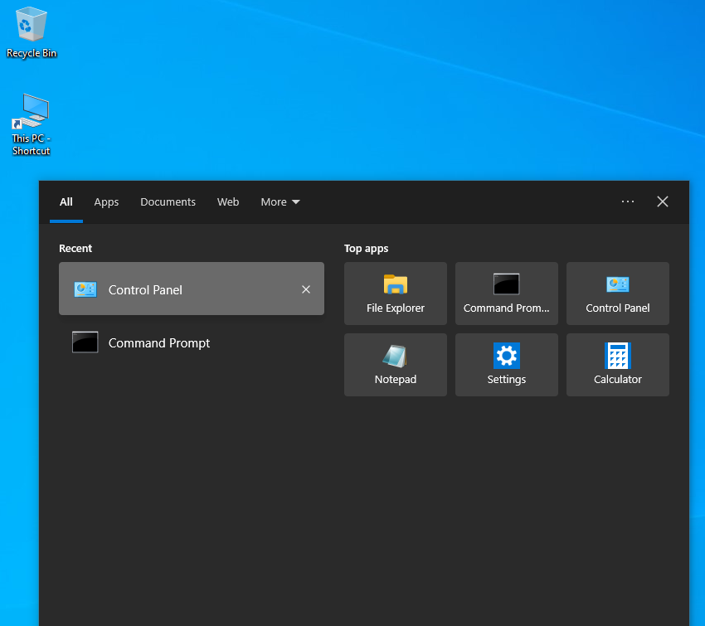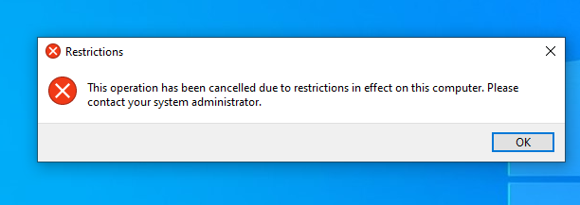

For the HR department, I applied a Group Policy that disables access to the Control Panel. This helps reduce the risk of accidental or unauthorized changes to system configurations, ensuring a more secure and stable working environment. It also supports centralized IT management and enforces compliance with organizational IT policies.

**To ensure proper control and organization, I implemented a customized set of Group Policy Objects (GPOs) for each Organizational Unit (OU). These policies were designed to align with the specific responsibilities and access needs of users within each department, helping enforce the appropriate level of permissions, restrictions, and security measures across the network.**

## **Group Policy Objects Applied to HR OU**

In the HR Organizational Unit (OU), I created and linked several Group Policy Objects (GPOs) to enhance security, limit unnecessary access, and maintain a consistent system environment for HR staff. Below is a breakdown of each policy:

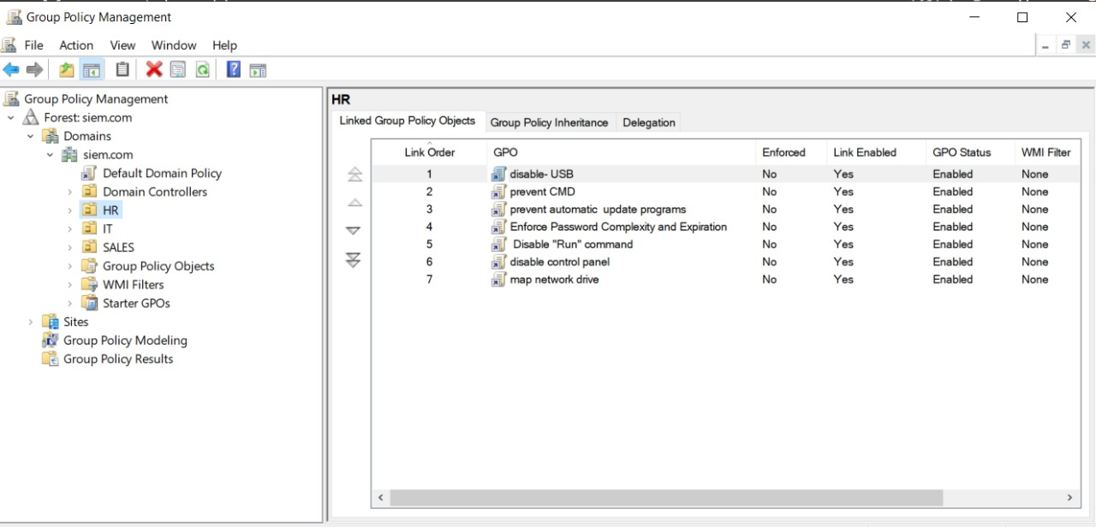

### **1. 🔌 disable-USB**

* **Purpose:** Prevents users from accessing or using USB storage devices.
* **Reason:** To protect sensitive HR data and avoid data leakage through external drives.

### **2. 💻 prevent CMD**

* **Purpose:** Disables access to the Command Prompt (cmd.exe).
* **Reason:** To stop non-technical users from running potentially harmful commands or scripts.

### **3. 🔄 prevent automatic update programs**

* **Purpose:** Blocks users from manually initiating system or software updates.
* **Reason:** Ensures that updates are managed centrally by the IT team to maintain version control and stability.

### **4. 🔐 Enforce Password Complexity and Expiration**

* **Purpose:** Enforces strong password policies (complexity requirements and expiration time).
* **Reason:** To improve account security and reduce the risk of brute-force attacks or weak credentials.

### **5. 🚫 Disable "Run" command**

* **Purpose:** Prevents users from accessing the Run dialog box.
* **Reason:** To restrict launching system tools or registry editors via shortcuts.

### **6. ⚙️ disable control panel**

* **Purpose:** Blocks access to the Control Panel.
* **Reason:** To prevent unauthorized system configuration changes by HR users.

### **7. 🌐 map network drive**

* **Purpose:** Automatically maps shared drives (e.g., for HR files or documents).
* **Reason:** To improve accessibility to common resources without requiring manual configuration.

## **Group Policy Objects Applied to IT OU**

To support the technical responsibilities of the IT department, I applied a tailored set of Group Policy Objects (GPOs) that balance flexibility with security. These GPOs provide essential access while still maintaining control over critical system behaviors.

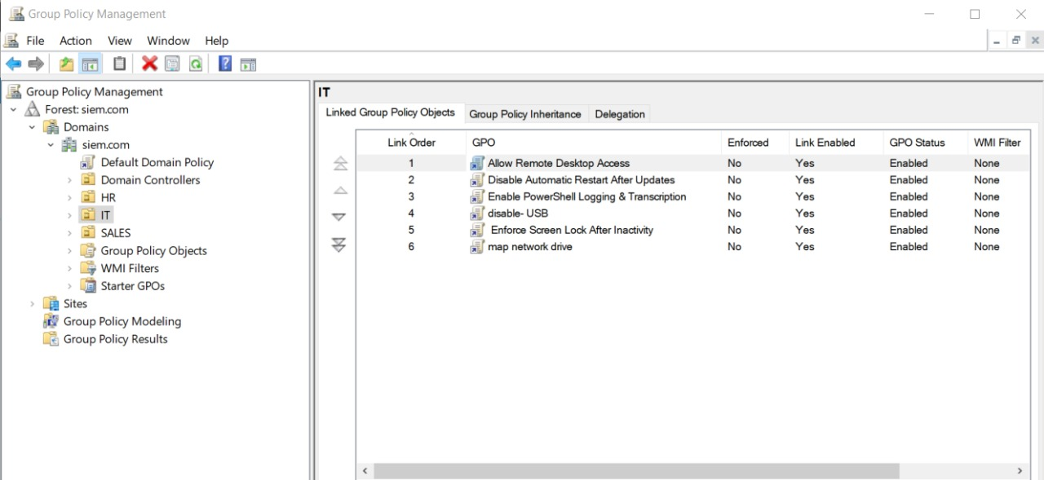

### **1. 💻 Allow Remote Desktop Access**

* **Purpose:** Enables users to connect to other systems using Remote Desktop Protocol (RDP).
* **Reason:** IT staff often need to manage systems remotely; this policy allows them to do so securely.

### **2. 🔄 Disable Automatic Restart After Updates**

* **Purpose:** Prevents the system from restarting automatically after Windows updates.
* **Reason:** To avoid disruption of tasks or services managed by IT users during working hours.

### **3. 🛠️ Enable PowerShell Logging & Transcription**

* **Purpose:** Enables detailed logging and transcription of PowerShell activities.
* **Reason:** Provides visibility into PowerShell usage for auditing and troubleshooting purposes.

### **4. 🔌 disable-USB**

* **Purpose:** Blocks USB storage devices.
* **Reason:** To prevent unauthorized data transfer or introduction of malware via removable devices.

### **5. ⏳ Enforce Screen Lock After Inactivity**

* **Purpose:** Automatically locks the user session after a period of inactivity.
* **Reason:** Enhances physical security by reducing the risk of unauthorized access to unattended workstations.

### **6. 🌐 map network drive**

* **Purpose:** Automatically maps shared drives for IT team use.
* **Reason:** Simplifies access to commonly used administrative or departmental file shares.

## **Group Policy Objects Applied to SALES OU**

To ensure a secure and controlled environment for the Sales department, I applied a set of GPOs that limit access to unnecessary system tools and enforce security standards, while still enabling access to essential shared resources.

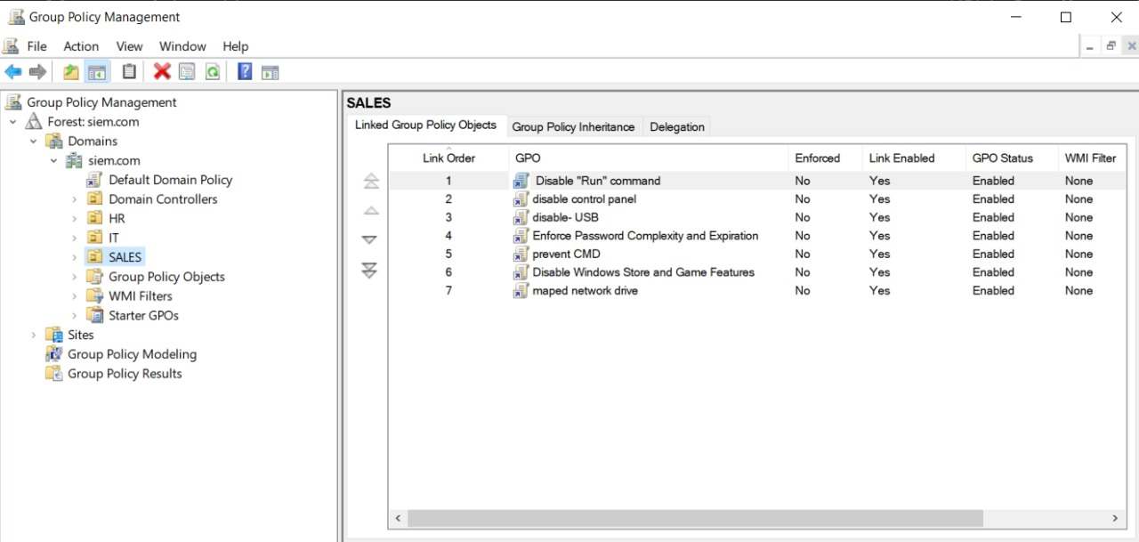

### **1. 🚫 Disable "Run" Command**

* **Purpose:** Prevents users from launching the "Run" dialog (Win + R).
* **Reason:** To limit the ability to execute system-level commands that may compromise security or system configuration.

### **2. ⚙️ Disable Control Panel**

* **Purpose:** Blocks access to the Control Panel.
* **Reason:** Prevents users from making unauthorized changes to system settings.

### **3. 🔌 disable-USB**

* **Purpose:** Disables USB storage device usage.
* **Reason:** Helps avoid unauthorized data transfers and reduces the risk of malware infections.

### **4. 🔐 Enforce Password Complexity and Expiration**

* **Purpose:** Enforces strong password policies and periodic expiration.
* **Reason:** Enhances account security and reduces the risk of compromised credentials.

### **5. 🖥️ prevent CMD**

* **Purpose:** Disables access to the Command Prompt.
* **Reason:** Prevents users from running potentially harmful system commands.

### **6. 🕹️ Disable Windows Store and Game Features**

* **Purpose:** Removes access to the Microsoft Store and built-in game features.
* **Reason:** Reduces distractions and ensures devices are used strictly for business purposes.

### **7. 🌐 maped network drive**

* **Purpose:** Automatically maps shared drives used by the Sales team.
* **Reason:** Simplifies file sharing and centralizes access to department resources.

# **9. configure DHCP srever**

**DHCP (Dynamic Host Configuration Protocol)** is a network management protocol used to **automatically assign IP addresses** and other network configuration parameters (like DNS servers and default gateway) to client devices on a network. Instead of manually configuring IP settings for each device, DHCP enables devices to get their network settings **dynamically** from a central server.

### **Why Use DHCP?**

Without DHCP, every device would need manual IP configuration — which is time-consuming and prone to errors. DHCP solves this by:

* Automatically assigning IP addresses from a defined range (scope).
* Preventing IP conflicts (no two devices get the same IP).
* Simplifying network administration.
* Allowing quick reconfiguration of network settings.

### **How It Works (DHCP Lease Process):**

1. **DHCP Discover:**  
    A client device sends a broadcast request to find a DHCP server.
2. **DHCP Offer:**  
    The DHCP server responds with an available IP and other settings.
3. **DHCP Request:**  
    The client requests to lease the offered IP address.
4. **DHCP Acknowledgment:**  
    The server confirms and leases the IP to the client for a specific **lease duration**.

### **What Can DHCP Configure?**

Besides IP address, DHCP can also assign:

* Subnet Mask
* Default Gateway
* DNS Server Addresses

## **Steps to configure DHCP**

### **🔧 Step 1: Install the DHCP Server Role**

1. Open **Server Manager**.
2. Click on **“Add Roles and Features”**.
3. In the **Wizard**, select:
   1. **Role-based or feature-based installation**
   2. Choose your server from the server pool.
4. From the roles list, check **DHCP Server**.

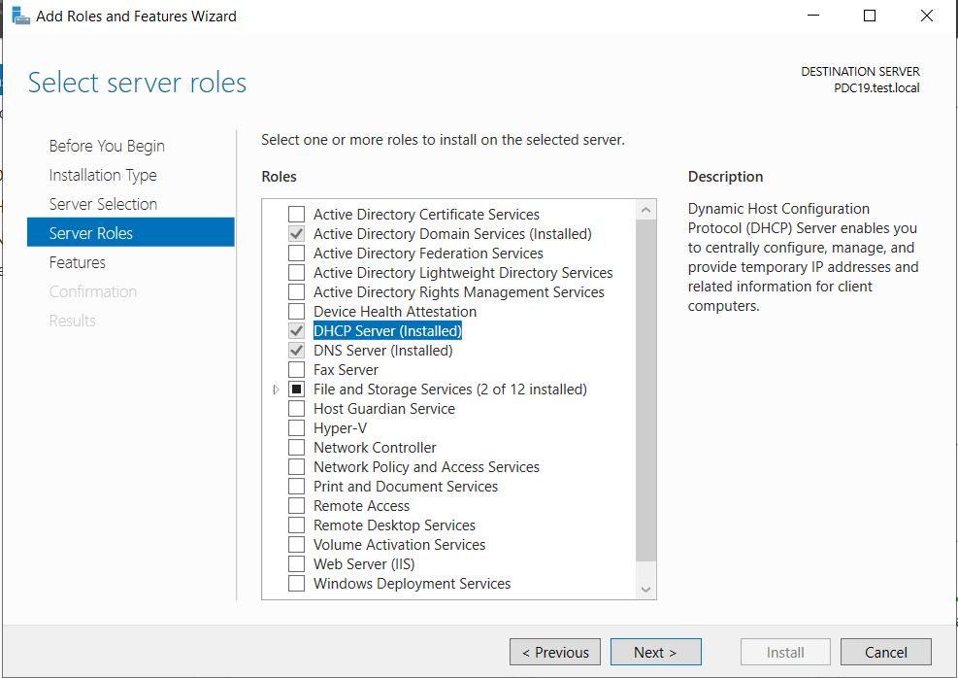

1. Click **Next** until the installation begins.
2. Click **Install**, then **Complete the DHCP Post-Install Configuration** when prompted.

### **Step 2: Authorize the DHCP Server**

1. Open **DHCP Management Console**.

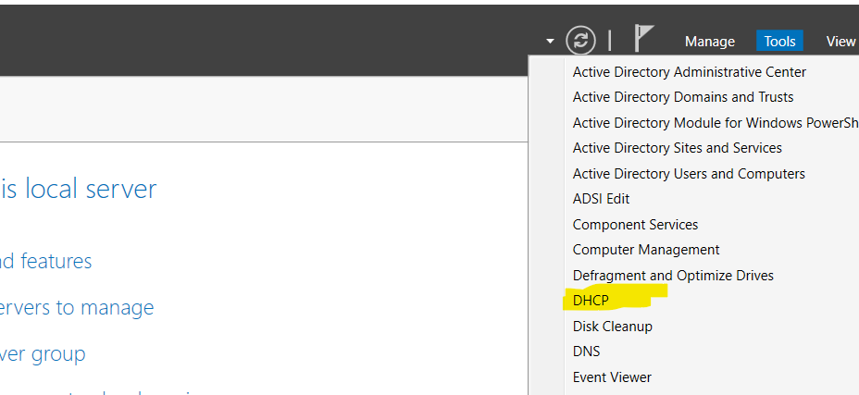

### **📦 Step 3: Create a New Scope**

A scope defines the range of IP addresses the server can lease to clients.

1. Right-click on **IPv4** → select **New Scope**.

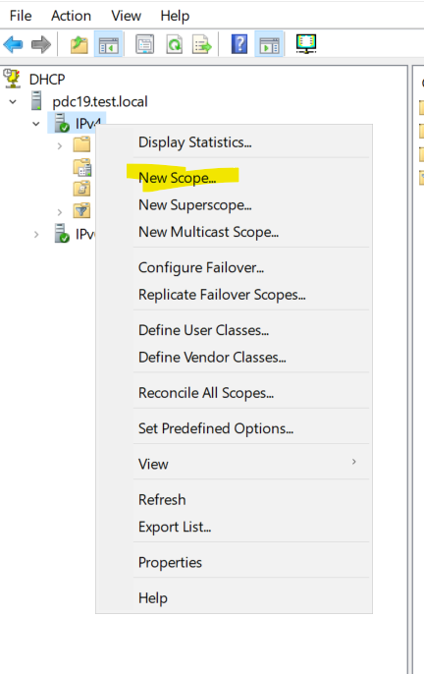

1. Enter a **Name** and **Description** (e.g VLAN 10)

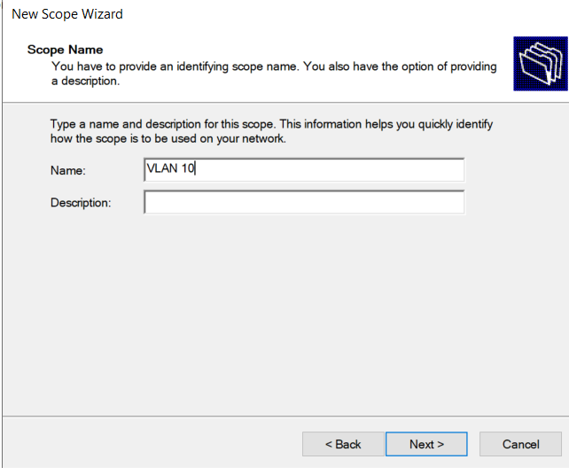

1. Define the **IP address range**:
   1. Start IP: 192.168.10.1
   2. End IP: 192.168.1.254
2. Set the **Subnet Mask** (e.g., 255.255.255.0).

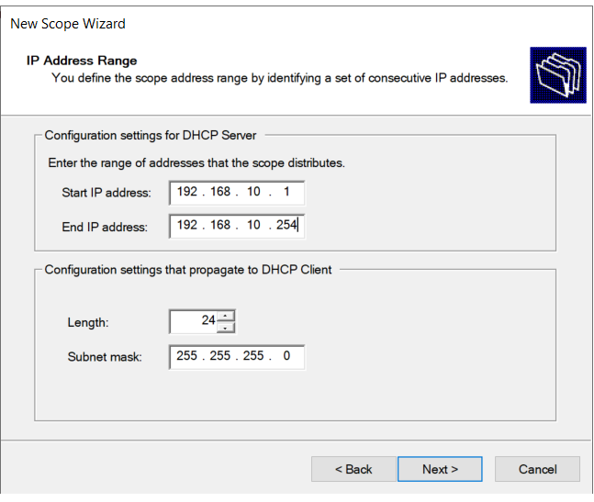

1. Add any **excluded addresses** if needed (e.g., reserved for printers or servers).

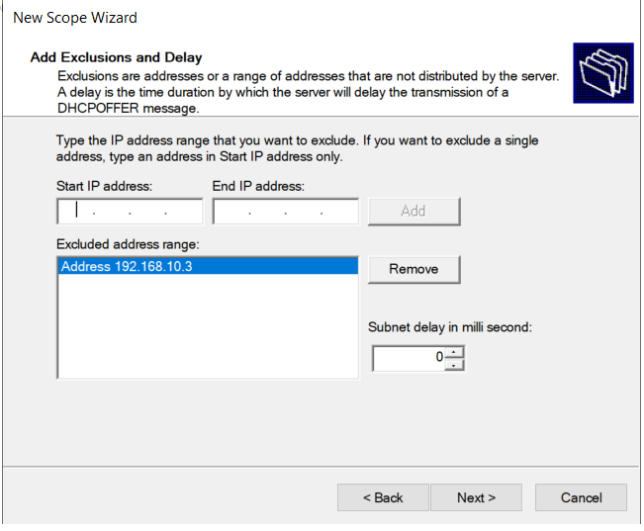

1. Set the **Lease Duration** .

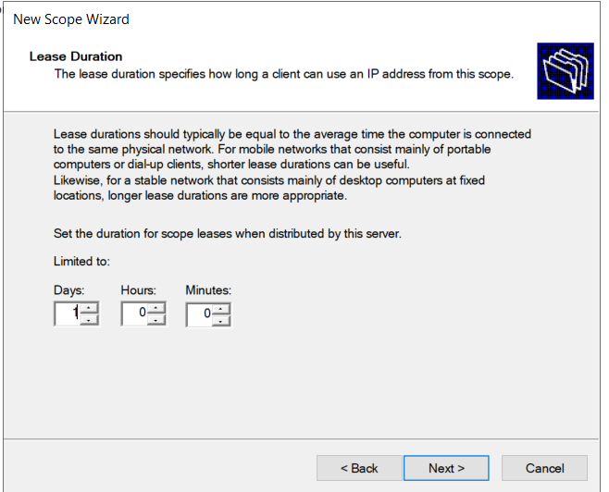

1. Configure other options like:
   1. **Default Gateway** (e.g., 192.168.1.1)

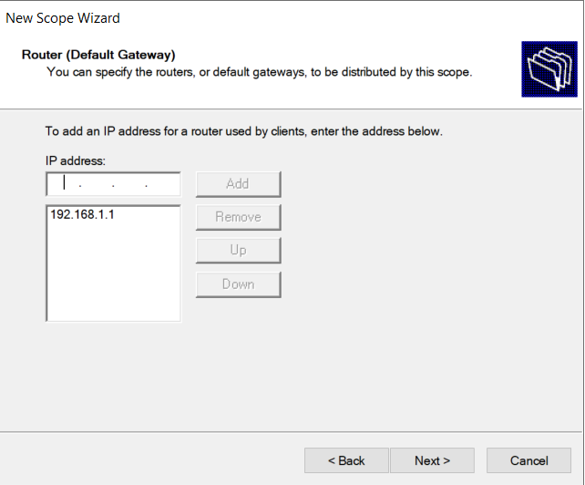

* 1. **DNS Servers**

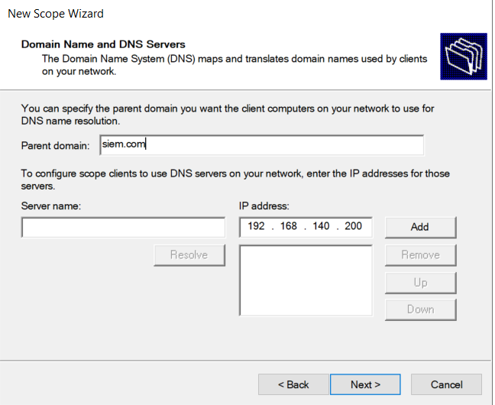

1. Choose **Activate Scope Now**.

### **🧪 Step 4: Test the Configuration**

* Go to a client machine.
* Set it to obtain an IP address automatically.

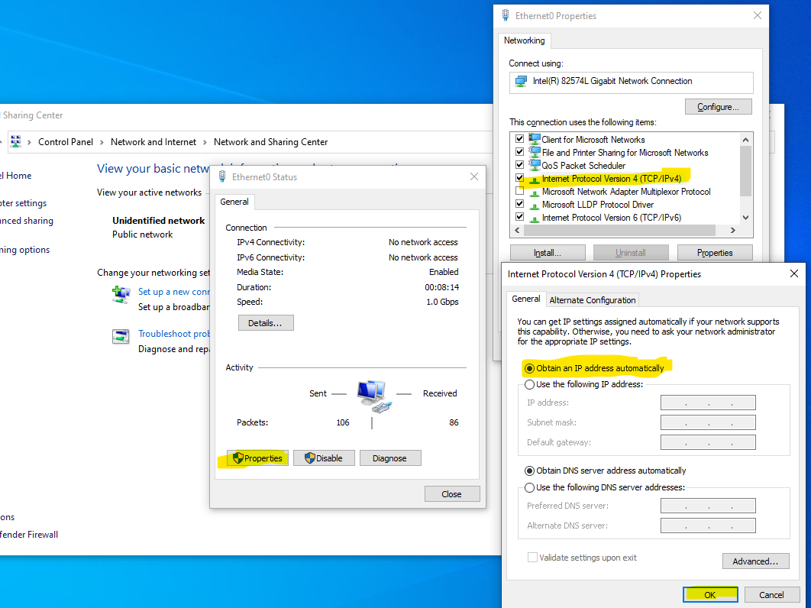

* Run ipconfig /release then ipconfig /renew in CMD.
* The client should receive an IP from the DHCP server.

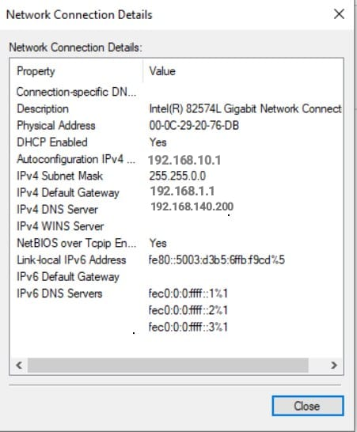

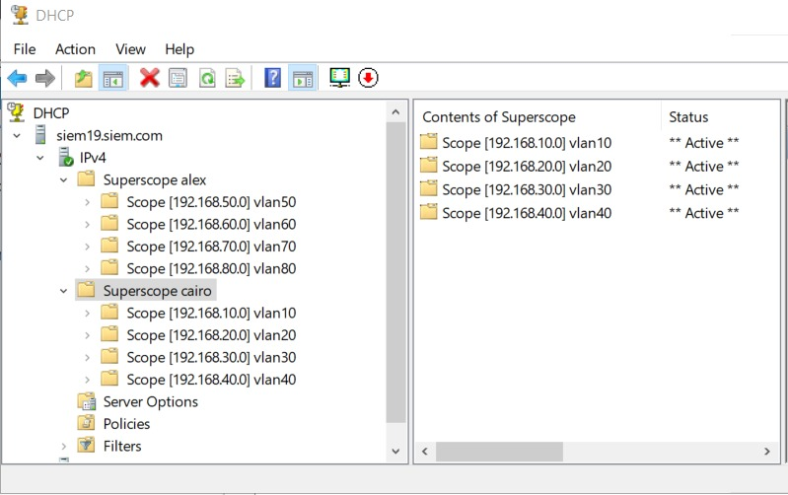  
As part of the DHCP configuration, I have created multiple IP address pools (scopes) to efficiently manage and distribute IP addresses across the organization's different branches.

* **Created Scopes:**
  + Scope 20
  + Scope 30
  + Scope 40
  + Scope 50
  + Scope 60
  + Scope 70
  + Scope 80

The allocation of these scopes is segmented by branch as follows:

* **Cairo Branch:** Assigned to receive IP addresses from Scopes **10**, **20**, **30**, and **40**.
* **Alexandria Branch:** Assigned to receive IP addresses from Scopes **50**, **60**, **70**, and **80**.

This segmentation helps maintain organized IP management, ensures proper address distribution, and supports network scalability across multiple geographic locations.

In order to reserve specific IP addresses and prevent them from being assigned to network devices automatically, I configured **IP exclusions** within the scopes. For example:

* In **Scope VLAN 10**, the following IP ranges were excluded:
  + 192.168.10.1 to 192.168.10.9
  + 192.168.10.151 to 192.168.10.152

These excluded IPs can be used for critical devices like servers, printers, or routers, ensuring they are not assigned dynamically and avoiding potential conflicts

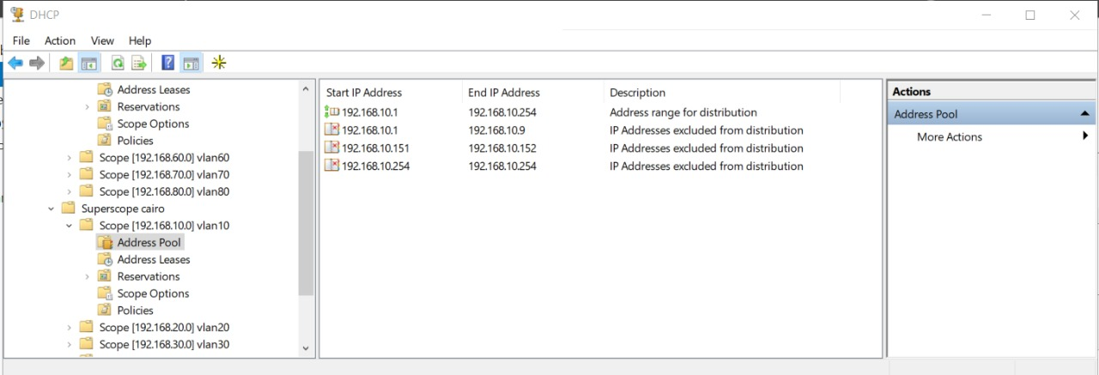

# **10. File server , shairing and disk qouta**

A **File Server** is a dedicated server that stores and manages access to files over a network. It's a core part of any infrastructure, allowing centralized data storage, easier backups, access control, and collaboration between users.

### **File Sharing**

**File Sharing** is the process of granting network users access to files or folders stored on the server. This allows users across different departments (e.g., HR, IT, Sales) to read, edit, or store files based on permissions assigned to them.

#### **Benefits:**

* Centralized file management
* Easy access for multiple users
* Permissions-based control (Read, Write, Modify)
* Supports Active Directory security groups

### **Step 1: Install File Server Role (if not installed)**

1. Open **Server Manager**
2. Go to **Manage → Add Roles and Features**
3. Select **“File and Storage Services” → “File Server”**

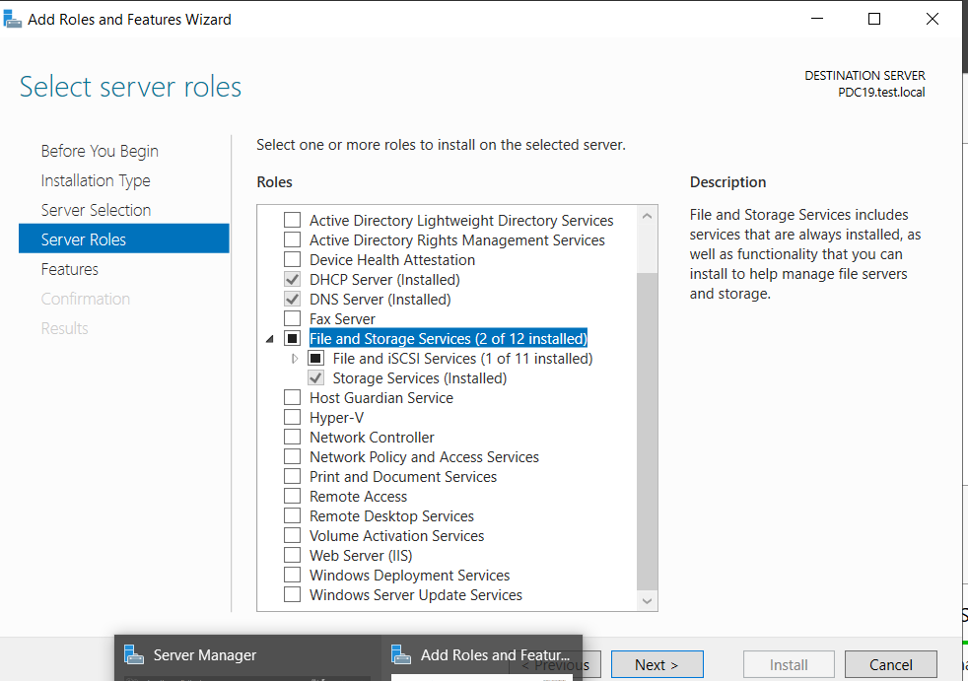

1. Click **Next** until you reach **Install**

### **Step 2: Create a Shared Folder**

1. Create a folder on server (e.g., D:\HR_Share)
2. Right-click the folder → **Properties**

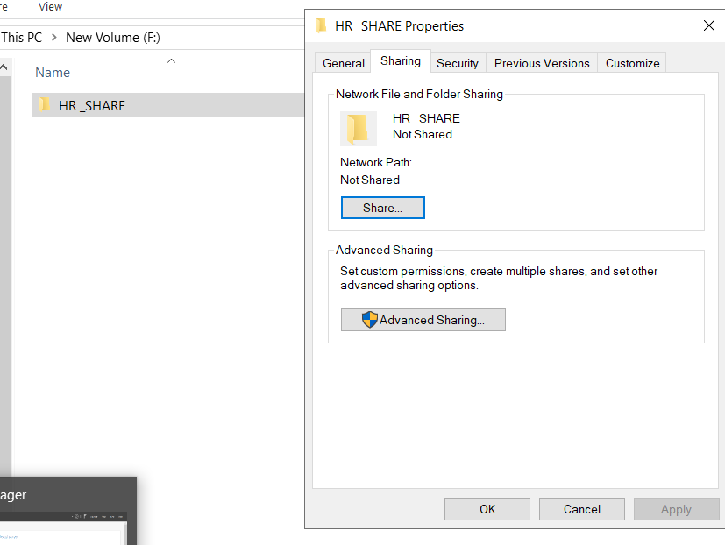

1. Go to the **Sharing** tab → Click **Advanced Sharing**
2. Check **"Share this folder"**
3. Give it a name (e.g., HR_Share)
4. Click **Permissions**:

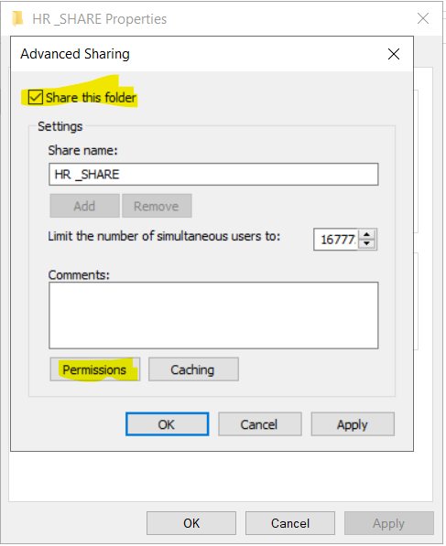

* 1. Remove “Everyone”
  2. Add specific users or groups (e.g., HR Group)
  3. Assign permissions: **Read / Change / Full Control** as needed

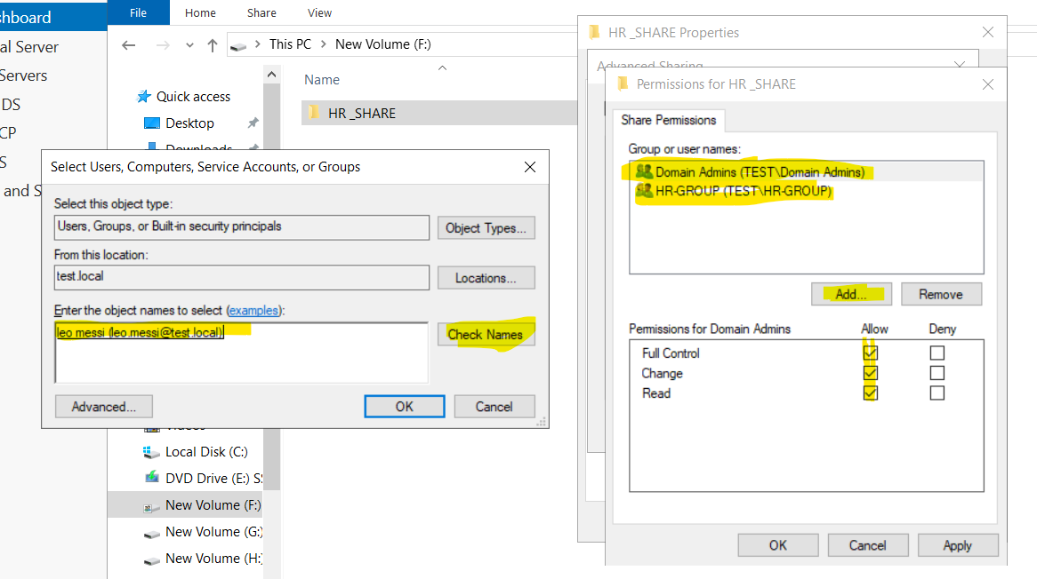Her i give HR-GROUP and domain admin groups permission for this folder to read and write also user name (leo.messi @siem.com ) from IT OU

### **Step 3: Set NTFS Permissions**

1. Go to the **Security** tab

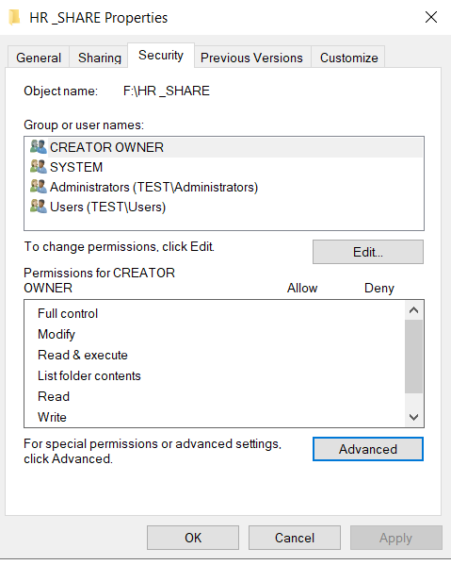

1. Click **Edit** → Add the same group (e.g., HR Group)

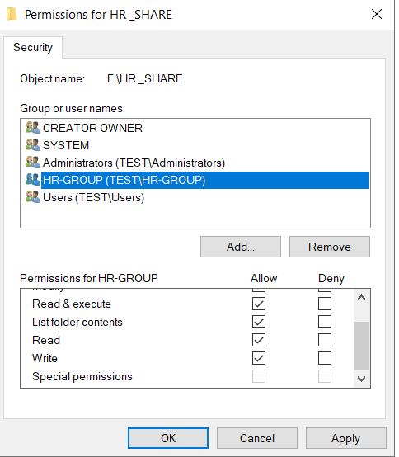

1. Set appropriate permissions:
   1. **Read** for view-only access
   2. **Modify** for editing
   3. **Full Control** for full access

NTFS permissions are enforced locally, while **Share permissions** apply over the network. The most restrictive of the two will be applied.

To view the shared folder on client pc

CLICK RUN -------> \\(DEVICE NAME )

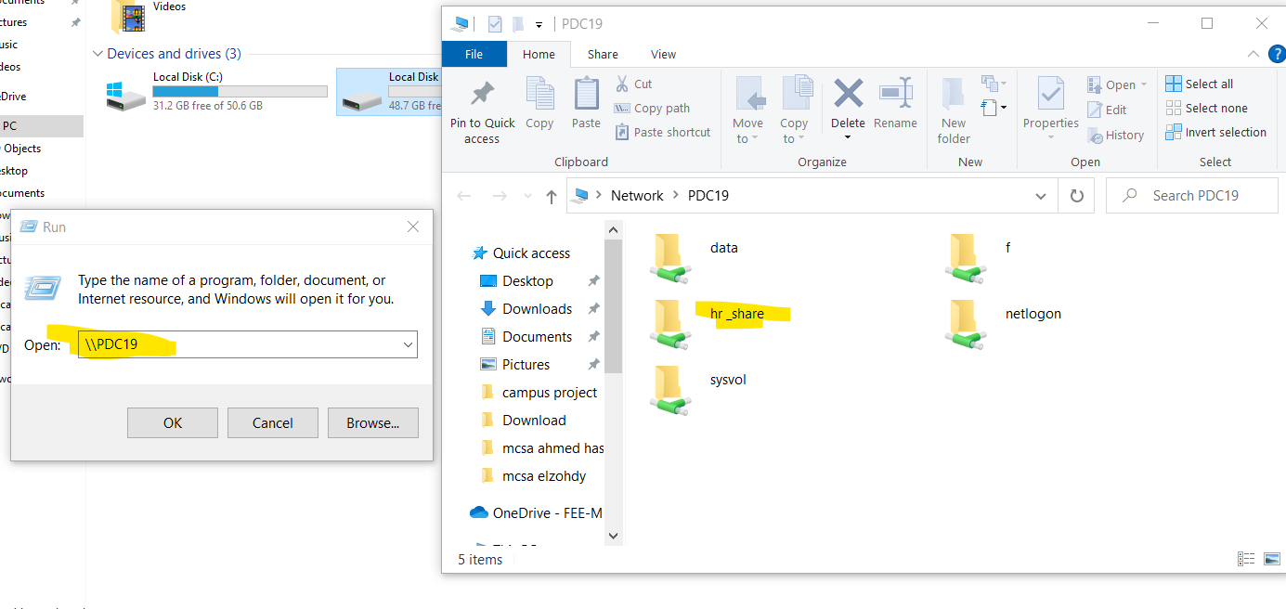

Or sometime the administrator restricts applying run

So must define GPO on OU to enable map network drive over the network

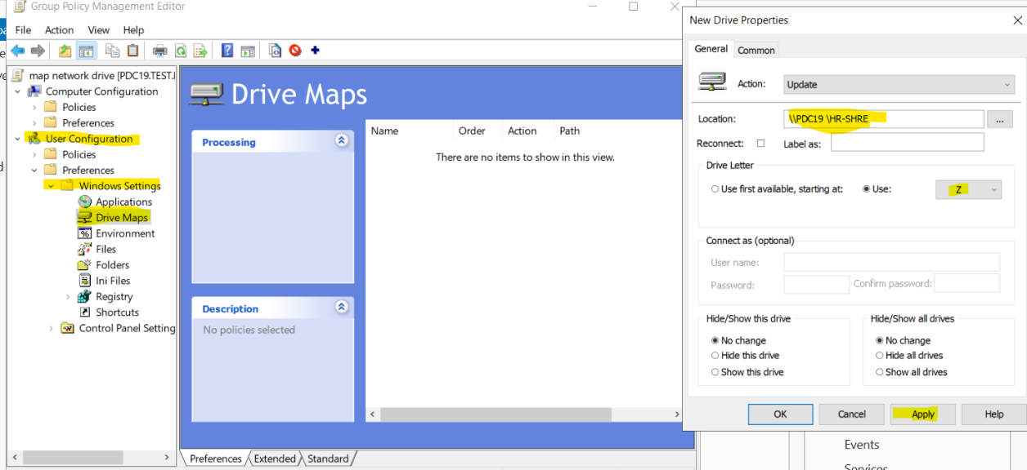

Add location of shared folder

Give it letter from a_z

Click apply

### **💽 Disk Quota**

**Disk Quota** is a feature in Windows Server that allows administrators to **limit the amount of disk space** each user can consume on a drive. It's useful for:

* Preventing any single user from using excessive storage
* Managing storage capacity effectively
* Encouraging users to keep storage organized

### **Configure Disk Quota**

1. Open **File Explorer**
2. Right-click on the drive (e.g., D:\) → **Properties**

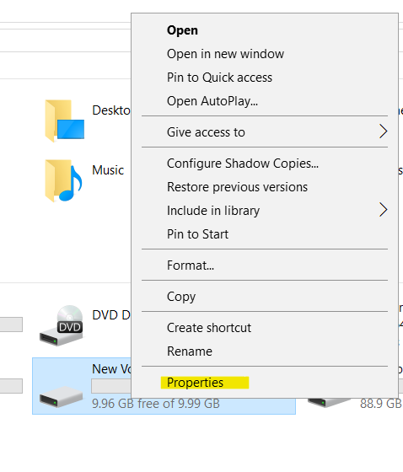

1. Go to the **Quota** tab
2. Click **Show Quota Settings**
3. Check **"Enable quota management"**
4. Set limits:
   1. **Limit disk space to**: e.g., 100 MB
   2. **Set warning level**: e.g., 50MB
5. Apply the settings and optionally deny disk space to users exceeding the quota

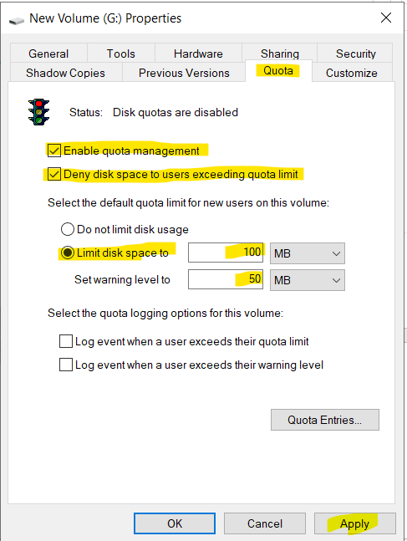

Of course we make the disk or partiton sharing and modify permission

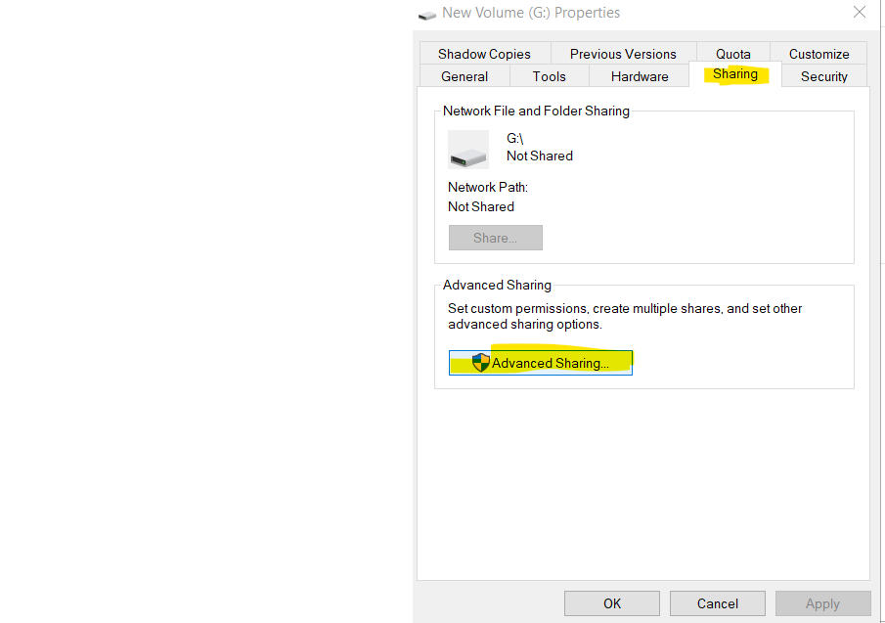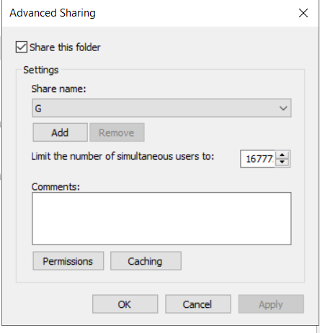

When user reach to warning level it will appear warning message to user

And when user use the 100 MB there not be allowed to allocate

And shoud talk to administrators to take more space

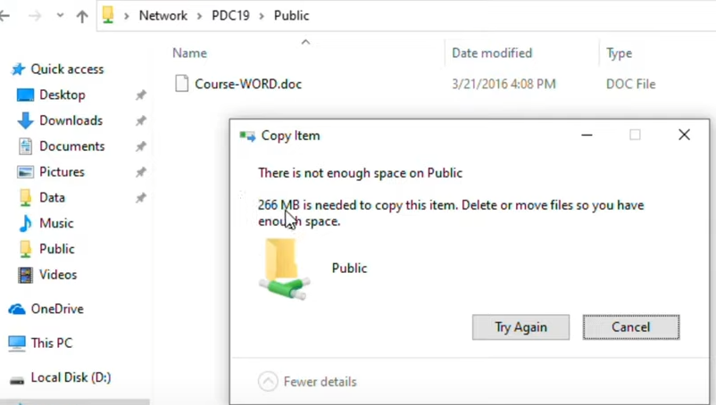

## **Additional Domain Controller (ADC)**

An **Additional Domain Controller (ADC)** is a secondary domain controller that is added to an existing domain. It acts as a **backup** to the Primary Domain Controller (PDC) and helps improve **availability**, **fault tolerance**, and **load balancing** in an Active Directory environment.

### **Why Use an Additional Domain Controller?**

1. **High Availability**  
    If the primary domain controller goes down due to failure or maintenance, the ADC ensures that domain services (like logins, authentication, group policies, etc.) continue to work without interruption.
2. **Load Balancing**  
    Distributes authentication requests between controllers, reducing the load on a single server.
3. **Redundancy and Fault Tolerance**  
    Prevents a single point of failure in the domain infrastructure.
4. **Faster Login and Replication**  
    Especially useful in environments with **multiple locations** (e.g., branch offices). Users authenticate faster to a local ADC.

### **How It Works**

When you promote a second server as an ADC:

* It **replicates all Active Directory data** from the existing domain controller.
* It becomes part of the same domain and shares responsibility for:
  + **User authentication**
  + **Group Policy application**
  + **DNS (if installed)**
  + **AD database replication**

All domain controllers in a domain operate in a **multi-master** replication model, meaning

changes can occur on any domain controller and are synchronized across all others.

**Steps to Install an Additional Domain Controller (ADC**

### **Step 1: Prepare the Second Server**

* Make sure the second server:
  1. Has Windows Server installed (same or compatible version)
  2. Has a **static IP address ----- (192.168.150.200)**
  3. Is connected to the same network as the existing domain controller
  4. Uses the **primary DNS** pointing to the **first domain controlle(192.168.140.200)**

### **Step 2: Join the Existing Domain**

1. Right-click **This PC** → **Properties**
2. Click **Change settings** next to( ADC)

### **Step 3: Install Active Directory Domain Services (AD DS)**

1. Open **Server Manager**
2. Click **Manage** → **Add Roles and Features**

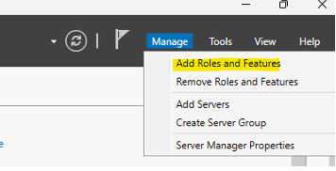

1. In the wizard:
   1. Choose **Role-based or feature-based installation**
   2. Select the local server
   3. Under **Server Roles**, check **Active Directory Domain Services**

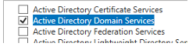

**Step 4: Promote the Server to a Domain Controlle**r

1. After installation, click the **flag icon** in Server Manager → **Promote this server to a domain controller**
2. In the wizard:
   1. Choose **Add a domain controller to an existing domain**
   2. Enter the domain name (e.g., siem.com)

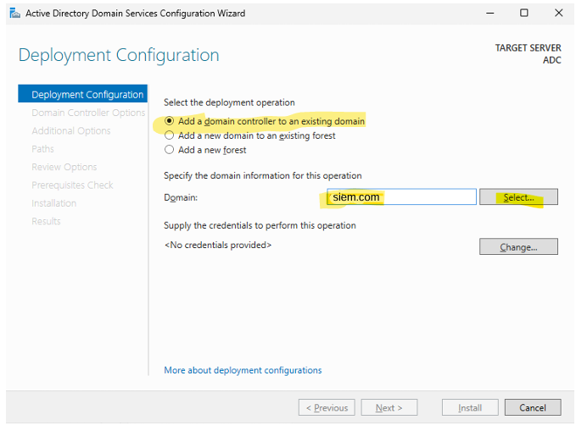

* 1. Provide domain admin credentials

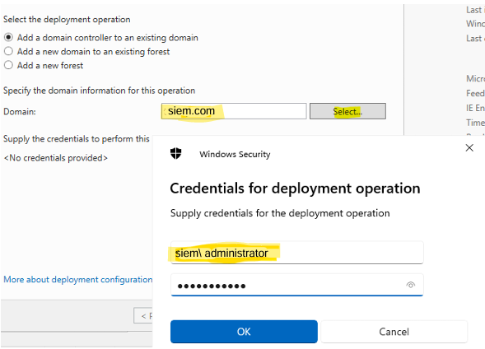

1. Select the following options:
   1. **Domain Name System (DNS) Server**
   2. **Global Catalog (GC)** → (checked by default)
   3. DO NOT select **Read-only domain controller (RODC)** unless needed
2. Choose the **site name** (or leave default)

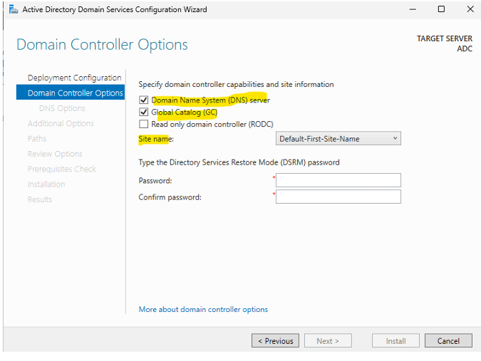

1. Let it replicate from the **existing domain controller**
2. Leave default paths (or customize as needed)

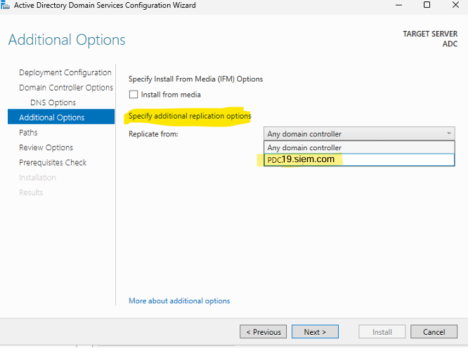

1. Click **Next**, then **Install**

**For check that ADC is created**

From active directory site and service**s**  
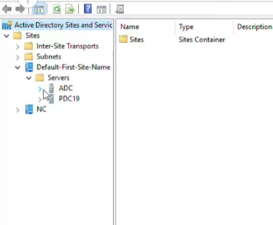**now if we create a user or make any modifications on primary it will be replicated on the secondary as too this property will ensure the availability of services**

Chapter 6: **FortiGate Firewall**

# **FortiGate Firewall Integration for Network Security: A Graduation Project Case Study**

## **Abstract**

This document details the design, implementation, and verification of integrating a FortiGate Next-Generation Firewall (NGFW) into an existing hierarchical campus network infrastructure. Focusing on the practical application within a graduation project, this study addresses the critical need for robust network security in modern environments. It covers the theoretical foundations of firewalls, the specific features of FortiGate, the strategic placement of the firewall within the network topology, and the step-by-step configuration of its interfaces, routing (static routing as a primary focus, with OSPF as an advanced alternative), NAT, and security policies. Furthermore, it includes a comprehensive testing methodology to validate connectivity, routing, and security policy enforcement, alongside a discussion of challenges encountered and their respective solutions. This project aims to demonstrate a practical approach to enhancing network security and providing a secure gateway to the internet.

## **6.1: Introduction to Network Security and Firewalls**

### **1.1 Introduction to Network Security**

In today's interconnected world, network security is paramount. Organizations of all sizes rely heavily on their digital infrastructure for daily operations, communication, and data management. However, this reliance exposes them to a growing array of cyber threats, ranging from sophisticated malware and ransomware to denial-of-service attacks and data breaches. Protecting sensitive information, ensuring business continuity, and maintaining regulatory compliance are critical objectives for any modern network. This chapter will lay the groundwork by exploring the fundamental concepts of network security and the indispensable role of firewalls.

### **1.2 Understanding Cyber Threats**

Cyber threats are constantly evolving, becoming more complex and targeted. These threats can originate from various sources, including malicious actors (hackers), organized cybercrime groups, state-sponsored entities, and even insider threats. Common types of cyber threats include:

* **Malware:** Viruses, worms, Trojans, ransomware, spyware designed to disrupt, damage, or gain unauthorized access to computer systems.
* **Phishing and Social Engineering:** Deceptive tactics used to trick users into revealing sensitive information or performing actions that compromise security.
* **Denial-of-Service (DoS/DDoS) Attacks:** Attempts to make a network resource unavailable to its intended users by overwhelming it with traffic.
* **Data Breaches:** Unauthorized access to and exfiltration of sensitive, protected, or confidential data.
* Zero-Day Exploits: Attacks that target vulnerabilities in software or hardware that are unknown to the vendor or public.  
  Understanding these threats is the first step in designing effective security measures.

### **1.3 The Role of Firewalls in Network Security**

A firewall is a network security device that monitors incoming and outgoing network traffic and decides whether to allow or block specific traffic based on a defined set of security rules. It acts as a barrier between a trusted internal network and untrusted external networks (like the internet), or between different segments of an internal network. Firewalls are the first line of defense, enforcing security policies and preventing unauthorized access.

### **1.4 Types of Firewalls**

Firewalls have evolved significantly over time, offering various levels of protection and functionality:

* **Packet-Filtering Firewalls:** The most basic type, filtering traffic based on IP addresses, port numbers, and protocols. They operate at the network layer.
* **Stateful Inspection Firewalls:** These firewalls monitor the state of active connections and use this information to make more intelligent filtering decisions. They are more secure than simple packet filters.
* **Proxy Firewalls:** Act as intermediaries for network requests, handling traffic on behalf of endpoints. They provide a higher level of security but can introduce latency.
* **Next-Generation Firewalls (NGFWs):** These are advanced firewalls that combine traditional firewall capabilities with additional security features such as:
  + **Intrusion Prevention Systems (IPS):** Detect and prevent known attacks.
  + **Application Control:** Identify and control specific applications, regardless of port or protocol.
  + **URL Filtering:** Block access to malicious or inappropriate websites.
  + **Deep Packet Inspection (DPI):** Examine the actual content of packets, not just headers.
  + **Sandboxing:** Isolate suspicious files in a secure environment to observe their behavior.
* **Hardware vs. Software Firewalls:** Hardware firewalls are dedicated appliances, offering high performance and robust security. Software firewalls run on general-purpose servers or endpoints.

### **1.5 Why FortiGate for This Project?**

FortiGate firewalls, developed by Fortinet, are widely recognized as leading Next-Generation Firewalls (NGFWs). They offer a comprehensive suite of security features, high performance, and a unified management platform (FortiOS). For this graduation project, FortiGate was chosen due to:

* **Comprehensive Security:** Its NGFW capabilities provide multi-layered protection against a wide range of threats.
* **Scalability:** FortiGate devices can scale to meet the needs of various network sizes, from small businesses to large enterprises.
* **Ease of Management:** The intuitive FortiOS graphical user interface (GUI) simplifies configuration and monitoring.
* **Industry Recognition:** Fortinet's strong market position and positive reviews make it a relevant and valuable technology to study and implement.
* **Learning Opportunity:** Integrating a FortiGate firewall provides practical experience with enterprise-grade security solutions.

### **1.6 Document Structure**

This document is organized into six chapters:

* **Chapter 1:** Introduces network security concepts and firewall fundamentals.
* **Chapter 2:** Provides an overview of FortiGate firewalls, their architecture, and operating modes.
* **Chapter 3:** Details the existing network topology and the strategic planning for FortiGate integration.
* **Chapter 4:** Covers the practical configuration steps for FortiGate interfaces, routing, firewall policies, and NAT.
* **Chapter 5:** Focuses on testing and verification of the implemented security measures, along with a discussion of challenges faced.
* **Chapter 6:** Concludes the project with a summary of achievements, lessons learned, and recommendations for future work.

## **6.2: FortiGate Firewall Overview**

### **2.1 Introduction to Fortinet and FortiGate**

Fortinet is a global leader in cybersecurity solutions, providing a wide range of products and services to secure networks, users, and applications. Founded in 2000, Fortinet's flagship product, the FortiGate firewall, has become a cornerstone of many organizations' security infrastructures. Fortinet's commitment to innovation is evident in its custom-built security processors (SPUs) and a unified operating system (FortiOS), which enable high performance and integrated security.

### **2.2 FortiGate Architecture and FortiOS**

FortiGate firewalls are purpose-built security appliances designed for high performance and deep inspection. Their architecture typically includes:

* **Custom ASICs (SPUs):** Fortinet develops its own Security Processing Units (SPUs) and Content Processors (CPs) to accelerate security functions like VPN, IPS, and content inspection, reducing reliance on general-purpose CPUs and improving throughput.
* **Multi-Core Processors:** Modern FortiGate models utilize multi-core CPUs to handle various tasks efficiently.
* **Network Interfaces:** A variety of Ethernet interfaces (Gigabit, 10-Gigabit, etc.) for connecting to different network segments.
* **FortiOS:** The proprietary operating system that powers all FortiGate devices. FortiOS provides a single pane of glass for managing all security and networking functions, including firewalling, VPN, IPS, application control, web filtering, anti-malware, and more. Its intuitive GUI and powerful CLI make configuration and monitoring straightforward.

### **2.3 FortiGate Operating Modes**

FortiGate firewalls can operate in different modes, depending on the network architecture and security requirements. The two primary modes are NAT/Route Mode and Transparent Mode.

#### **2.3.1 NAT/Route Mode**

**NAT/Route Mode** is the most common operating mode for FortiGate firewalls and is the mode chosen for this project. In this mode, the FortiGate acts as a Layer 3 device (router) and performs Network Address Translation (NAT) between different network segments.

* **Functionality:** It routes traffic between interfaces, each residing in a different IP subnet. It can perform NAT, enforce routing protocols (like OSPF, BGP, RIP), and apply comprehensive security policies.
* **Use Cases:** Ideal for perimeter security (between internal network and internet), segmenting internal networks, and acting as a central security gateway.
* **Advantages:** Provides full routing capabilities, robust security enforcement, and clear network segmentation.
* **Disadvantages:** Requires IP address changes and routing adjustments in the existing network when inserted.

#### **2.3.2 Transparent Mode (Brief)**

In **Transparent Mode** (also known as Bridge Mode), the FortiGate acts as a Layer 2 device (bridge). It filters traffic between two network segments without requiring any IP address changes on the existing network devices.

* **Functionality:** It passes traffic between its interfaces as if it were a network switch, inspecting packets based on MAC addresses. It can still apply security policies like IPS, application control, and web filtering.
* **Use Cases:** Ideal for inserting a firewall into an existing network without disrupting the IP addressing scheme or routing.
* **Advantages:** Minimal network disruption during deployment.
* **Disadvantages:** Lacks Layer 3 routing capabilities and cannot perform NAT.

#### **2.3.3 High Availability (HA) Modes (Brief)**

FortiGate devices can be deployed in High Availability (HA) clusters to provide redundancy and ensure continuous network operation in case of a device failure.

* **Active-Passive HA:** One FortiGate unit is active and processes all traffic, while the other is in standby mode, ready to take over if the active unit fails.
* Active-Active HA: Both FortiGate units actively process traffic, sharing the load. This mode provides both redundancy and load balancing.  
  While HA is crucial for production environments, for this project, we will focus on a single FortiGate deployment to simplify the initial integration and configuration.

### **2.4 Initial Access and Management**

To begin configuring a new FortiGate device, initial access is typically gained through:

* **Console Port:** Connecting a computer directly to the FortiGate's console port using a serial cable. This provides command-line interface (CLI) access.
* **Default IP Address:** Out-of-the-box, FortiGate devices usually have a default IP address configured on one of their interfaces (commonly Port1, e.g., 192.168.1.99). A computer can be connected to this port and configured with a compatible IP address to access the FortiGate's web-based Graphical User Interface (GUI) via HTTPS.
* **Default Credentials:** The default username is typically admin, and the password might be blank or fortinet (check the device label or documentation). It is crucial to change the default password immediately upon first login for security reasons.

## **6.3 Network Design and FortiGate Integration Planning**

### **3.1 Current Network Topology Analysis**

The existing network infrastructure for this graduation project is designed as a hierarchical network, comprising Core, Distribution, and Access layers. This design promotes scalability, redundancy, and efficient traffic flow.

* **Core Layer:** Consists of two Cisco Core Switches, SWCore-1 (Router ID: 1.1.1.1) and SWCore-2 (Router ID: 2.2.2.2). These switches are responsible for high-speed packet forwarding and inter-VLAN routing. They utilize OSPF (Open Shortest Path First) for dynamic routing and have an EtherChannel (Port-channel 11) between them for redundancy and increased bandwidth.
* **Distribution Layer:** This layer is segmented into three main blocks:
  + **Cairo Block (SWCairo-D1, SWCairo-D2):** Manages VLANs 10, 20, 30, 40. Uses Rapid-PVST for spanning-tree, HSRP (Hot Standby Router Protocol) for default gateway redundancy, and VTP (VLAN Trunking Protocol) for VLAN management within the "cairo" domain.
  + **Alexandria Block (SWAlex-D1, SWAlex-D2):** Manages VLANs 50, 60, 70, 80. Similar to Cairo, it uses Rapid-PVST, HSRP, and VTP within the "alex" domain.
  + Datacenter Block (SWDC-D1, SWDC-D2): Manages VLANs 130, 140, 150, 160. Also utilizes Rapid-PVST, HSRP, and VTP within the "Datacenter" domain.  
    Each Distribution pair connects to the Core layer via Layer 3 links and to the Access layer via Layer 2 trunks and EtherChannels.
* **Access Layer:** Comprises multiple Cisco Access Switches (e.g., SWC-1 to SWC-8, SWDC-1 to SWDC-4). These switches provide connectivity to end-user devices and servers. They operate as VTP clients and assign devices to their respective VLANs.
* **Router:** A Cisco Router (Router ID: 3.3.3.3) currently acts as the internet gateway, performing NAT (Network Address Translation) for outbound traffic. It participates in OSPF with the Core switches to exchange routing information.

### **3.2 Strategic Placement of the FortiGate Firewall**

The objective is to integrate a FortiGate firewall to enhance the network's security posture. Based on the current hierarchical design, the most logical and effective placement for the FortiGate firewall is **between the Core Switches and the Internet Router**.

**Rationale for this placement:**

* **Centralized Security Enforcement:** By placing the FortiGate at this critical juncture, it can inspect and control all traffic flowing between the internal network (all VLANs) and the external network (Internet). This provides a single point of enforcement for security policies.
* **Perimeter Defense:** It acts as the primary perimeter firewall, protecting the entire internal infrastructure from external threats and controlling outbound access.
* **Routing Control:** It can take over NAT functionalities from the router and participate in routing protocols to ensure seamless traffic flow.
* **Scalability:** This placement allows for future expansion of internal networks without requiring major changes to the firewall's position.

In this setup, the FortiGate will become the "Gateway of Last Resort" for the internal network, forwarding all unknown traffic (typically internet-bound) to the external router.

### **3.3 IP Addressing Scheme for FortiGate Integration**

To integrate the FortiGate in NAT/Route mode, new point-to-point IP subnets are required for the links connecting the FortiGate to the Core Switches and the Router. We will use /29 subnets to allow for future flexibility.

* **Link between SWCore-1 and FortiGate (FortiGate Port2):**
  + Network: 10.0.0.0/29 (Subnet Mask: 255.255.255.248)
  + SWCore-1 (Ethernet3/0): 10.0.0.1
  + FortiGate (Port2): 10.0.0.2
* **Link between SWCore-2 and FortiGate (FortiGate Port3):**
  + Network: 10.0.0.8/29 (Subnet Mask: 255.255.255.248)
  + SWCore-2 (Ethernet3/0): 10.0.0.9
  + FortiGate (Port3): 10.0.0.10
* **Link between FortiGate (FortiGate Port4) and the Internet Router (Router GigabitEthernet0/0):**
  + Network: 10.0.0.16/29 (Subnet Mask: 255.255.255.248)
  + FortiGate (Port4): 10.0.0.17
  + Router (GigabitEthernet0/0): 10.0.0.18

### **3.4 Physical Cabling Plan**

The physical connections are crucial for establishing connectivity between the FortiGate and the existing network devices.

* Connect an Ethernet cable from Ethernet3/0 on **SWCore-1** to Port2 on the **FortiGate**.
* Connect an Ethernet cable from Ethernet3/0 on **SWCore-2** to Port3 on the **FortiGate**.
* Connect an Ethernet cable from GigabitEthernet0/0 on the **Internet Router** to Port4 on the **FortiGate**.

## **6.4: FortiGate Firewall Configuration (Practical Implementation)**

This chapter details the step-by-step configuration of the FortiGate firewall, along with the necessary modifications on the Cisco Core Switches and the Internet Router.

### **4.1 Interface Configuration**

The first step on the FortiGate is to configure its network interfaces with the planned IP addresses and roles.

**On FortiGate (GUI):**

1. Access the FortiGate GUI (e.g., https://192.168.1.99 from a management PC connected to a default management port).
2. Navigate to **Network > Interfaces**.
3. **Configure Port2 (Internal - to SWCore-1):**
   * **Interface Name:** Port2 (or Internal_Core1)
   * **Role:** LAN
   * **Addressing Mode:** Manual
   * **IP/Netmask:** 10.0.0.2/29
   * **Administrative Access:** Enable HTTPS, PING, SSH (for management access).
   * **DHCP Server:** Disable
   * Click OK.  
     [Screenshot of FortiGate Port2 Interface Configuration]  
     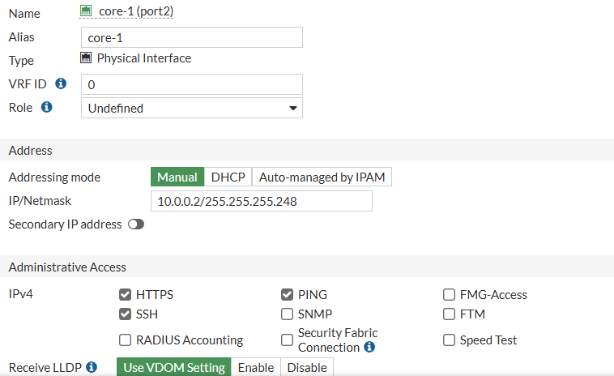
4. **Configure Port3 (Internal - to SWCore-2):**
   * **Interface Name:** Port3 (or Internal_Core2)
   * **Role:** LAN
   * **Addressing Mode:** Manual
   * **IP/Netmask:** 10.0.0.10/29
   * **Administrative Access:** Enable HTTPS, PING, SSH.
   * **DHCP Server:** Disable
   * Click OK.  
     [Screenshot of FortiGate Port3 Interface Configuration]  
     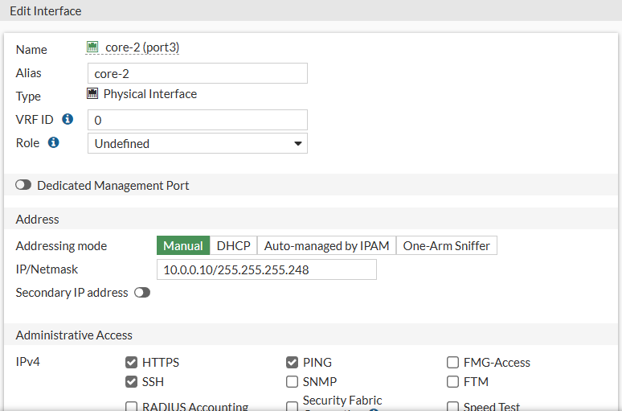
5. **Configure Port4 (External - to Router):**
   * **Interface Name:** Port4 (or WAN_Router_Link)
   * **Role:** WAN
   * **Addressing Mode:** Manual
   * **IP/Netmask:** 10.0.0.17/29
   * **Administrative Access:** Enable PING.
   * **DHCP Server:** Disable
   * Click OK.  
     [Screenshot of FortiGate Port4 Interface Configuration]  
     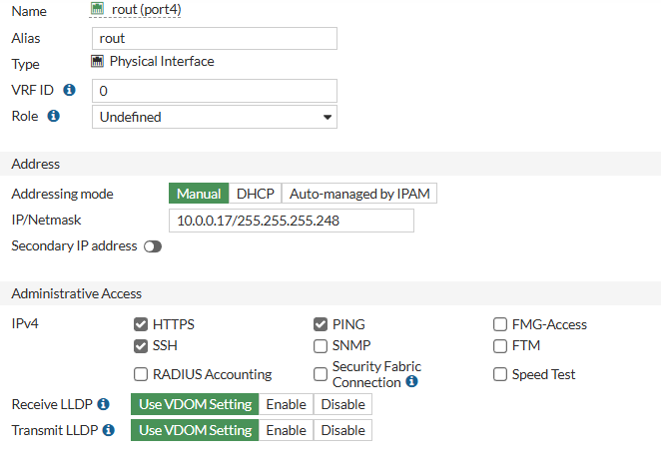

On Cisco Core Switches and Router (CLI):

These configurations were applied in the previous planning phase. Ensure they are correctly implemented.

* **On SWCore-1 (Router ID: 1.1.1.1):**  
  configure terminal  
  interface Ethernet3/0  
   description Link to FortiGate Port2  
   no switchport  
   ip address 10.0.0.1 255.255.255.248  
   ip ospf network point-to-point  
   no shutdown  
  exit  
  router ospf 1  
   network 10.0.0.0 0.0.0.7 area 0  
   default-information originate always  
  exit  
  end  
  write memory  
    
  [Screenshot of SWCore-1 CLI configuration for Ethernet3/0 and OSPF]  
  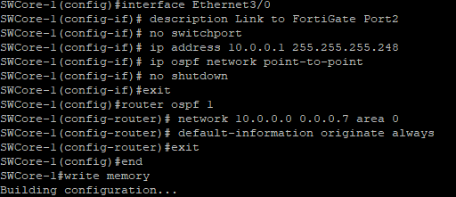
* **On SWCore-2 (Router ID: 2.2.2.2):**  
  configure terminal  
  interface Ethernet3/0  
   description Link to FortiGate Port3  
   no switchport  
   ip address 10.0.0.9 255.255.255.248  
   ip ospf network point-to-point  
   no shutdown  
  exit  
  router ospf 1  
   network 10.0.0.8 0.0.0.7 area 0  
   default-information originate always  
  exit  
  end  
  write memory  
    
  [Screenshot of SWCore-2 CLI configuration for Ethernet3/0 and OSPF]  
  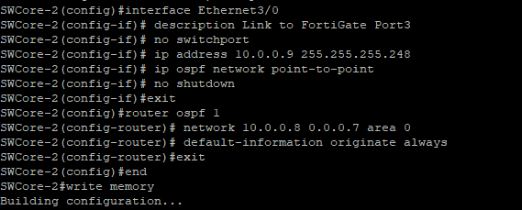
* **On the Router (Router ID: 3.3.3.3):**  
  configure terminal  
  no ip nat inside source list 1 interface Ethernet0/2 overload  
  no access-list 1  
    
  interface Ethernet0/0  
   description Link to FortiGate Port4  
   ip address 10.0.0.18 255.255.255.248  
   ip ospf network point-to-point  
   no shutdown  
  exit  
  router ospf 1  
   no network 192.168.0.0 0.0.63.255 area 0  
   no network 192.168.128.0 0.0.31.255 area 0  
   no network 192.168.160.0 0.0.0.255 area 0  
   network 10.0.0.16 0.0.0.7 area 0  
   default-information originate always  
   passive-interface Ethernet0/2  
  exit  
  end  
  write memory  
    
  [Screenshot of Router CLI configuration for GigabitEthernet0/0 and OSPF, and NAT removal]  
  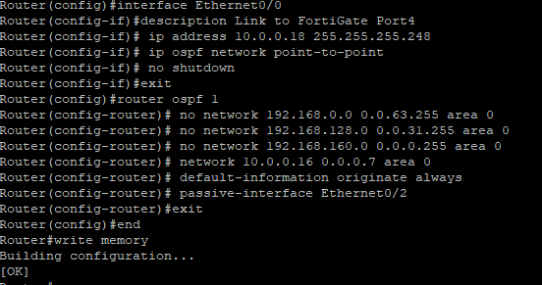

### **4.2 Routing Configuration (Static Routing Focus)**

Given the challenges in establishing OSPF adjacency, static routing was implemented as a robust alternative to ensure connectivity for the project demonstration. This section details the static routing configuration on the FortiGate and the Cisco devices.

**On FortiGate (GUI):**

1. Navigate to **Network > Static Routes**.
2. **Default Route (to Internet via Router):**
   * Click Create New.
   * **Destination:** 0.0.0.0/0
   * **Device:** Port4 (WAN_Router_Link)
   * **Gateway:** 10.0.0.18
   * Click OK.  
     [Screenshot of FortiGate Default Static Route]  
     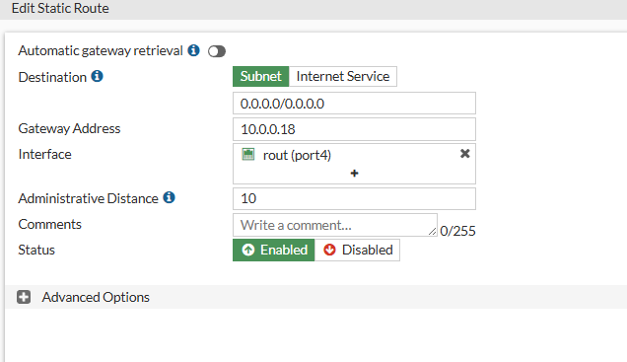
3. **Route to Internal Networks (via SWCore-1):**
   * Click Create New.
   * **Destination:** 192.168.0.0/16 (This supernet covers all internal VLANs: 192.168.10.0, 192.168.20.0, ..., 192.168.160.0)
   * **Device:** Port2 (Internal_Core1)
   * **Gateway:** 10.0.0.1
   * Click OK.  
     [Screenshot of FortiGate Static Route to Internal Networks]  
     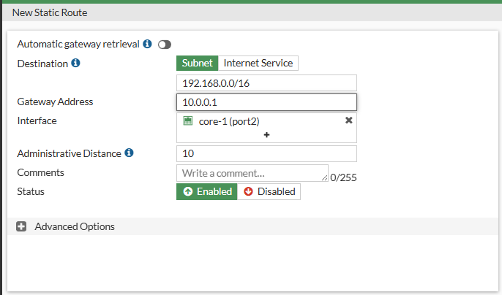

**On Cisco Core Switches and Router (CLI):**

* **On SWCore-1:**  
  configure terminal  
  no router ospf 1  
  ip route 0.0.0.0 0.0.0.0 10.0.0.2 # Default route to FortiGate Port2  
  end  
  write memory  
    
  [Screenshot of SWCore-1 CLI Static Route]  
  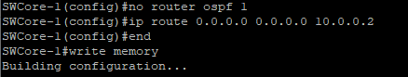
* **On SWCore-2:**  
  configure terminal  
  no router ospf 1  
  ip route 0.0.0.0 0.0.0.0 10.0.0.10 # Default route to FortiGate Port3  
  end  
  write memory  
    
  [Screenshot of SWCore-2 CLI Static Route]  
  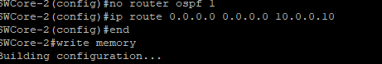
* **On the Router:**  
  configure terminal  
  no router ospf 1  
  ip route 192.168.0.0 255.255.0.0 10.0.0.17 # Route to internal networks via FortiGate Port4  
  end  
  write memory  
    
  [Screenshot of Router CLI Static Route]  
  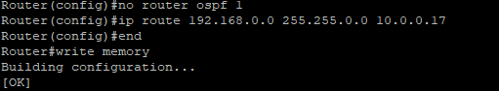

### **4.3 Firewall Policy Configuration**

Firewall policies are the core of FortiGate's security enforcement. They define which traffic is allowed or denied based on source, destination, service, and other criteria.

**On FortiGate (GUI):**

1. Navigate to **Policy & Objects > Firewall Policy**.
2. **Policy to Allow Management Access to FortiGate:**
   * Click Create New.
   * **Name:** Allow_Mgmt_to_FortiGate
   * **Incoming Interface:** Port2, Port3 (or create an Interface Zone for internal interfaces)
   * **Outgoing Interface:** Port2, Port3 (select the same interfaces as incoming, as traffic is destined for the firewall itself)
   * **Source:** all (or specific management subnets, e.g., 192.168.10.0/24)
   * **Destination:** This Firewall
   * **Service:** PING, HTTPS, SSH (and any other management protocols needed)
   * **Action:** ACCEPT
   * **NAT:** Disable
   * Click OK.
   * Note: Ensure this policy is placed at the top of the policy list to be evaluated first.  
     [Screenshot of FortiGate Management Access Policy]  
     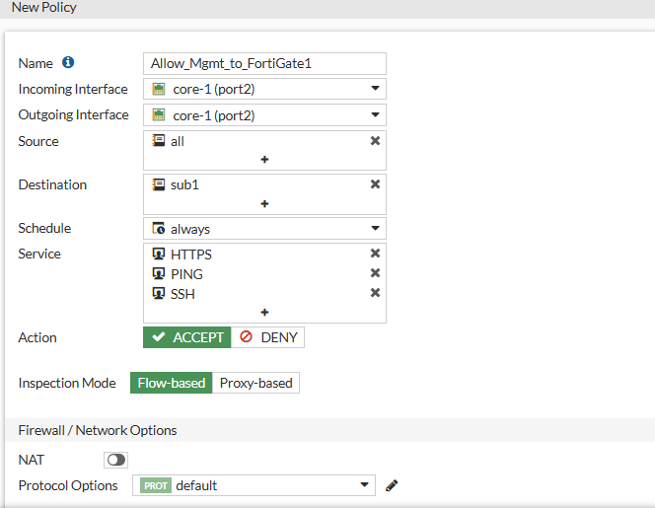  
     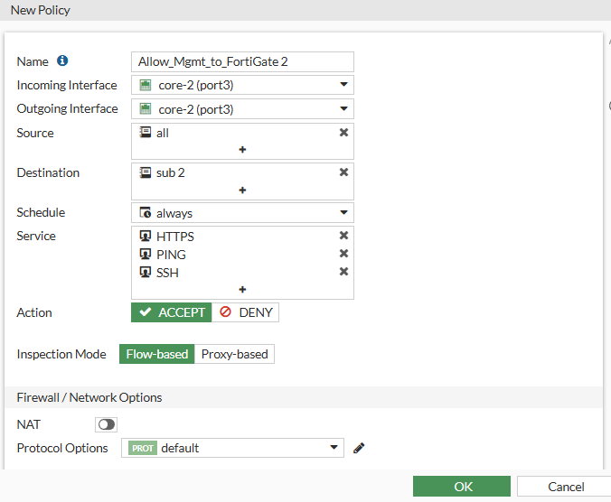
3. **Policy to Allow Internal Networks to Access Internet:**
   * Click Create New.
   * **Name:** Internal_to_WAN_Access
   * **Incoming Interface:** Port2, Port3 (or Interface Zone for internal interfaces)
   * **Outgoing Interface:** Port4 (WAN_Router_Link)
   * **Source:** all (or create Address Objects for your internal VLAN subnets, e.g., 192.168.10.0/24, 192.168.20.0/24, etc., and group them)
   * **Destination:** all
   * **Service:** HTTP, HTTPS, DNS, NTP, etc. (or ALL for broad access, then refine later)
   * **Action:** ACCEPT
   * **NAT:** Enable (select "Use Outgoing Interface Address")
   * Click OK.  
     [Screenshot of FortiGate Internal to WAN Access Policy]  
     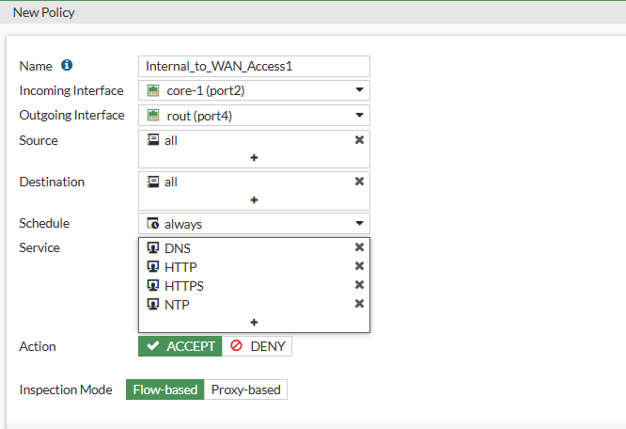  
     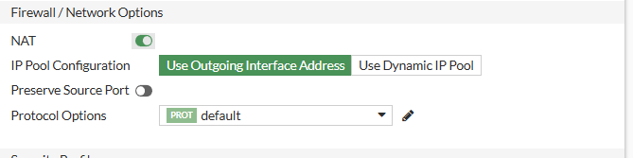

### **4.4 Network Address Translation (NAT) Configuration**

NAT is essential for allowing multiple devices on the private internal network to share a single public IP address when accessing the internet. In FortiGate, Source NAT (SNAT) is typically configured as part of the firewall policy.

On FortiGate (GUI):

As shown in the "Internal to WAN Access" policy above, Source NAT is enabled by selecting NAT and choosing Use Outgoing Interface Address. This automatically translates the private source IP addresses of internal devices to the IP address of FortiGate's Port4 (10.0.0.17) when traffic exits towards the Router.

* **Verification of NAT Settings:**
  + Navigate to **Policy & Objects > Firewall Policy**.
  + Edit the Internal_to_WAN_Access policy.
  + Under the NAT section, ensure Enable is checked and Use Outgoing Interface Address is selected.  
    [Screenshot of FortiGate NAT Configuration within Policy]  
    

On the Router (CLI):

The NAT configuration was removed from the Router in Section 4.1. This ensures that only the FortiGate performs NAT for internal traffic.

no ip nat inside source list 1 interface Ethernet0/2 overload  
no access-list 1

## **6.5: Testing, Verification, and Security Enhancements**

This chapter focuses on validating the FortiGate integration, ensuring proper connectivity, routing, and firewall policy enforcement.

### **5.1 Connectivity and Routing Verification**

After configuring the interfaces and static routes, it's crucial to verify end-to-end connectivity.

* **Ping from FortiGate CLI:**
  + execute ping 10.0.0.1 (SWCore-1)
  + execute ping 10.0.0.9 (SWCore-2)
  + execute ping 10.0.0.18 (Router)
  + execute ping 8.8.8.8 (External Internet DNS server)
* **Ping from Internal PC to Internet:**
  + From a PC in VLAN 10 (e.g., 192.168.10.X), ping 8.8.8.8.
* **Traceroute from Internal PC to Internet:**
  + From a PC in VLAN 10, traceroute 8.8.8.8.
  + **Expected Path:** 192.168.10.254 (HSRP Gateway) -> 10.0.0.1 (SWCore-1) or 10.0.0.9 (SWCore-2) -> 10.0.0.2 (FortiGate Port2) or 10.0.0.10 (FortiGate Port3) -> 10.0.0.17 (FortiGate Port4) -> 10.0.0.18 (Router) -> Internet.
* **Verify Routing Tables (Cisco CLI):**
  + **On SWCore-1/SWCore-2:** show ip route (Verify 0.0.0.0/0 points to FortiGate).
  + **On Router:** show ip route (Verify 192.168.0.0/16 points to FortiGate).
* **Verify Routing Table (FortiGate CLI):**
  + get router info routing-table all (Verify all internal subnets are reachable via Core Switches and default route via Router).

### **5.2 Firewall Policy Enforcement Testing**

Test the firewall policies to ensure they are correctly blocking or allowing traffic.

* **Test Allowed Traffic:**
  + From an internal PC, try browsing a website (e.g., google.com). This should be allowed by the Internal_to_WAN_Access policy.
* **Test Blocked Traffic (Implicit Deny):**
  + If no specific policy is created to allow, for example, inbound SSH from the internet to an internal server, attempt this connection. It should be blocked by the implicit deny policy.
* **Test Specific Blocking (Optional):**
  + Create a temporary policy to explicitly deny PING from an internal subnet to all destinations.
  + Test ping from that subnet. It should fail.
  + Review FortiGate logs to see the denied traffic.

### **5.3 Basic Security Features Implementation**

Beyond basic firewalling, FortiGate's NGFW capabilities offer advanced security. This section demonstrates a basic implementation of a key NGFW feature.

* **Application Control (Example):**
  + Navigate to **Security Profiles > Application Control**.
  + Create a new profile or edit an existing one.
  + Add a category (e.g., "Social.Networking") or specific application (e.g., "Facebook") and set its action to Block.
  + Apply this Application Control profile to the Internal_to_WAN_Access firewall policy.
  + From an internal PC, try to access the blocked application/category. It should be blocked.
  + Verify the blocked traffic in **Log & Report > Application Control**.

### **5.4 Challenges Encountered and Solutions**

During the integration process, several challenges were faced, which provided valuable learning experiences.

* **Challenge 1: OSPF Adjacency Failure:**
  + **Problem:** Initial attempts to establish OSPF adjacency between FortiGate and Cisco devices failed, despite correct IP configurations and point-to-point network types. Debugging revealed that FortiGate was not sending/receiving OSPF Hello packets on some interfaces, possibly due to underlying physical layer issues or initial GUI configuration glitches.
  + **Solution:** After extensive troubleshooting of physical connections and interface status, and ensuring FortiGate interfaces were correctly configured and saved, a decision was made to temporarily switch to **Static Routing** for the project's core demonstration. This allowed progress on firewall policies and NAT while deferring deeper OSPF debugging.
* **Challenge 2: FortiGate Interface IP Resetting to 0.0.0.0:**
  + **Problem:** The IP address configured on a FortiGate interface (e.g., Port4) would sometimes revert to 0.0.0.0 after applying changes via the GUI.
  + **Solution:** This was resolved by ensuring all OK and Apply buttons were clicked sequentially, and in some cases, by configuring the interface directly via the FortiGate CLI, which provided a more reliable way to persist the configuration.
* **Challenge 3: Ping Failure despite Up/Up Interfaces:**
  + **Problem:** Even with interfaces showing up/up on both FortiGate and Cisco devices, ping tests between certain directly connected interfaces (e.g., FortiGate Port3 to SWCore-2) were failing.
  + **Solution:** This pointed to a physical layer issue. Thorough inspection of cabling, trying different cables, and verifying duplex/speed settings on both ends of the connection were crucial. Ensuring auto-negotiation was consistent or manually setting matching duplex/speed resolved these intermittent connectivity problems.

### **5.5 Logging and Monitoring**

FortiGate provides extensive logging and monitoring capabilities, which are essential for security analysis, troubleshooting, and compliance.

* **Log Viewer:**
  + Navigate to **Log & Report > Forward Traffic**.
  + Review the logs to see allowed and denied sessions, source/destination IPs, services, and policies hit.
* **System Events:**
  + Navigate to **Log & Report > System Events**.
  + Monitor system-level events, such as configuration changes, interface status, and daemon restarts.

## **6.6: Conclusion and Future Work**

### **6.1 Project Summary and Achievements**

This graduation project successfully demonstrated the integration of a FortiGate Next-Generation Firewall into a complex hierarchical network infrastructure. Key achievements include:

* **Strategic Deployment:** The FortiGate was strategically placed between the Core layer and the Internet Router, acting as a central security enforcement point.
* **Network Integration:** Interfaces were configured with appropriate IP addresses and roles, and static routing was successfully implemented across the FortiGate, Core Switches, and Router to ensure full network connectivity.
* **Security Policy Implementation:** Essential firewall policies were created to control traffic flow, including allowing internal-to-WAN access with NAT, and enabling management access to the firewall itself.
* **NAT Functionality:** The FortiGate successfully took over NAT responsibilities from the router, providing secure outbound internet access for internal networks.
* **Basic NGFW Feature Demonstration:** A basic Application Control policy was implemented to showcase the advanced capabilities of the FortiGate.
* **Troubleshooting Experience:** The project provided valuable hands-on experience in diagnosing and resolving common network and firewall integration challenges, such as OSPF adjacency issues and physical layer connectivity problems.

### **6.2 Lessons Learned**

The project offered several critical lessons:

* **Importance of Planning:** Detailed IP addressing and cabling plans are crucial for smooth integration.
* **Layered Troubleshooting:** When connectivity issues arise, systematically troubleshooting from Layer 1 (physical) upwards is essential.
* **Firewall Policy Order:** The order of firewall policies is critical; specific ALLOW or DENY rules must be placed before broader rules or the implicit deny.
* **Understanding Firewall Modes:** Choosing the correct FortiGate operating mode (NAT/Route vs. Transparent) is fundamental to successful deployment.
* **Documentation:** Thorough documentation of configurations, IP schemes, and troubleshooting steps is invaluable for complex projects.
* **Dynamic Routing vs. Static Routing:** While static routing simplified initial deployment, the project highlighted the benefits of dynamic routing (like OSPF) for scalability and redundancy in larger networks.

Chapter 7 : Using SIEM solution in network

* 1. introduction to siem

**Security Information and Event Management (SIEM)** emerged in the early to mid-2000s as a response to the growing complexity of IT environments, the rise in cyber threats, and the increasing need for compliance with regulations like PCI-DSS, HIPAA, and GDPR. SIEM is a combination of two earlier technologies: Security Information Management (SIM) and Security Event Management (SEM). It provides a centralized platform that collects, stores, analyzes, and correlates security event data from various sources such as firewalls, servers, databases, and applications. Organizations turned to SIEM solutions because manual analysis of large volumes of log data became unmanageable and ineffective in detecting sophisticated attacks. SIEM addresses several critical problems: it offers real-time threat detection by correlating events across systems, centralizes log management for better visibility, enables forensic investigations by storing historical data, reduces alert fatigue by filtering out false positives, and supports compliance efforts through automated reporting. Modern SIEMs can also integrate with SOAR (Security Orchestration, Automation, and Response) tools to automate incident response actions like isolating infected machines or disabling compromised accounts. Common use cases include detecting brute-force attacks, privilege escalations, insider threats, and malware propagation. Overall, SIEM plays a vital role in enhancing an organization's security posture by providing visibility, intelligence, and control over its security data

**1. Security Information and Event Management (SIEM)**

A SIEM (Security Information and Event Management) system is a critical component of any modern cybersecurity infrastructure. It provides real-time visibility into an organization’s IT environment, enabling the detection, analysis, and response to potential security threats.

**Definition and Purpose**

SIEM combines the functionalities of two legacy security systems:

* **Security Information Management (SIM):** Focuses on collecting, storing, and analyzing log data from across the network.
* **Security Event Management (SEM):** Focuses on real-time monitoring and correlation of events for alert generation.

Together, SIEM provides a centralized platform for:

* Monitoring and analyzing security events
* Conducting incident response
* Meeting regulatory compliance
* Performing forensic investigations

**SIM vs. SEM**

|  |  |  |
| --- | --- | --- |
| **Feature** | **SIM** | **SEM** |
| Focus | Historical log analysis | Real-time event monitoring |
| Use Case | Compliance, auditing | Threat detection, alerting |
| Storage | Long-term | Short-term |
| Tools | Log analyzers, data warehouses | Event correlation engines |

Modern SIEMs integrate both SIM and SEM, offering a unified platform.

**Core SIEM Functions**

1. **Data Collection:** Collects logs and events from diverse sources including firewalls, IDS/IPS, endpoints, servers, and cloud apps.
2. **Aggregation:** Centralizes and consolidates the data.
3. **Parsing:** Breaks down raw data into structured formats.
4. **Normalization:** Unifies data into a common format.
5. **Enrichment:** Adds contextual information like threat intel, geolocation, or asset risk scores.
6. **Correlation:** Connects different events to identify complex attack patterns.
7. **Alerting:** Notifies analysts based on predefined rules or behavioral anomalies.
8. **Dashboards and Visualization:** Enables monitoring through graphical interfaces.
9. **Reporting:** Facilitates compliance and management reporting.
10. **Storage and Retention:** Archives data for long-term compliance and investigation.

**Importance of SIEM in Modern Security**

* **Threat Detection:** Detects sophisticated attacks across large, distributed environments.
* **Compliance:** Helps meet requirements for GDPR, HIPAA, PCI-DSS, etc.
* **Forensics:** Provides detailed logs for root cause analysis.
* **Response:** Enables faster, automated response to threats.

Modern SIEMs integrate with SOAR (Security Orchestration, Automation, and Response) platforms, threat intelligence feeds, UEBA (User and Entity Behavior Analytics), and machine learning to improve detection accuracy and reduce alert fatigue.

## 2. QRadar Overview

IBM QRadar is a next-generation SIEM platform that enables real-time threat detection, incident response, and compliance management. It is designed to consolidate log and flow data from thousands of devices, endpoints, and applications distributed throughout a network. QRadar uses this data to identify, prioritize, and help resolve cybersecurity threats.  
  
Introduction to IBM QRadar  
QRadar is part of IBM’s broader security portfolio. It integrates log management, behavior analytics, vulnerability scanning, and threat intelligence into a centralized system. Unlike traditional SIEMs, QRadar focuses heavily on automation, correlation, and context-aware analysis.  
  
Key benefits of QRadar:  
- Scalable from small businesses to large enterprises  
- Real-time threat detection and response  
- Customizable correlation rules  
- Unified view of security data across the organization  
- Cloud-ready (available as SaaS via IBM Cloud)  
  
QRadar Architecture  
The platform is modular and consists of several key components:  
1. QRadar Console (Magistrate): Web-based UI for central management, search, reports, and configuration  
2. Event Collector: Collects event data (logs) and normalizes/compresses it  
3. Flow Collector: Gathers flow data (NetFlow, sFlow, QFlow) and provides Layer 4–7 visibility  
4. Event/Flow Processor: Stores/correlates normalized data and detects anomalies  
5. Data Nodes: Expand storage and improve search speed  
6. Apps and Extensions: Available via IBM App Exchange  
  
Deployment Models  
QRadar supports:  
- All-in-One Appliance: Combines all functions for SMBs  
- Distributed Deployment: Scales across enterprise nodes  
- Cloud-Based SaaS: Fully managed by IBM, ideal for hybrid environments  
  
Core and Additional Components  
QRadar's extensibility is key to its success. Notable additions include:  
- QRadar Vulnerability Manager (QVM): Performs vulnerability scans and risk prioritization  
- Threat Intelligence Integration: Includes IBM X-Force and third-party feeds  
- Incident Forensics: Tracks and reconstructs attacker actions  
- User Behavior Analytics (UBA): Detects anomalies from internal users  
- Custom Rules Engine (CRE): Enables logic-based threat detection

## 3. Data Collection in QRadar

Data collection forms the foundation of QRadar’s detection and analytics engine. It encompasses log data (Events) and network metadata (Flows), along with vulnerability and threat intelligence inputs.  
  
Event Collection  
QRadar uses Device Support Modules (DSMs) to parse and normalize logs from various sources like:  
- Firewalls, routers, IDS/IPS  
- Operating systems (Windows, Linux)  
- Endpoint and antivirus tools  
- Cloud providers (AWS, Azure, GCP)  
- SaaS apps (Office 365, Salesforce)  
  
Collection Methods:  
- Syslog (TCP/UDP/TLS)  
- REST APIs  
- Log file collectors  
- JDBC (for DB activity)  
  
Normalization uses QID Mapping to ensure consistency across vendors.  
  
Flow Collection  
Flows represent network communications. QRadar gathers this data from:  
- NetFlow, sFlow, J-Flow, IPFIX  
- QFlow (deep packet inspection)  
- VFlow (virtualized networks)  
  
Use Cases:  
- Identify lateral movement  
- Detect exfiltration  
- Spot beaconing from malware  
  
Flows are normalized and correlated with event data for better context.  
  
Vulnerability Scanning  
With QRadar Vulnerability Manager (QVM):  
- Scan hosts for open ports, outdated software, misconfigurations  
- Integrate findings with asset profiles  
- Prioritize vulnerabilities using CVSS scores  
  
Also integrates with tools like:  
- Tenable Nessus  
- Rapid7 Nexpose  
- Qualys  
  
Integration with External Sources  
QRadar enriches analysis by ingesting:  
- Threat Intelligence (STIX/TAXII, IBM X-Force, MISP)  
- Cloud telemetry (GuardDuty, Azure Security Center)  
- SOAR tools for automated response  
  
Data Enrichment Examples:  
- IP geolocation  
- Domain reputation  
- WHOIS lookups  
- User-identity mapping

**4. Event Management**

Event management is central to QRadar’s functionality. Events represent log entries from devices and systems, each potentially containing critical clues about security incidents.

### Event Concepts

Each event in QRadar follows a lifecycle:

* **Collection** from log sources
* **Parsing and Normalization** into a standard format
* **Correlation** with other events and context
* **Alert Generation** (if applicable)

Events are stored as individual “rows” in the QRadar database, enabling detailed search and investigation capabilities.

### Event Properties and Metadata

Key event attributes include:

* **Timestamp:** When the event occurred
* **QID (QRadar Identifier):** Normalized identifier for event type
* **Log Source:** Device or system that generated the event
* **Event Category:** Network, Application, Identity, Access, etc.
* **Severity/Magnitude:** Indicates criticality and risk impact

### Coalescing and Normalization

* **Coalescing:** QRadar can group similar events together to reduce storage and improve performance.
* **Normalization:** Converts varied vendor-specific log formats into standardized fields for correlation.

This enables cross-platform analysis and unified threat detection.

### Practical Event Scenarios

Example:

* A login failure from multiple locations in a short time span may indicate credential stuffing.
* Correlation with other events (e.g., access to sensitive file) can escalate severity.

**5. Network Flows**

### Flow Fundamentals

Flows are representations of network sessions – not full packet captures. QRadar uses these to reconstruct communication patterns and detect abnormal behaviors.

A single flow record includes:

* Source and Destination IPs
* Ports and Protocols
* Bytes Sent/Received
* Duration of Communication

### Types of Flows

1. **Standard Flows:** NetFlow, sFlow, J-Flow
2. **Deep Packet Inspection (DPI) Flows:** QRadar QFlow for Layer 7 visibility
3. **Virtual Flows:** VFlow for cloud and virtual environments

### Flow Processing and Usage

Flows are:

* Correlated with events
* Used to identify silent scans, port sweeps, data exfiltration
* Critical in lateral movement and beaconing detection

### Normalized Fields

QRadar parses and normalizes flow data similarly to event logs. Fields include:

* Application Protocol (e.g., HTTP, DNS)
* Flow Direction
* ASN info (for public IP tracking)

**6. Offenses and Threat Detection**

QRadar automatically generates **offenses** when correlated data meets defined criteria. Offenses are prioritized alerts indicating potential security incidents.

### Understanding Offenses

Offenses are linked to:

* Source and destination IPs
* Associated log and flow data
* Triggered correlation rules
* Historical offenses (to identify recurring threats)

### Offense Creation and Correlation

Correlation rules define what conditions trigger an offense:

* Threshold breaches (e.g., 100 failed logins in 10 minutes)
* Behavior anomalies (e.g., first-time access to critical server)
* Combined conditions (e.g., malware alert + unusual outbound traffic)

### Threat Analysis and Forensics

Analysts can investigate offenses via:

* Linked flows and events
* Timeline views
* Packet capture (QFlow)
* Risk scores and asset value

**7. Rules and Detection Logic**

QRadar allows administrators to define and customize detection logic using rules and building blocks.

### Rule Building Blocks

Building blocks are reusable logic components that define sets of criteria:

* Network segments
* User groups
* Service categories

Used in multiple rules to promote modularity.

### Rule Types

* **CRE Rules (Custom Rules Engine):** Traditional correlation rules
* **Anomaly-Based Rules:** Use baselines to flag deviations
* **Threshold Rules:** Trigger when a numeric threshold is crossed
* **Behavioral Rules:** Detect changes in behavior (e.g., access time, location)

### Rule Actions and Responses

Upon rule match, QRadar can:

* Create an offense
* Add tags or labels
* Send notifications
* Trigger scripts or SOAR playbooks

### Datasets and Logic Flow

QRadar supports dataset definitions from saved searches, which can be referenced in rule logic for advanced detection.

**8. Asset Management in QRadar**

Assets are core to risk-based threat analysis. QRadar maintains a dynamic database of network assets.

### Asset Database and Grouping

QRadar can:

* Discover assets from event and flow data
* Group assets by IP range, business function, location
* Tag critical assets for offense prioritization

### Auto-Discovery and Enrichment

Enrichment sources include:

* Vulnerability scan results
* DHCP and DNS logs
* Flow analysis

Helps in identifying device types, software versions, operating systems.

### Asset Risk Evaluation

Asset context (e.g., known vulnerabilities, business impact) affects:

* Magnitude scoring in offenses
* Prioritization in dashboards
* Filtering and searches

**9. Reporting Capabilities**

QRadar’s reporting module is essential for compliance, audit readiness, and management visibility.

### Report Configuration

* Based on saved searches, charts, and widgets
* Schedule reports for daily, weekly, or monthly delivery
* Filter by time, asset, offense type, log source

### Custom Reports

Users can create:

* Executive summaries
* Technical audits
* Regulatory compliance (e.g., PCI-DSS, HIPAA)

### Data Sources and Outputs

Reports can include:

* Event trends
* Offense distribution
* Network usage
* User behavior

Export options:

* PDF
* CSV
* HTML

**10. Dashboards and Visualization**

Dashboards provide real-time visualization of security posture and activity.

### Default vs. Custom Dashboards

* Default: Include basic system health, offenses, log sources
* Custom: Built using widgets (charts, tables, KPIs)

### KPI Monitoring

Track:

* Offenses by type/severity
* Top attacking IPs
* Failed login attempts
* Flow volume

### Creating and Sharing Dashboards

* Role-based access
* Save and export dashboard layouts
* Share templates among teams

**11. Extended Features in QRadar**

### Threat Intelligence with X-Force

IBM’s X-Force provides curated threat intelligence:

* Malicious IPs, URLs, and file hashes
* Attack patterns and techniques (MITRE ATT&CK mapping)
* Integrated into correlation rules

### SaaS and Cloud Integration

QRadar on Cloud (QRoC):

* Fully managed by IBM
* Scales with demand
* Ideal for hybrid/multi-cloud environments

### App Marketplace

QRadar supports third-party and IBM apps:

* User Behavior Analytics (UBA)
* QRadar Assistant
* Compliance Manager
* Case Management integration

### Incident Forensics and UBA

* Deep dive into network sessions
* Track lateral movement, suspicious users
* UBA highlights outliers in login time, volume, destination

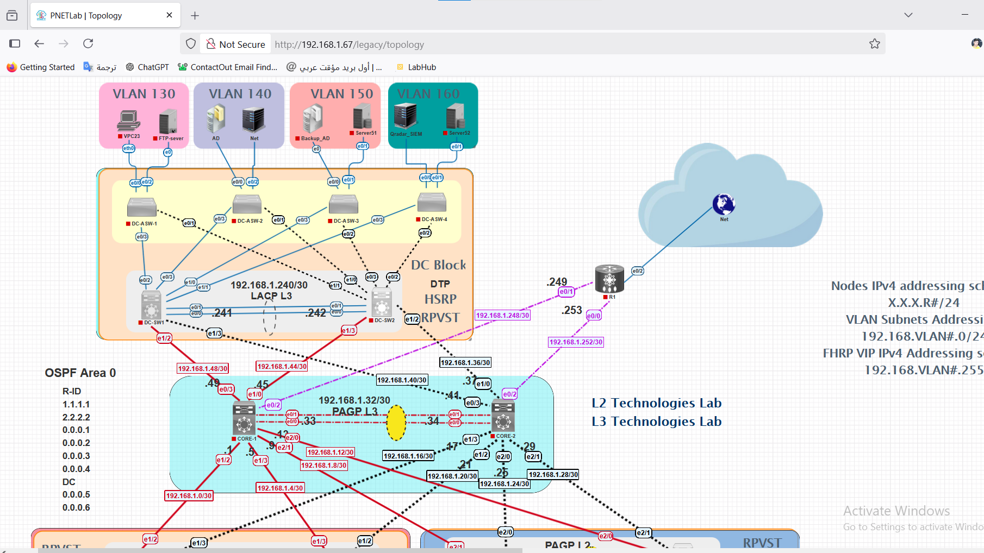

12. Configration of Qradar :

1-Setup Qradar:

Press on .ova and open with vmware

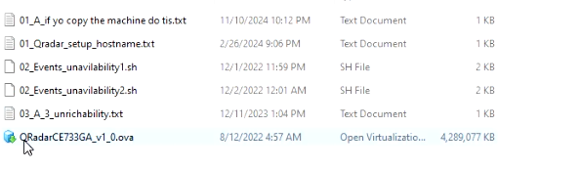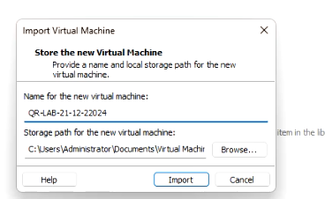

Change ram to 6300

Network bridged

Hard 250G

And power on the vm

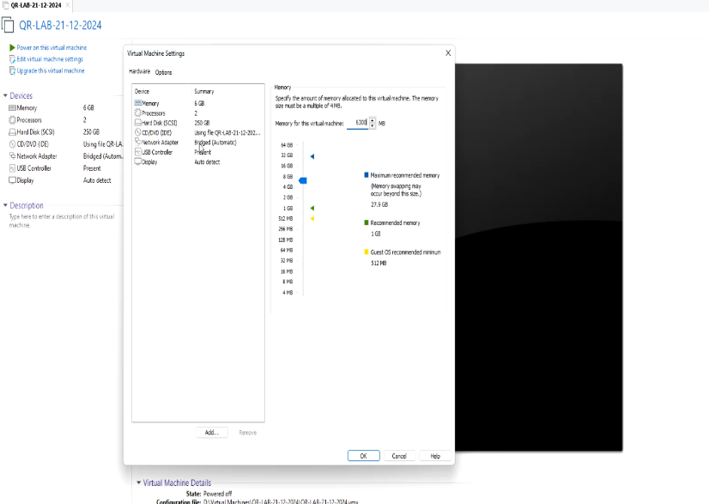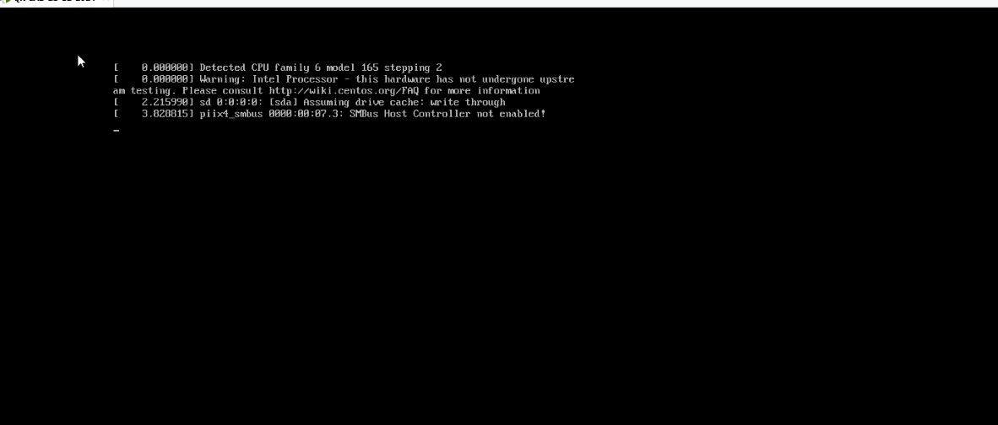

Username root

password press enter

then write new password

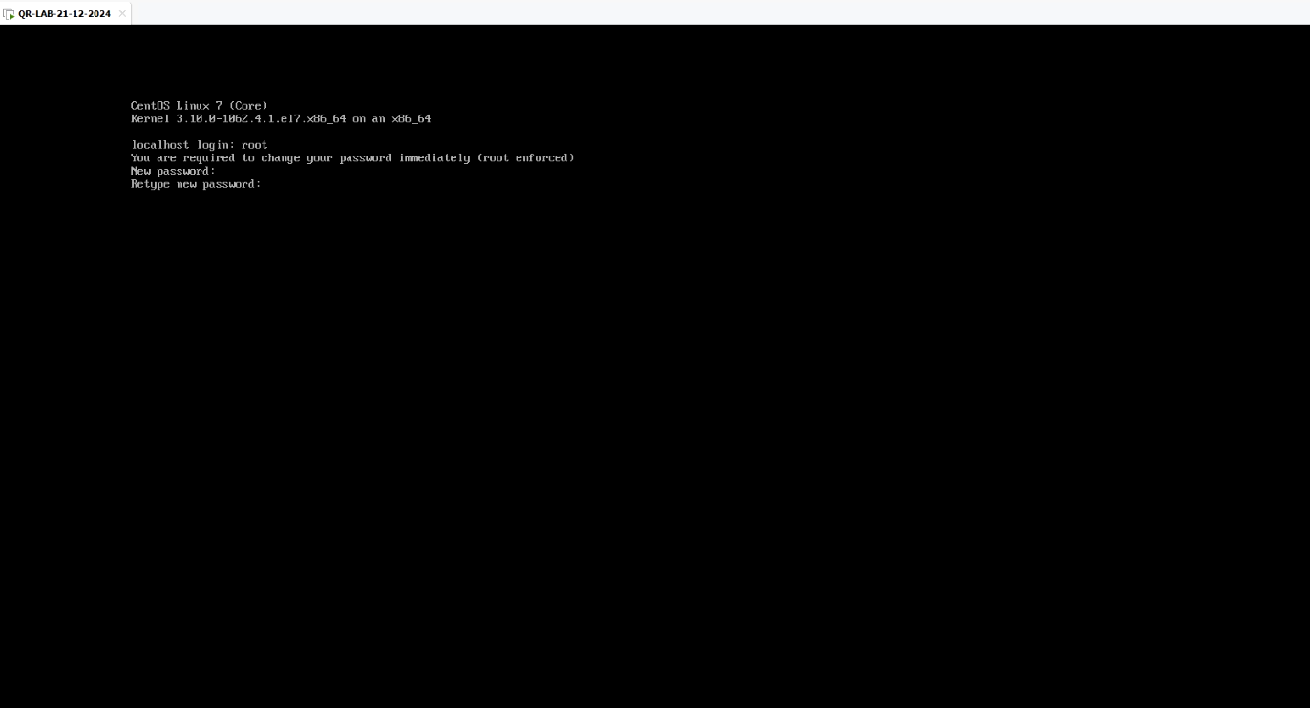

and retype it

Check the hostname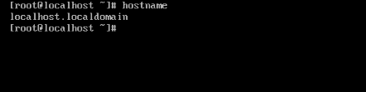

If not localhost.localdomain

Write

# sudo hostnamectl set-hostname qradar.lab

# sudo systemctl restart systemd-hostnamed.service

Now we can setup

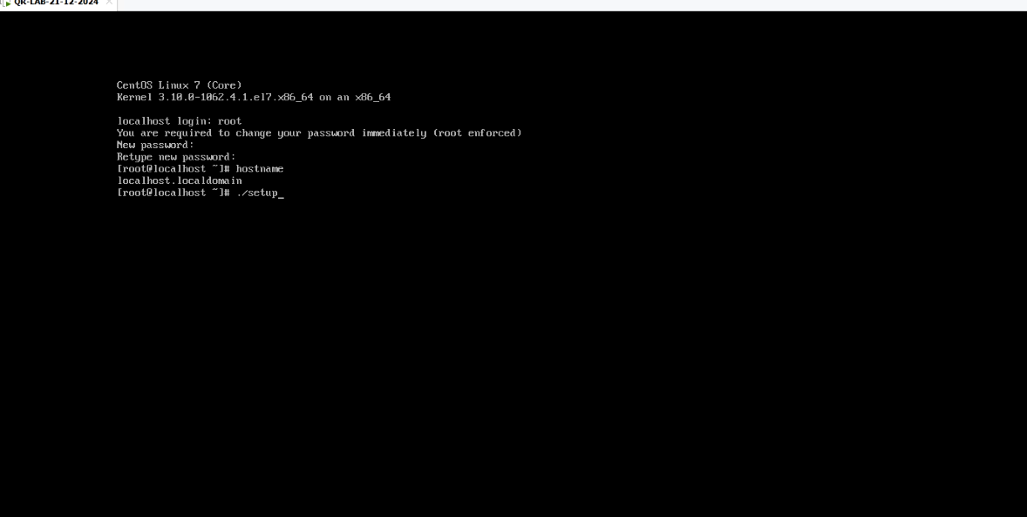

Press enter

Then press enter and hold then q then enter

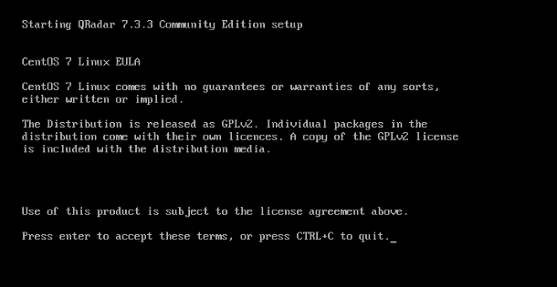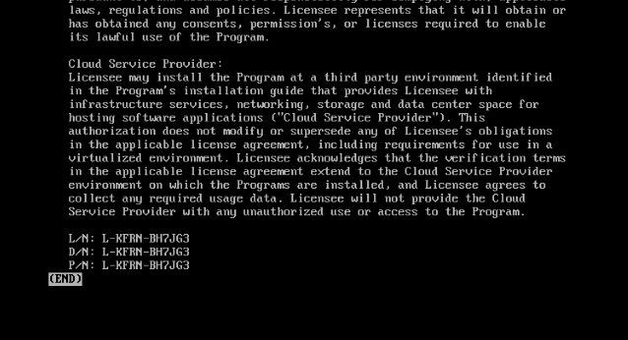

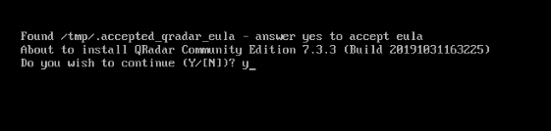

Wait the setup finish

After installation completed write new password for gui

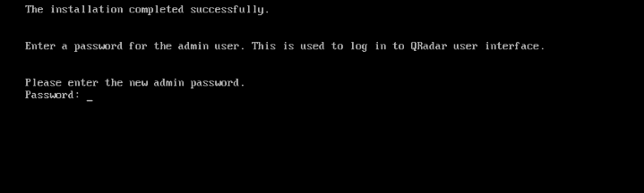

Execute ifconfig to know the ip of ens33

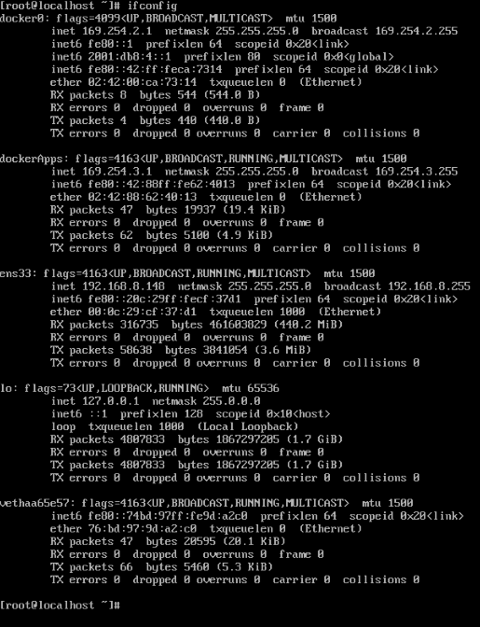

Then go to browser and write the ip

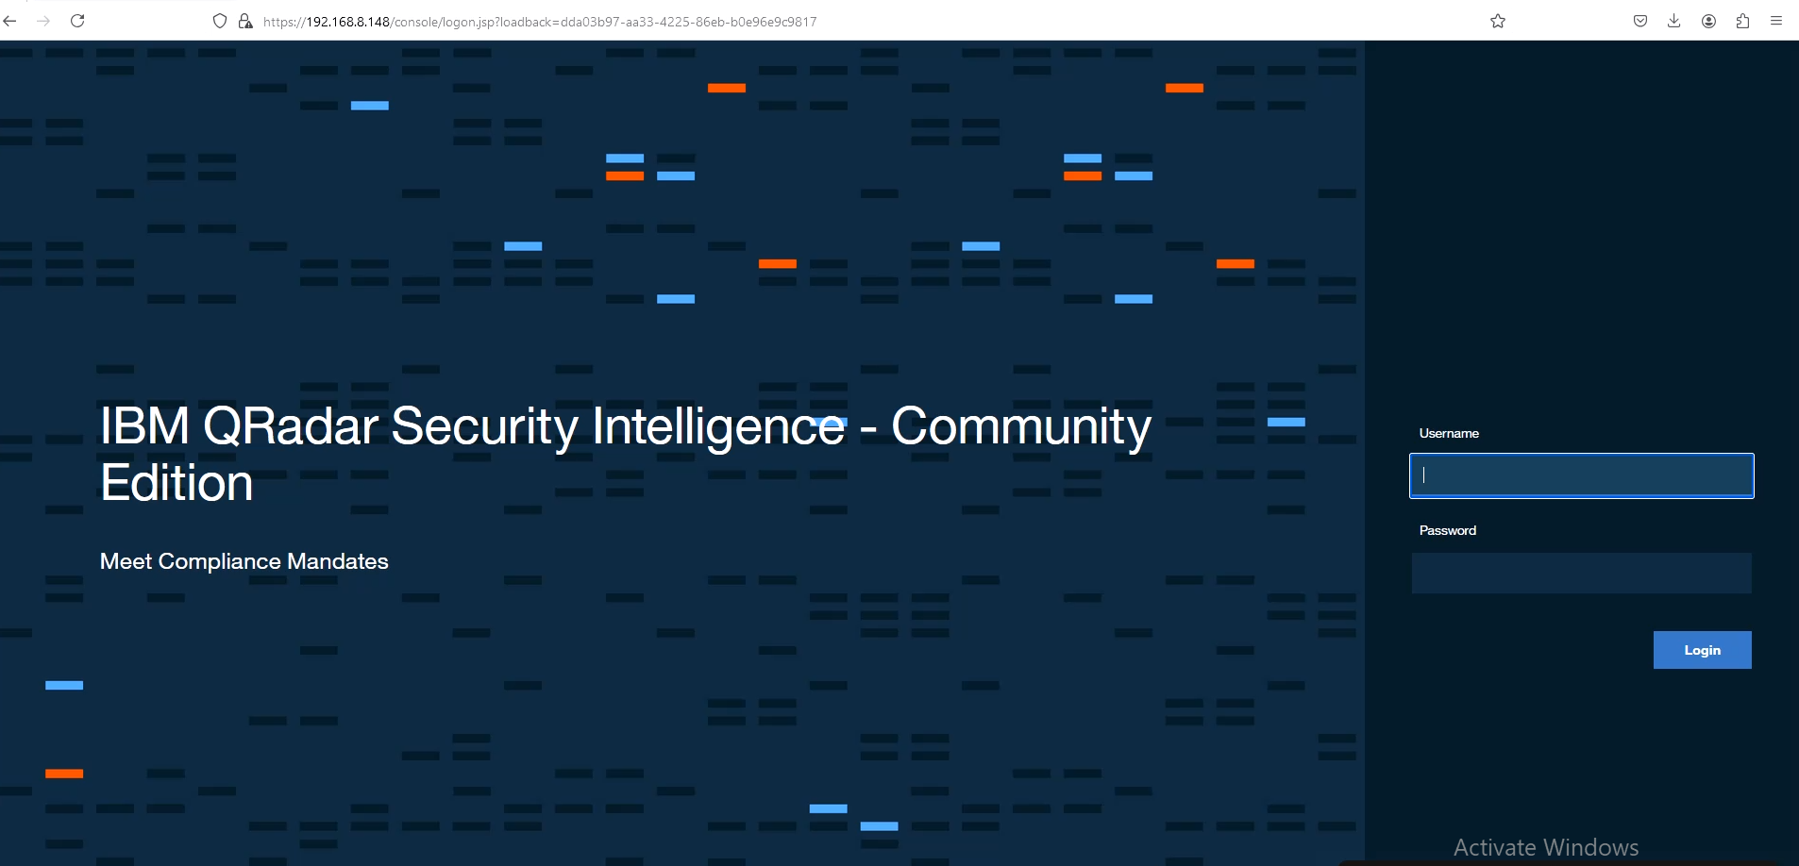

Enter the username admin and password ****

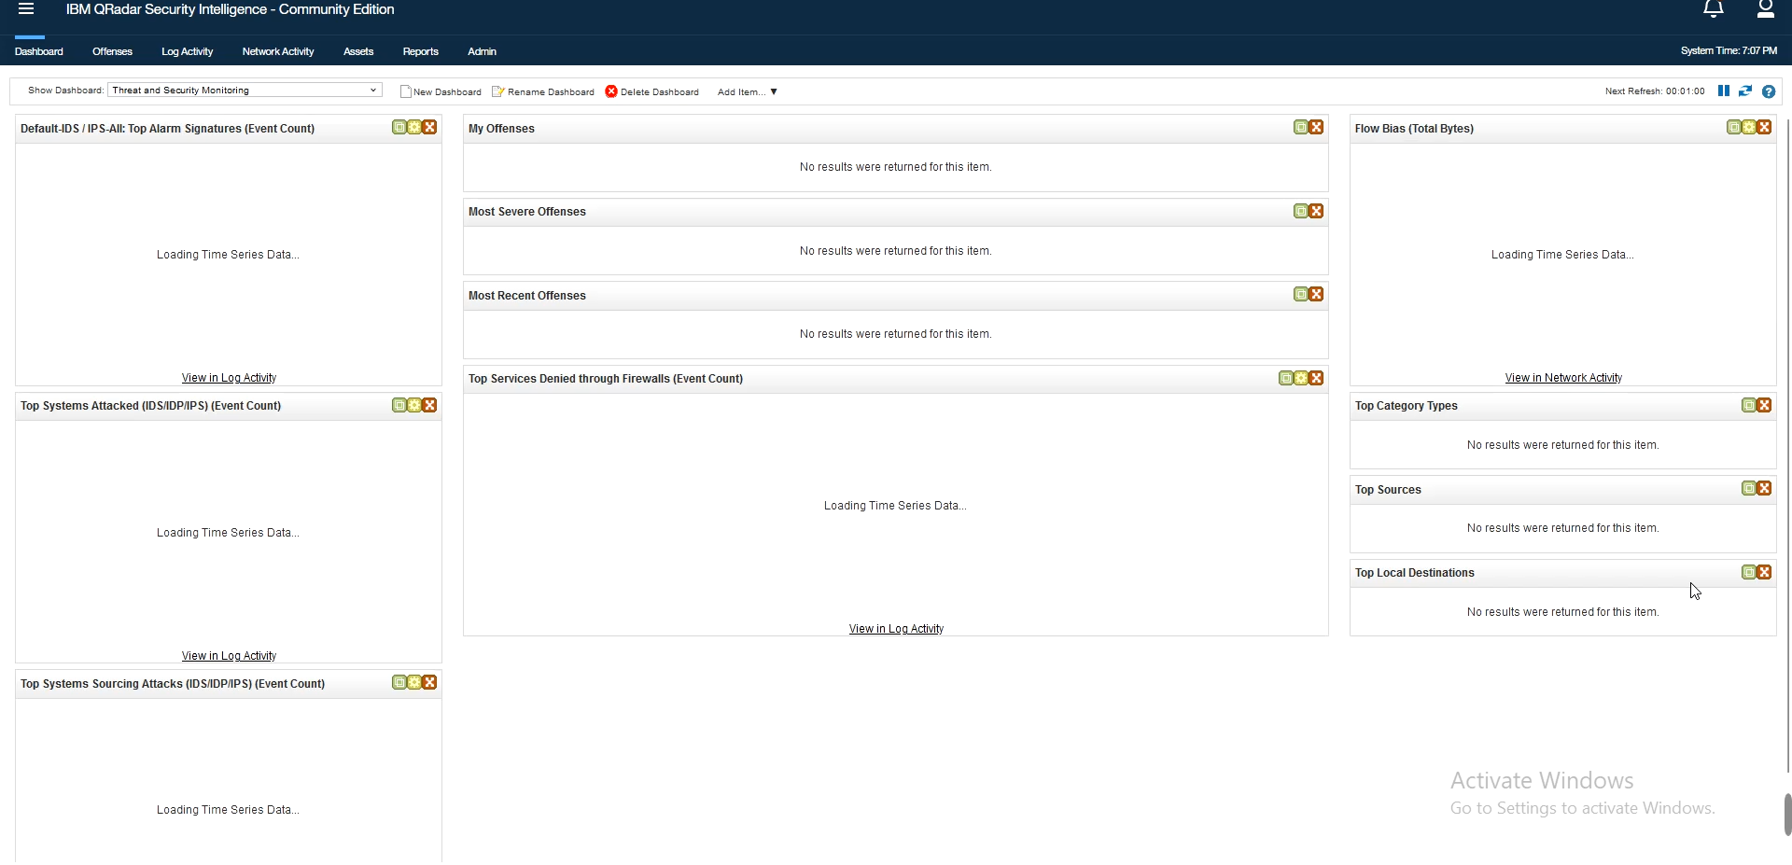

2-integrate windows with qradar using wincollect agent:

*Notes:

#To manage a deployment of WinCollect agents from the QRadar user interface, you must first upgrade your QRadar Console to a supported version of WinCollect by using the WinCollect Agent SFS Bundle. This bundle includes the required protocols to enable communication between QRadar and the managed WinCollect agents on the Windows hosts. Both the QRadar Console and managed WinCollect agents can be upgraded to newer versions of WinCollect by installing the newer version of SFS Bundle on the QRadar console.

# If you reinstall QRadar on your Console, you must delete this file on any existing WinCollect agent installations before WinCollect can function properly: Program Files/IBM/WinCollect/ config/ConfigurationServer.PEM

-------------------------- -----------------------------

*first on qradar:

1. Download the WinCollect Agent SFS Bundle installation file from the IBM website: (<http://www.ibm.com/support>).

2. Use SSH to log in to the QRadar Console as the root user.

3. For initial installations, create the /storetmp and /media/updates directories if they do not exist.Type the following commands:

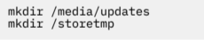

4. Using a program such as WinSCP, copy the downloaded SFS file to /storetmp on your QRadar Console.

5. To change to the /storetmp directory, type the following command: cd /storetmp

6. To mount the SFS file, type the following command: mount -t squashfs -o loop<Installer_file_name.sfs> /media/updates

7. To run the WinCollect installer, type the following command and then follow the prompts: /media/updates/installer



8. Type Y to continue with the update. During the update, the SFS installs new protocol updates. If your Secure Shell (SSH) session is disconnected while the upgrade is in progress, the upgrade continues. When you reopen your SSH session and run the installer again, the patch installation resumes. After the installation is complete, services are restarted, and the user interface is available.

Note: During installation, the following message is displayed:

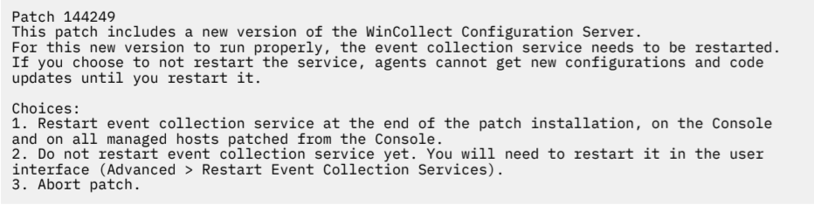

After you choose an option, the patch installation continues. When it is complete, press the Enter key to exit the patch screen.

9. If you selected the second option in step 8, you must perform the following steps:

• In the QRadar admin settings, click Advanced > Deploy Full Configuration.

• In the QRadar admin settings, click Advanced > Restart Event Collection Services.

10. To unmount the SFS file from the Console, type the following command: umount /media/updates

11. Verify that WinCollect agents are configured to accept remote updates:

a) Log in to QRadar.

b) On the navigation menu, click Data Sources.

c) Click the WinCollect icon.

d) Review the Automatic Updates Enabled column and select WinCollect agents that have a False value.

e) Click Enable/Disable Automatic Updates.

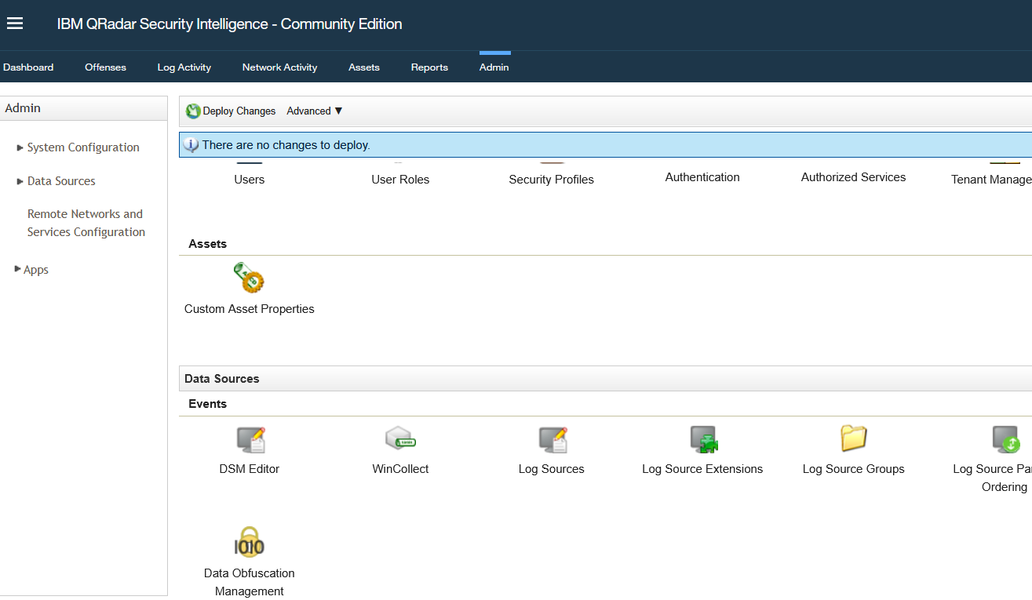

*on Host (AD,Windows)



1. Use the second icon this is the agent that install in host

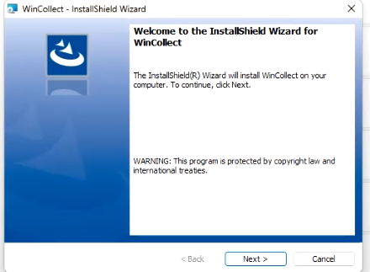

3-

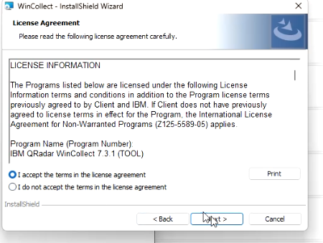

4-next

5-next

6-

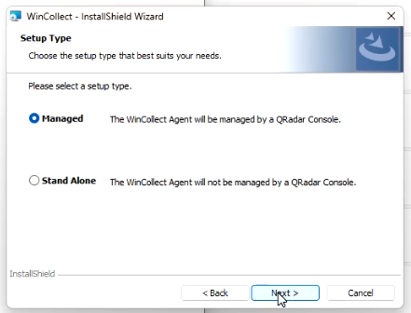

7-

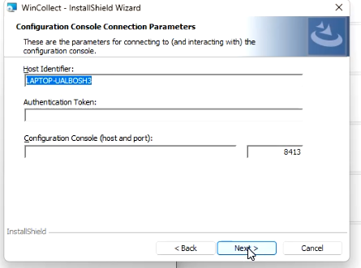

Host identifier 🡪 name of host that have agent

Configuration console 🡪 ip of qradar

Authentication token 🡪 get it from qradar :

*Press in wincollect then go to destination then press Add icon and identifier the host and save

*go to authorized services and add authorized service and name it then press create

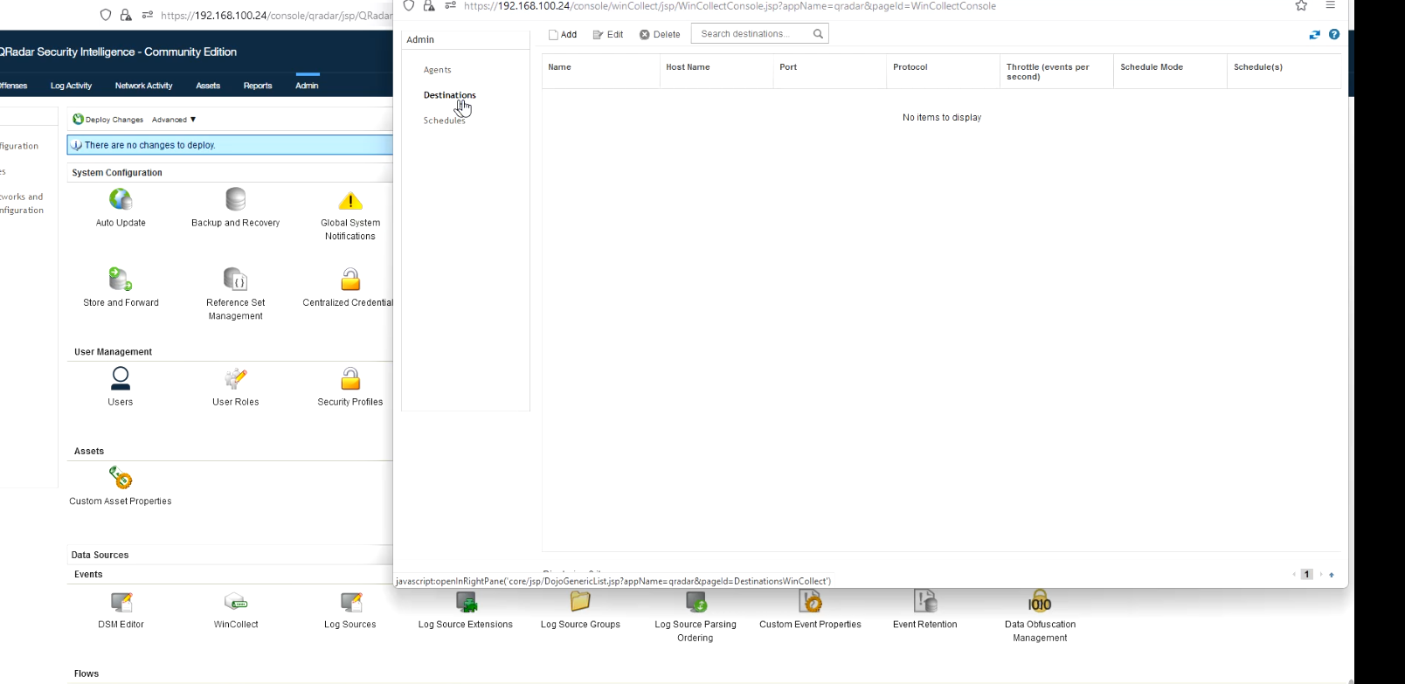

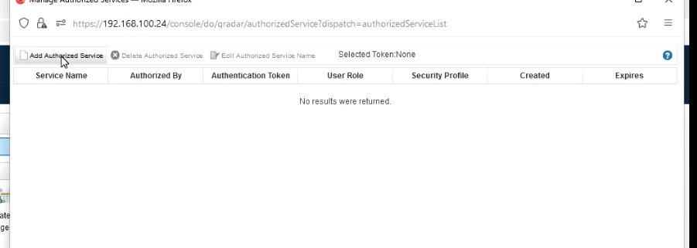

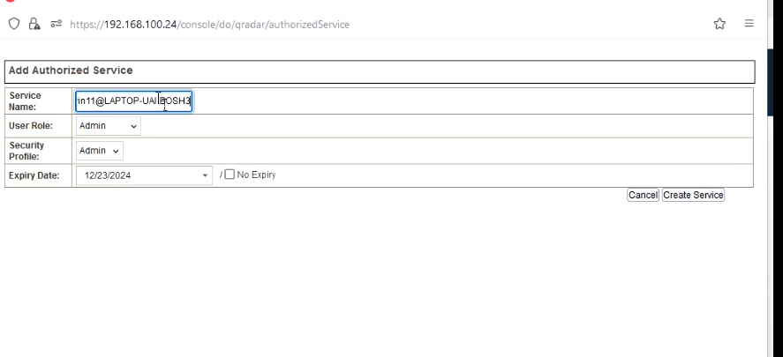

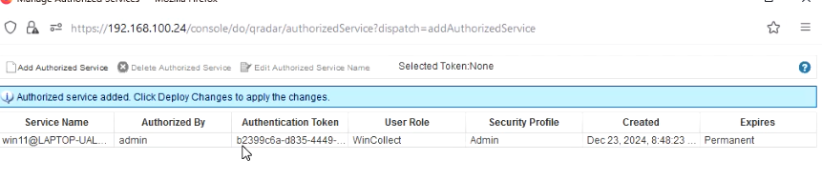

THIS is a token that we will use

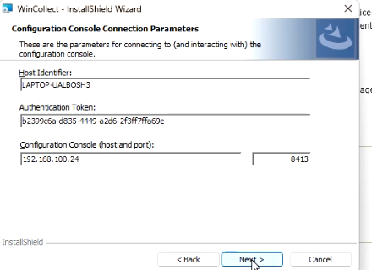 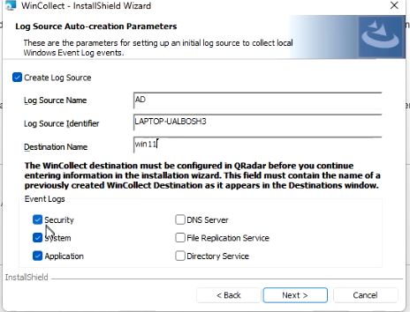

next then finish

* Now if we go to wincollect icon from qradar
* 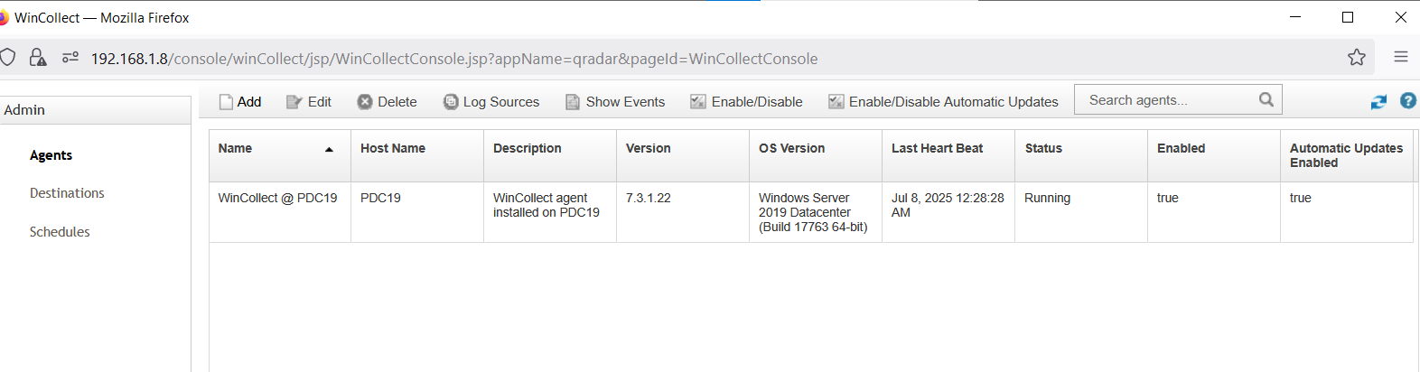
* 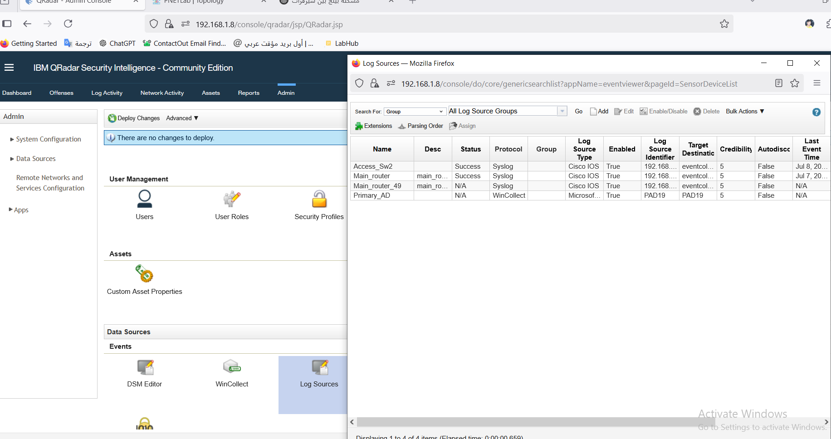

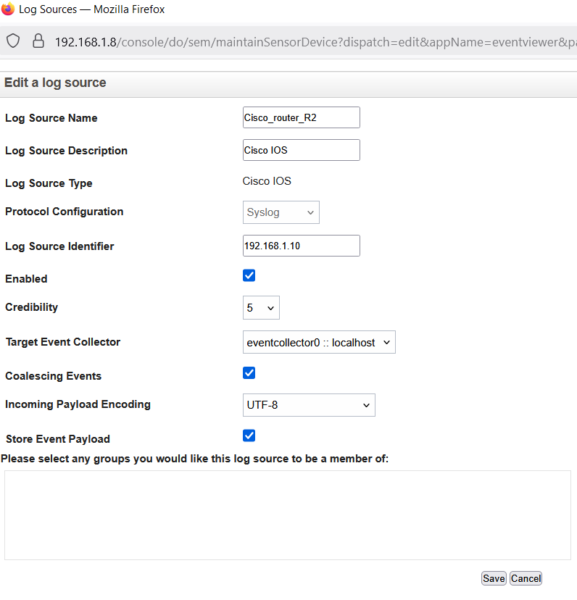

*TO INTEGRATE ROUTER WITH QRADAR

-->LOGS

On router :  
   
 config t  
 logging (ip qradar)  
 logging trap debugging

On qradar :

Add log source from admin tab

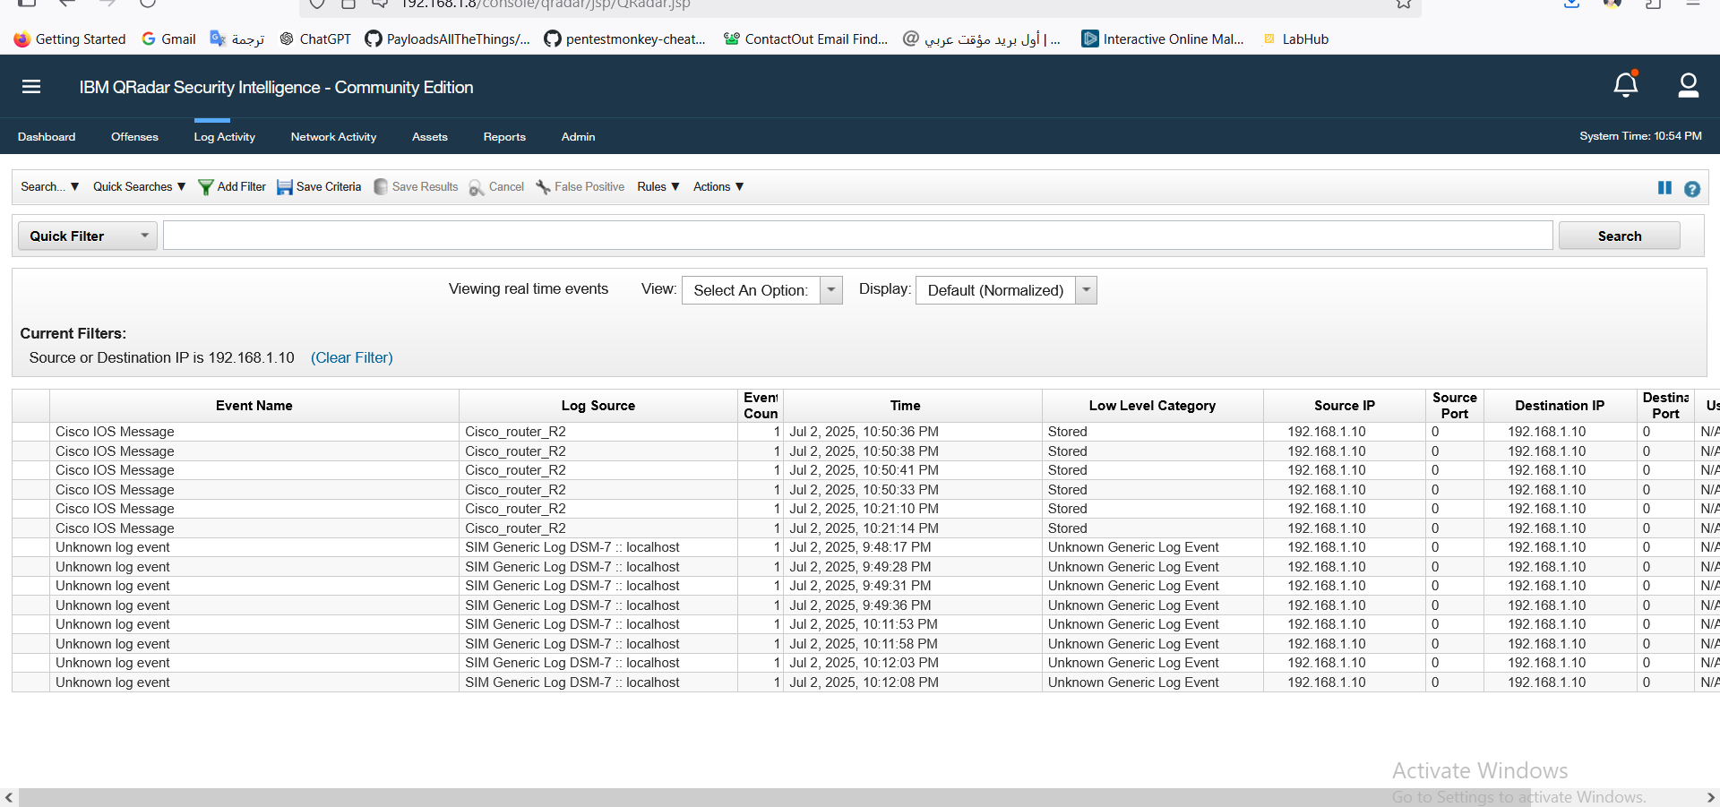

→ NETFLOW

On router :

conf t  
interface Ethernet0/0 ! ← غيّرها بالانترفيس المناسب  
ip flow ingress  
ip flow egress  
exit  
ip flow-export destination 192.168.1.8 2055ip flow-export version 5  
ip flow-export source Ethernet0/0

on Qradar :

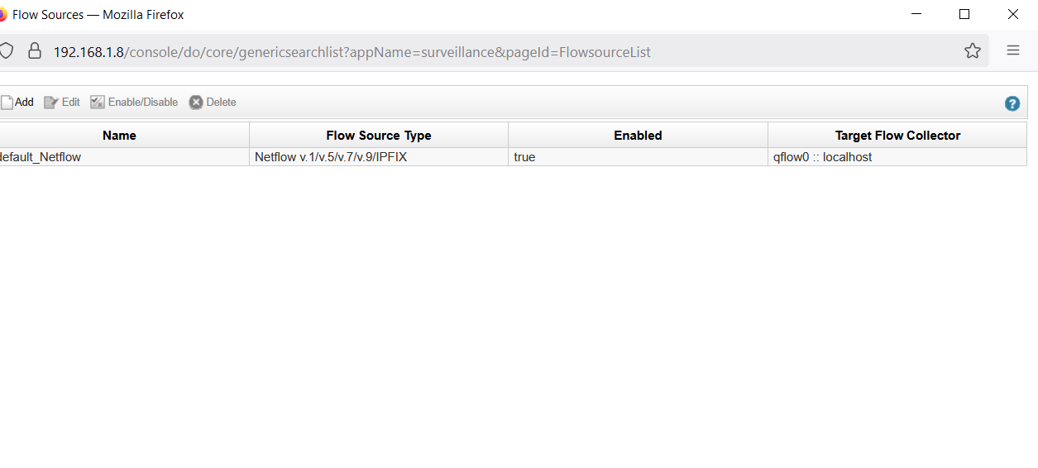 flow source is already created and ready

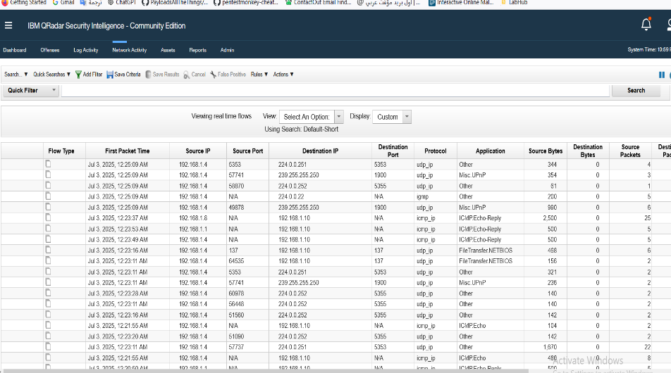

TO INTEGRATE FW WITH QRADAR

*first go on fw gui :

logs&report  
 logs setting  
 turn on send logs to syslog  
 write ip of qradar

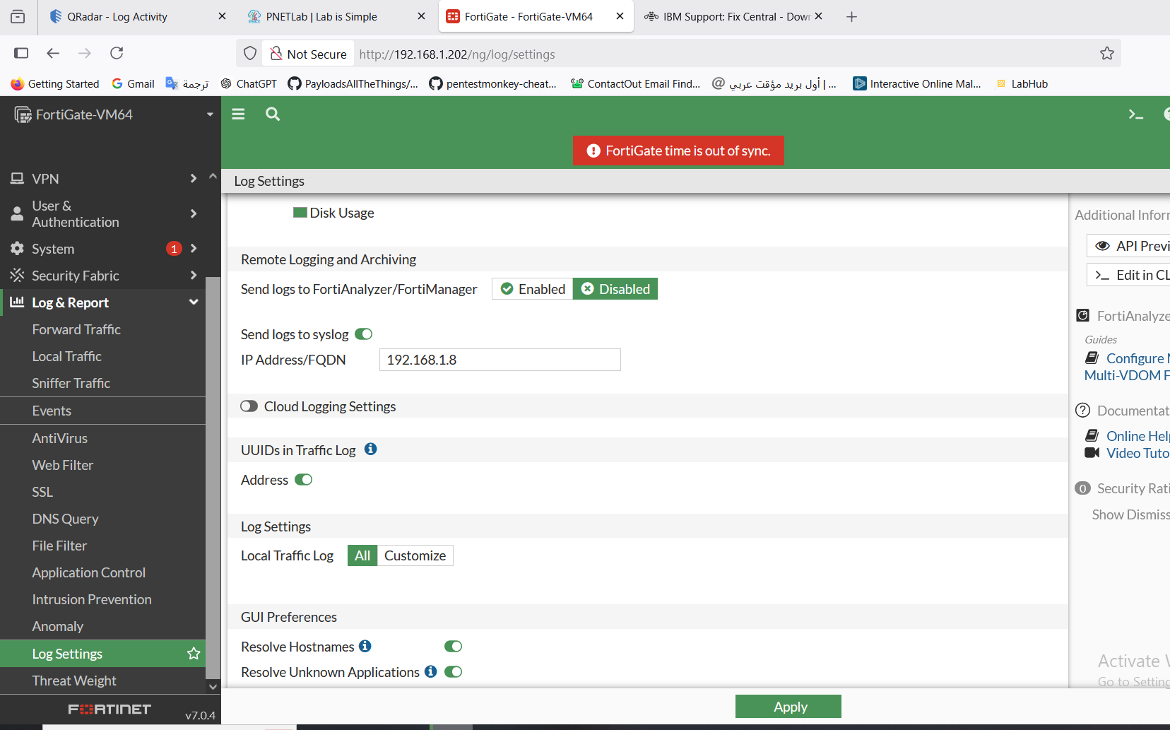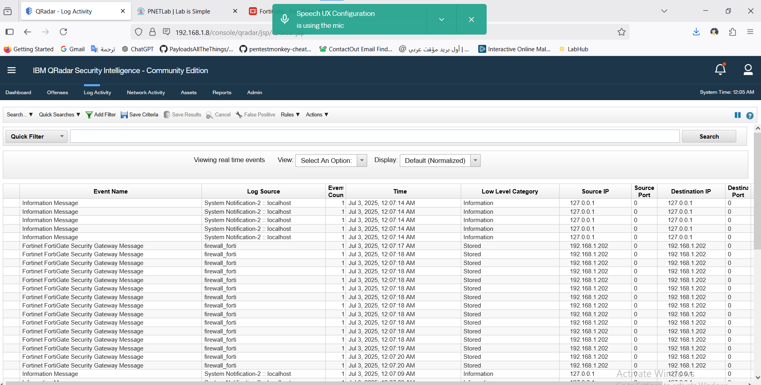

NOTE :When integrate any device with qradar you should install DSM for this device on qradra to known it :

1-go to ibm fix center

2-search in product about qradar siem&select version&os

3-in text field write type of device we need dsm for it

4-and choose it & download

--------------------

5-Then go to WinSCP to transfer dsm to qradar in /stortemp

6-from putty go to the location of dsm we put it (/stortemp)

7-excute🡪yum -y install <DSM NAME>

8-go in gui for qradar to admin tab and deploy change

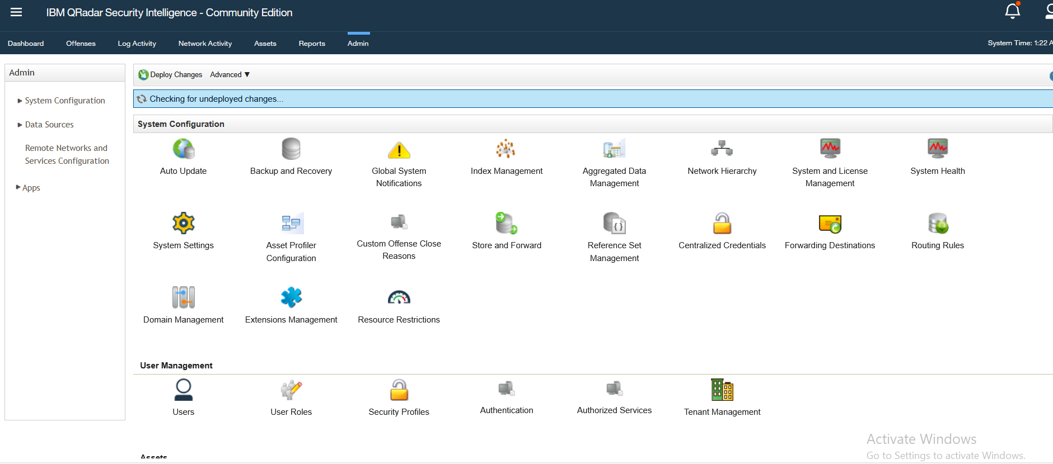

🡪 qradar have a rules built in but you can add a new rule

*from offense tab

*press in rules

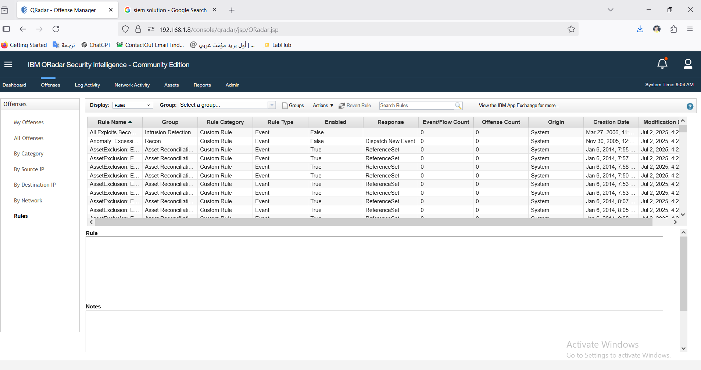

* To add new rule press to the action icon and choose type of rule 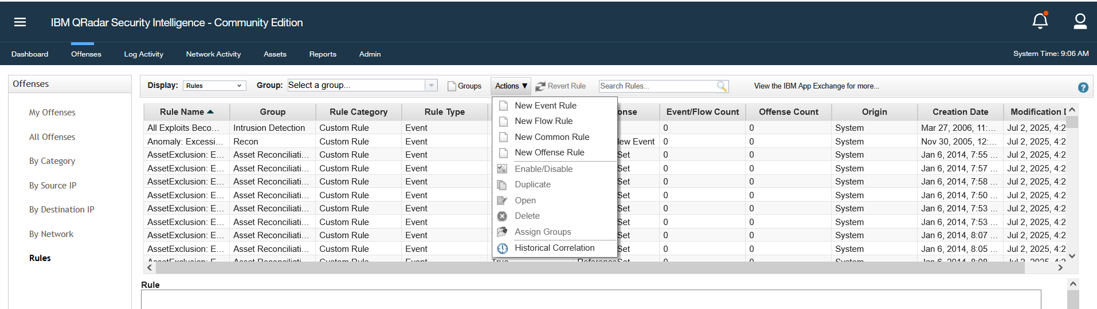
* And then choose what a rule you need and configer it and can select what a group the rule apply on it

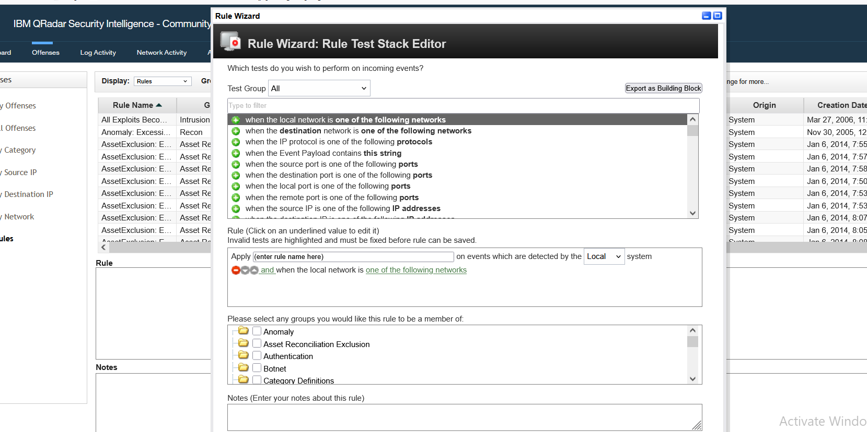

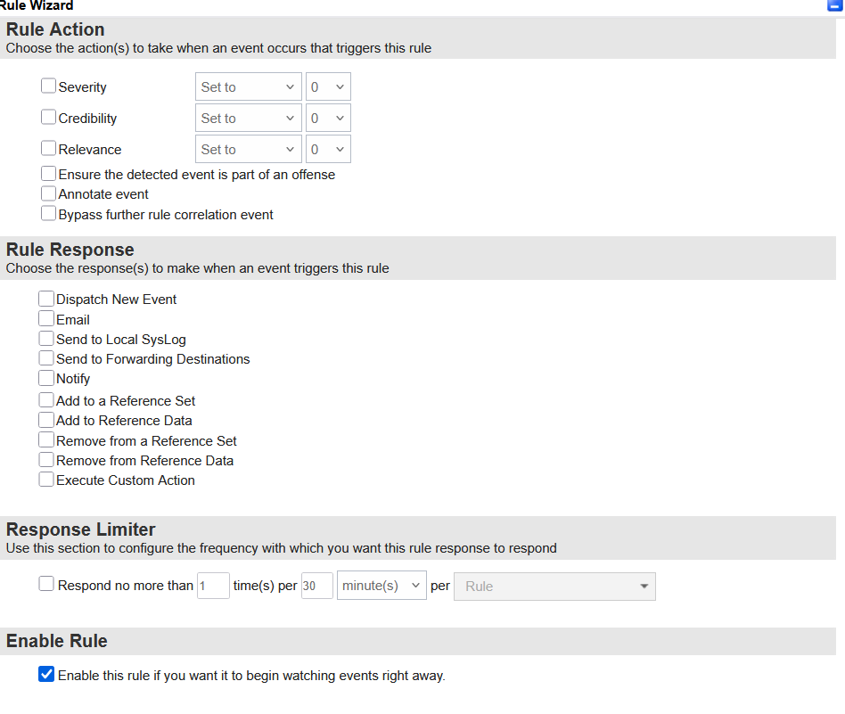 Then finish.

13.TEST Qradar

------------------------------------------Now got Offense tab---------------------------- 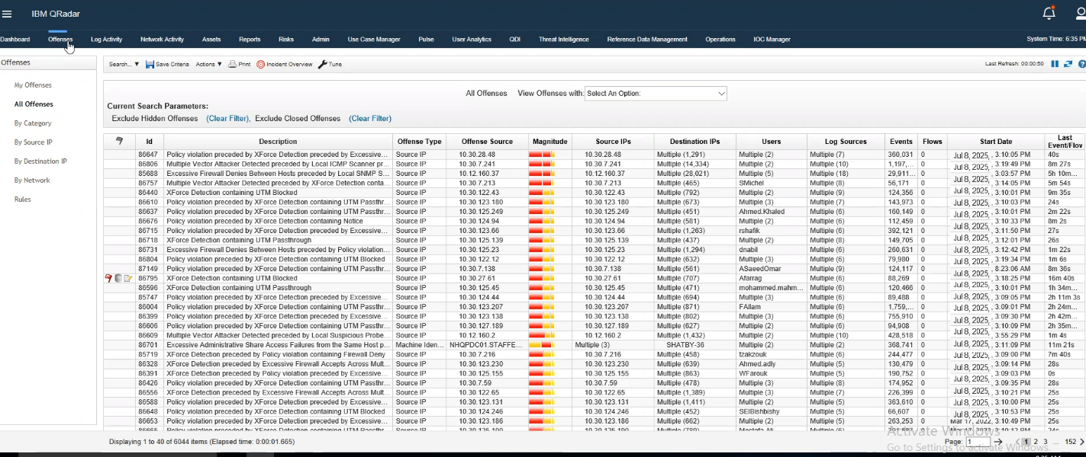

Can see the offense that related by any log from here in first column

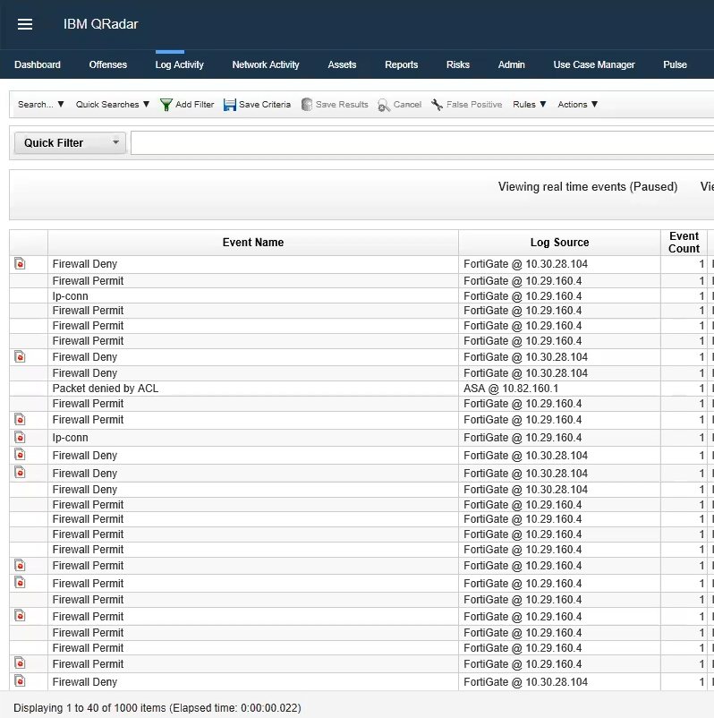Here we will see the alart of qradar call offense .

------------------------------Now it time to hack-----------------------------

we will test Qradar can detect some Attack or not but in the first we will identify every one attack we use :

* 1. Brute force attack : A is a method used by attackers to gain unauthorized access to systems, networks, or encrypted data by systematically trying every possible combination of passwords or encryption keys until the correct one is found.



Brute force attacks exploit weak or short passwords. The attacker uses automated tools (like Hydra, John the Ripper, or Hashcat) to try millions or billions of combinations in a short time.

There are several types of brute force attacks:

### Types of Brute Force Attacks:

1. **Simple Brute Force Attack**
   * Tries all possible combinations without any logic.
   * Effective against short, simple passwords.
2. **Dictionary Attack**
   * Uses a predefined list (dictionary) of likely passwords (like password123, admin, qwerty).
   * Faster and more efficient than pure brute force.
3. **Hybrid Attack**
   * Combines a dictionary with variations (e.g., replacing letters with numbers: P@ssw0rd).
4. **Credential Stuffing**
   * Uses previously leaked username/password pairs to try on multiple sites.
5. **Reverse Brute Force**
   * Tries one common password against many usernames.

* Now we will use John the Ripper tool to try make brute force on AD and see what Qradar detect : Log activity: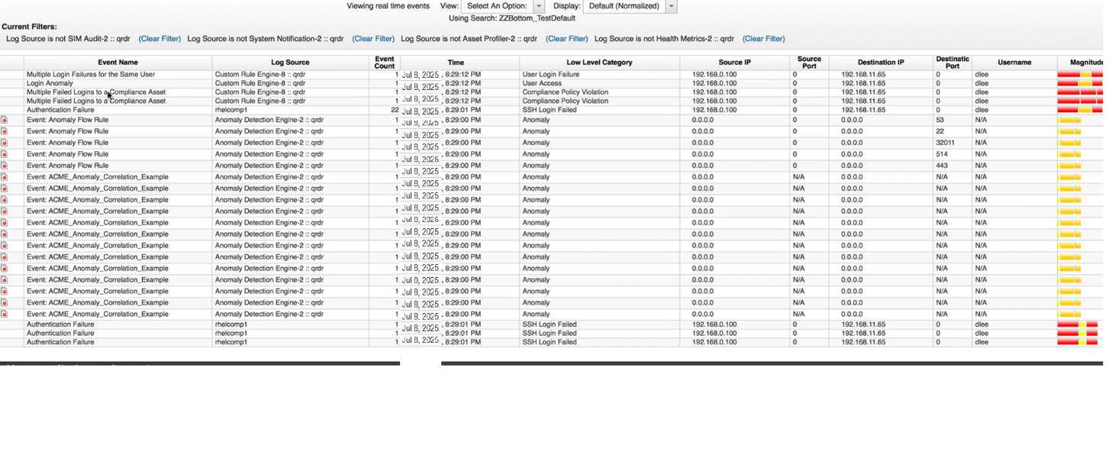 offense: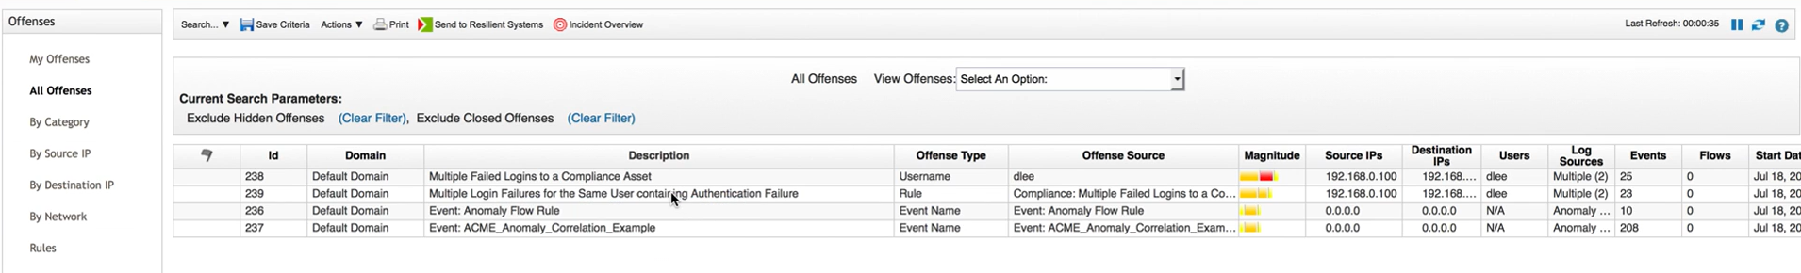

* We will found multiple failures and this a brute force attack.

2-RScan :

A **remote scan attack** is a type of **cyber reconnaissance** where an attacker **scans a target system or network from a remote location** to gather information about:

* Open ports
* Running services
* Operating systems
* Known vulnerabilities
* Weak configurations

This is typically the **first step in a cyberattack**, helping attackers find potential entry points before attempting actual exploitation (like brute-force attacks, malware deployment, or data theft).

### Why It's Done:

To identify:

* Weak services (like old versions of SSH, FTP, RDP)
* Misconfigured firewalls
* Exposed login portals or APIs
* Vulnerable software that could be exploited

### Types of Remote Scanning Attacks:

1. **Port Scanning**
   * Finds open ports (e.g., 22 for SSH, 80 for HTTP)
   * Helps attackers map the network
2. **Service Scanning**
   * Determines which services are running on open ports (e.g., Apache, MySQL)
3. **Vulnerability Scanning**
   * Identifies known CVEs (Common Vulnerabilities and Exposures)
   * Example: Outdated versions of Apache, SMBv1, etc.
4. **Banner Grabbing**
   * Reads system messages or headers that reveal software versions
5. **Stealth Scanning**
   * Uses techniques (like SYN scans or fragmented packets) to avoid detection by firewalls/IDS

* We will use nmap tool to scan on AD then go to qradar :

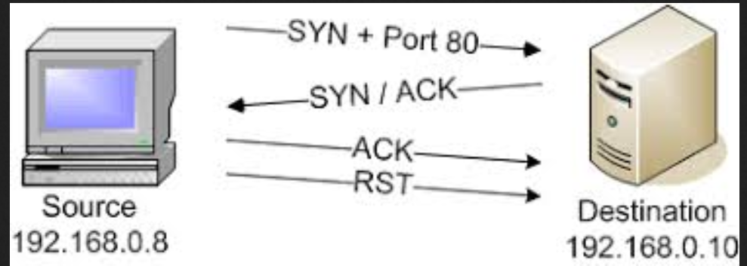

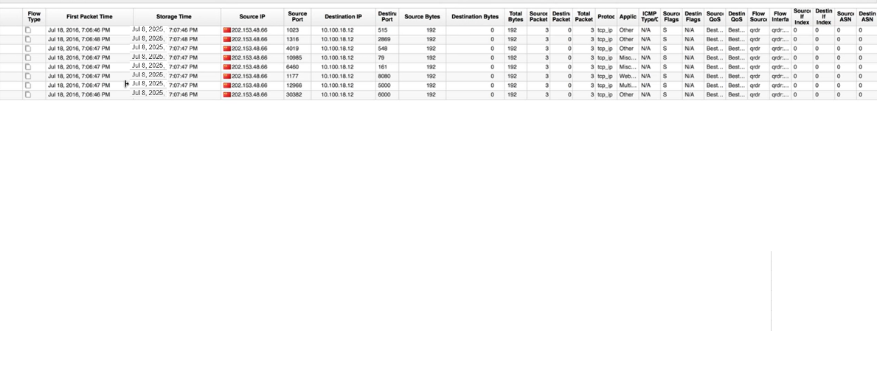

We will one ip try to open connection with one distention but use many ports this a scan to learn what a ports is open .

3-DDOS ATTACK :

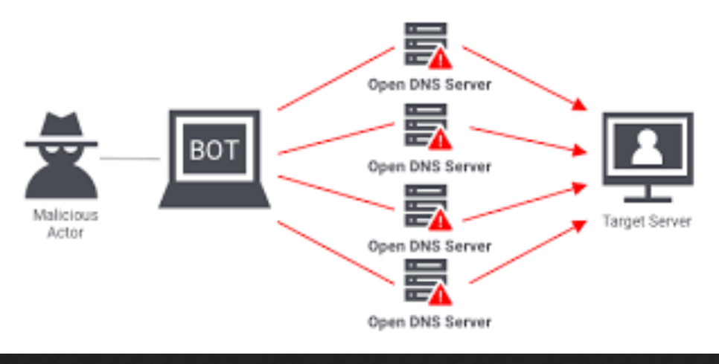

A **DDoS attack** (Distributed Denial-of-Service) is a malicious attempt to **disrupt the normal traffic** of a targeted server, service, or network by **overwhelming it with a flood of internet traffic**.

### What is a DDoS Attack?

* **"Denial-of-Service" (DoS)** = flooding a target with traffic until it crashes or becomes unusable
* **"Distributed"** = traffic comes from **multiple sources** (usually a **botnet**) to make the attack harder to stop
* Goal: **Take down** websites, apps, or services temporarily or permanently

### How DDoS Attacks Work:

1. **Attacker controls a botnet** (a network of infected devices: PCs, IoT, etc.)
2. Botnet devices send massive traffic to the target server
3. The server becomes **overloaded** and crashes or slows down
4. 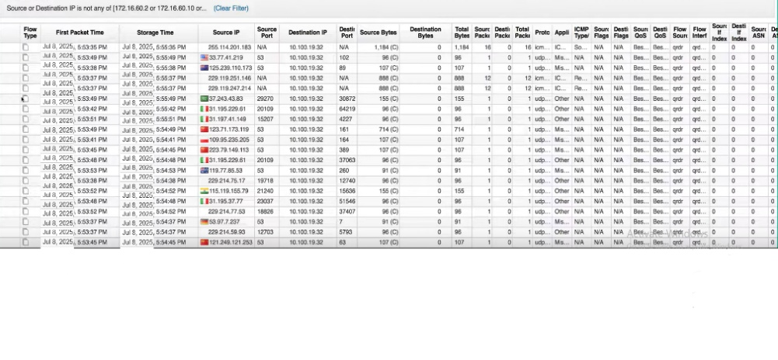Legitimate users **can’t access** the service anymore

* We will use Hping3 to try make DDOS on AD then go to Qradar :
* We will found many pf ips open connection with one distention

**Conclusion**

This project has demonstrated the practical application of core networking, cybersecurity, and system integration concepts to build a reliable enterprise infrastructure capable of supporting SIEM technologies. Through a structured design based on the Cisco three-tier model and supported by industry-standard protocols such as OSPF, HSRP, and Rapid-PVST+, we were able to ensure network scalability, redundancy, and performance.

Security was integrated throughout the infrastructure with multiple protective mechanisms including DHCP snooping, DAI, port security, and strict VLAN segmentation. The network design allowed for centralized service hosting in the Data Center and supported real-time log collection and threat monitoring using IBM QRadar SIEM. Logs from routers, firewalls, and Windows servers were analyzed for common threats such as brute-force, port scanning, and network anomalies.

The success of this implementation highlights the importance of collaboration between different IT domains—networking, server administration, firewall management, and SIEM analytics—to achieve a secure and resilient architecture. Moreover, the use of emulation tools like PNETLab helped validate all configurations in a simulated enterprise environment.

In future developments, the infrastructure can be further expanded with VPN site-to-site connections, next-generation firewall features, and cloud-based SIEM enhancements. Overall, this project has provided a strong foundation in enterprise network security design and hands-on experience that aligns with real-world industry practices.

**References**

1. Cisco Press – CCNA 200-301 Official Cert Guide, Volume 1 & 2
2. Cisco Press – CCNP Enterprise Advanced Routing ENARSI 300-410 Official Guide
3. IBM Security – IBM QRadar SIEM Documentation and User Guides
4. Microsoft Docs – Windows Server 2022 Configuration
5. Fortinet Knowledge Base – FortiGate Firewall Configuration
6. Pluralsight – Detection and Response with IBM Security QRadar
7. YouTube – QRadar Training Playlist: https://youtube.com/playlist?list=PL8w50Tf79XHfoygbMSoramCOP5pEnSnfC
8. Mega Repository (Training Content): https://mega.nz/folder/jAEhlZ7b#VFxS-tPb3tUaA3X8EDxCbQ
9. Cisco Packet Tracer & PNETLab Community Forums for simulation insights
10. YouTube – QRadar Training Playlist: https://youtube.com/playlist?list=PL8w50Tf79XHfoygbMSoramCOP5pEnSnfC
11. Mega Repository (Training Content): https://mega.nz/folder/jAEhlZ7b#VFxS-tPb3tUaA3X8EDxCbQ
12. Cisco Packet Tracer & PNETLab Community Forums for simulation insights
13. <https://www.ibm.com/community/101/qradar/ce/>
14. <https://www.pluralsight.com/paths/detection-and-response-with-imb-security-qradar>
15. <https://mega.nz/folder/jAEhlZ7b#VFxS-tPb3tUaA3X8EDxCbQ> (عربي)
16. <https://youtube.com/playlist?list=PL8w50Tf79XHfoygbMSoramCOP5pEnSnfC&si=SBItyIuwmOmdujif>